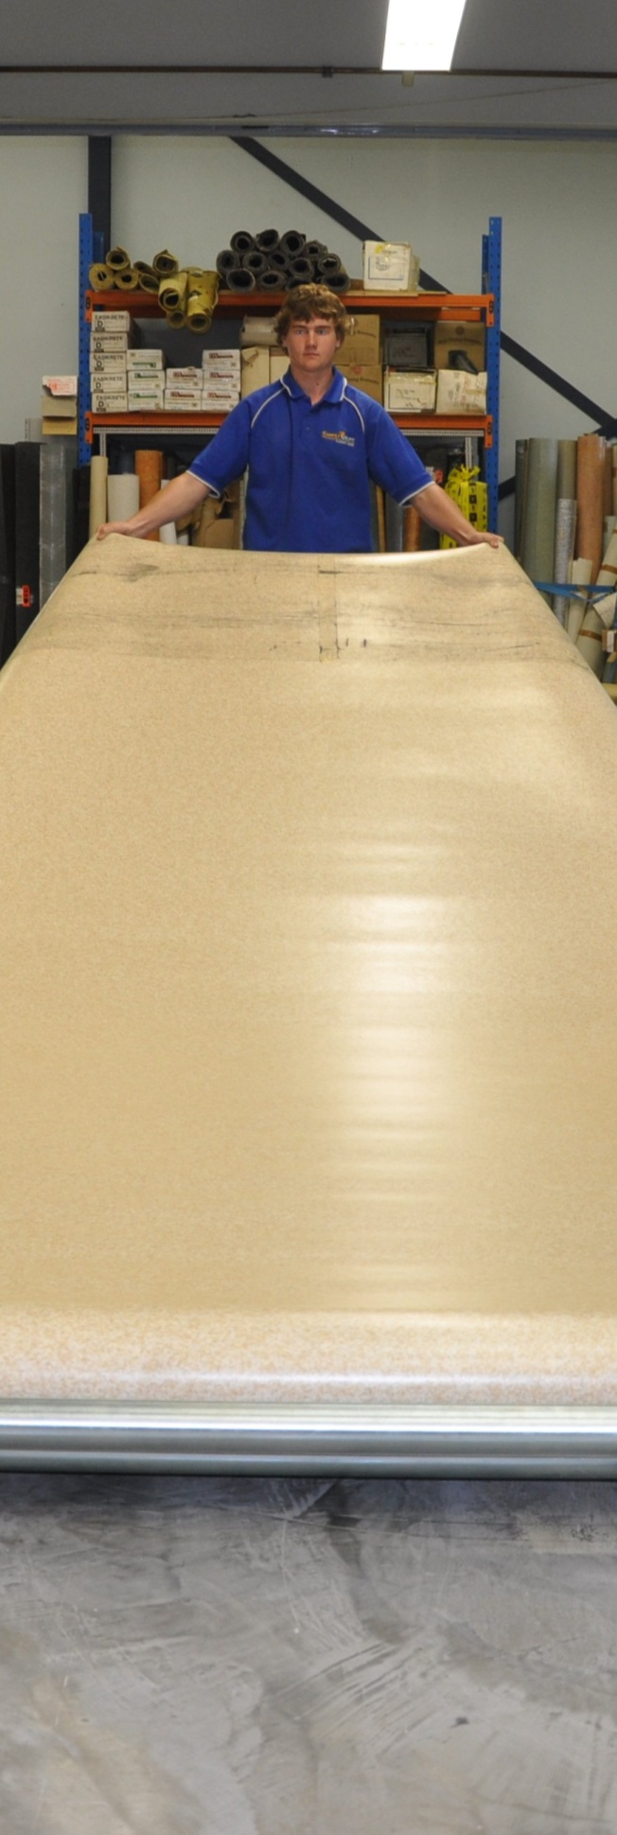
Linoleum
DRAFT VERSION
October 11
Developed in 2012-2013 for the WELL Program

Supporting:
LMFFL3301A: Install
linoleum floor coverings

Learner guide

Linoleum
Learner guide

This unit is also available in an e-learning format, which contains additional photos, interactive exercises and a voice-over narration of the text. It can be viewed on CD-ROM, or live on the web at:
www.flooringtech.com.au

Developed by Workspace Training for the 2012-2013
Workplace English Language and Literacy (WELL) Program
Flooring Technology resource development project

Copyright and disclaimer
ISBN: 978-1-925087-04-8
Funded under the Workplace English Language and Literacy Program by the Australian Government through the Department of Industry, Innovation, Climate Change, Science, Research and Tertiary Education
© Commonwealth of Australia 2013
CC BY-NC-SA
This work is copyright. Except where otherwise indicated, and save for the Commonwealth Coat of Arms, the Department has applied the Creative Commons Attribution-Noncommercial-Share Alike 3.0 Australia Licence to this work.
The Department of Industry, Innovation, Climate Change, Science, Research and Tertiary Education must be attributed as the author of the Department’s copyright material.
As far as practicable, material for which the copyright is owned by a third party has been clearly labelled. The Department has made all reasonable efforts to ensure that this material has been reproduced in the print-based resources and accompanying website with the full consent of the copyright owners.
Requests and enquiries concerning the Department’s copyright material should be addressed to:
The Legal Branch
Department of Industry, Innovation, Climate Change, Science, Research and Tertiary Education
GPO Box 9839 Canberra ACT 2601
Email: legalservices@innovation.gov.au
Questions about the design and content of the resource itself should be addressed to the project manager:
David McElvenny
Workspace Training
PO Box 1954 Strawberry Hills, NSW, 2012
Email: david@workspacetraining.com.au

Disclaimer
The content of this Learner guide is provided for educational purposes only. No claim is made as to the accuracy or authenticity of the content. The views expressed in this publication do not necessarily represent the view of the Minister for Tertiary Education, Skills, Science and Research or the Australian Government. The Australian Government does not give any warranty nor accept any liability in relation to the contents of this work.

About this resource
This Learner guide is part of a suite of resources developed for the Flooring Technology project, funded by the WELL Program. The resources support 19 competencies from the Certificate III in Flooring Technology (LMF31208). The project comprises a website and an accompanying set of Learner guides and work books.
The individual competencies are grouped into ‘Learning units’ as shown below. Each one is given a title describing the main theme of that set of integrated competencies.

Learning unit title Competencies covered
Safety at work MSAPMOHS200A: Work safely
LMFFL3002A: Establish and maintain a safe flooring technology work environment
Inspecting and testing subfloors LMFFL2004A: Moisture test timber and concrete floors
LMFFL3101A: Inspect sub-floors
Planning and costing LMFFL3001A: Plan and cost flooring technology work
Subfloor coatings and toppings LMFFL2102A: Prepare, select and apply smoothing and patching compounds
LMFFL2103A: Select and apply appropriate compounds and additives
LMFFL2105A: Select, prepare and apply moisture barriers and damp proof membranes to concrete sub-floors
Concrete grinding LMFFL2107A: Select, operate and maintain grinding equipment
Preparing floor coverings LMFFL2002A: Receive and prepare floor covering materials for installation
Lay flat vinyl LMFFL2301A: Install lay flat vinyl floor coverings
Resilient tiles LMFFL2302A: Install resilient tiles using standard installation practices
Commercial vinyl LMFFL3302A: Install commercial vinyl floor coverings
LMFFL3303A: Install resilient floor coverings using custom designs and decorative finishes
Linoleum LMFFL3301A: Install linoleum floor coverings
ESD floors LMFFL3308A: Install anti-static resilient floor coverings
LMFFL3309A: Install conductive resilient floor coverings
Making measurements MSAPMOPS101A: Make measurements
Working sustainably MSAENV272B: Participate in environmentally sustainable work practices
The purpose of these resources is to help trainee floor layers acquire the background knowledge needed to satisfy the theoretical components of the competencies covered in this project. However, the resources are not designed to replace the practical training necessary to develop the hands-on skills required. Learners will still need to receive extensive on-the-job training and supervision before they will be ready to be formally assessed in the relevant competencies.

E-learning version
All of the content material contained in this Learner guide is also available in an e-learning format, which has additional photos, interactive exercises and a voice-over narration of the text. The e-learning version can be viewed on the web at: www.flooringtech.com.au
The web version can also be purchased on a CD at a cost-recovery price from the project developer:
Workspace Training
PO Box 1954 Strawberry Hills, NSW, 2012
Email: david@workspacetraining.com.au

Acknowledgements

Project team
Project manager: David McElvenny
Instructional designer: Kath Ware
Technical developer (website): Jim Vaughan
Assistant technical developer (and voice-over artist): Alex Vaughan
Quality assurance consultant: Giselle Mawer
Industry coordinator: Gary Dunshea (MSA Industry Skills Council)

Technical Advisory Group

Lead advisors
William Tree – South West Sydney Institute of TAFE
Mark Willis – Council of Textile and Fashion Industries of Australia
Craig Bennett – Hunter Institute of TAFE

Reviewers
Ian Ciesla – Polytechnic West
Robert Cole – Furnishing Industry Association of Australia
Steven Dalton – Marleston TAFE
Shane Eales – SkillsTech Australia
David Hayward – Australian Timber Flooring Association
Bruce Ottens – Holmesglen TAFE
Chris Shaw – Skills Institute Tasmania
Warren West – Australian Resilient Floor Covering Association

Industry advisors
Peter Brack – Forbo Flooring Systems
Don Considine – IKW Consulting Group
Gary Eggers – Tarkett Flooring
Jim Hilston – Hilston Floors
Lionel Jacobs – Epoxy Solutions
Owen Jordian – Choices Flooring
Steven King – Armstrong Floors
Jarka Kluth – Pro Grind Australia
Haydn Reynolds – Floorex Products
Naomi Archer – All Preparation Equipment

Photographs
Most of the photos in this suite of resource were taken by David McElvenny. Additional photos were provided by:
David Beeforth (ParexDavco)
Don Considine (IKW Consulting Group)
Craig Bennett (Hunter TAFE)
David Hayward (Australian Timber Flooring Association)
Gary Eggers (Tarkett)
Lionel Jacobs (Epoxy Solutions)
Jarka Kluth (Pro Grind Australia)
Haydn Reynolds (Floorex Products)
Naomi Archer (All Preparation Equipment)
We would like to thank the following organisations for allowing us to take on-site photos of their employees at work or students in class.
Choices Flooring – Sandgate, Bulleen, Thomastown and Mornington
Lidcombe College of TAFE
Lomac Commercial Flooring
Tarkett
Epoxy Solutions

Graphics
Graphics were drawn by Kath Ware. Many of these graphics are based on line drawings or photographs from installation manuals published by the following flooring manufacturers:
Armstrong: http://www.armstrong.com/flooring/guaranteed-installation-systems.html
Forbo: http://www.forbo-flooring.com.au/Commercial-flooring/Support-installation-and-maintenance/Installation/Installation-technique/
Tarkett: http://professionals.tarkett.com.au/commdocu?field_docu_type_value=
Installation+guide

Financial contributions
This resource was funded by the Workplace English Language and Literacy Program by the Australian Government through the Department of Industry, Innovation, Climate Change, Science, Research and Tertiary Education. Additional financial assistance was provided by Manufacturing Skills Australia (Industry Skills Council).

Table of contents
Introduction 1
Properties of linoleum 3
Cutting and welding 5
Bight marks and end curls 8
Border coving 10
Assignment 12
Practical demonstrations 13

Introduction
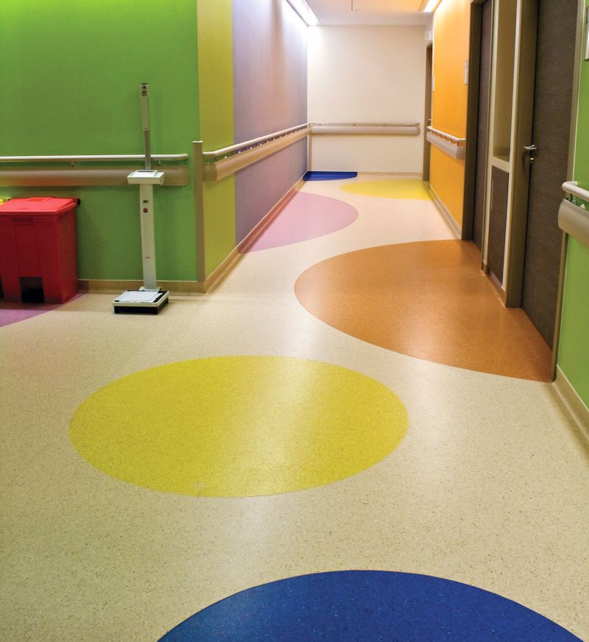
The word linoleum comes from ‘linum’ (Latin for flax) and ‘oleum’ (meaning oil).
It was first invented in the 1850s, using oxidised linseed oil, cork dust and gum to form a resinous mixture, which was poured onto a cotton cloth backing.
Although there have been many refinements to the manufacturing process over the last 160 years, the basic principles haven’t changed.
The main reason linoleum is still so popular is due to its long-term durability and wide range of colours. It is also highly resistant to scratching and performs very well in high traffic areas.

Completing this unit
This unit is designed to be read in conjunction with the following two units:
- Commercial vinyl
- Lay flat vinyl.
All of the general techniques relating to installing resilient sheet products are covered in those two units. The preparations you should make before starting an installation are also covered, along with discussions on safety, adhesives and tools.
So in this unit, we’ll look at the specific installation techniques that apply to linoleum due to its different properties and structure.
There are four lessons in this unit:
- Properties of linoleum
- Cutting and welding
- Bight marks and end curls
- Border coving.
These lessons will provide you with background information relevant to the assignment and practical demonstration requirements.

References
The methods described in this unit are based primarily on the information provided by Forbo in their installation guide. You can download the original PDF documents from their website via the following link:
http://www.forbo-flooring.com.au/Commercial-flooring/Support-installation-and-maintenance/Installation/Installation-technique/
We have also used a variety of photos provided by Tarkett Australia. You can see these photos in the original document at: http://viewer.zmags.com/publication/6612b1a9#/6612b1a9/22.

Assignment
Your trainer may ask you to submit the assignment as part of your assessment evidence for the unit. You will find a hard-copy template in the separate workbook.
An electronic ‘Word’ template of the assignment is available on the website for this resource, at: www.flooringtech.com.au

Learning activities
Each of the lessons has a learning activity at the end. The Workbook for this unit contains all of the learning activities together with spaces for written answers.
Again, you will find the learning activities on the website version, together with some interactive ‘Just for fun’ exercises.

Practical demonstrations
Your final assessment of competency will include various practical demonstrations. Their purpose is to assess your ability to install linoleum floor coverings. To help you get ready for these hands-on assessment activities, see the sample checklist shown in the Practical demonstrations section at the back of this Learner guide.

Properties of linoleum
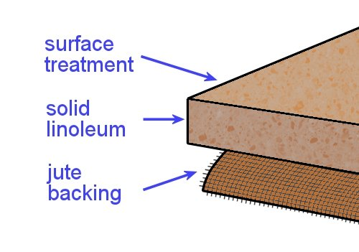
Linoleum is made from natural materials. The primary ingredients are linseed oil and rosin (tree resin). These are mixed with other substances, such as wood flour, limestone powder and colour pigments, to form ‘linoleum granulates’.
The granulates are pressed onto a hessian backing in a rolling mill to make the linoleum sheet. Hessian is a fabric that’s woven from jute plant fibres.
Given the fact that all of these materials are naturally occurring and biodegradable, linoleum is often considered to be more environmentally friendly than vinyl flooring.
Having said that, it is true that vinyl manufacture requires less power – so there are less greenhouse gasses emitted while it is being made. It’s also the case that recycled PVC flooring is increasingly being used as a base material in the manufacture of new vinyl products.
Nonetheless, linoleum still has the reputation for being eco-friendly and available in a wide range of warm ‘earthy’ colours.

Drying room yellowing
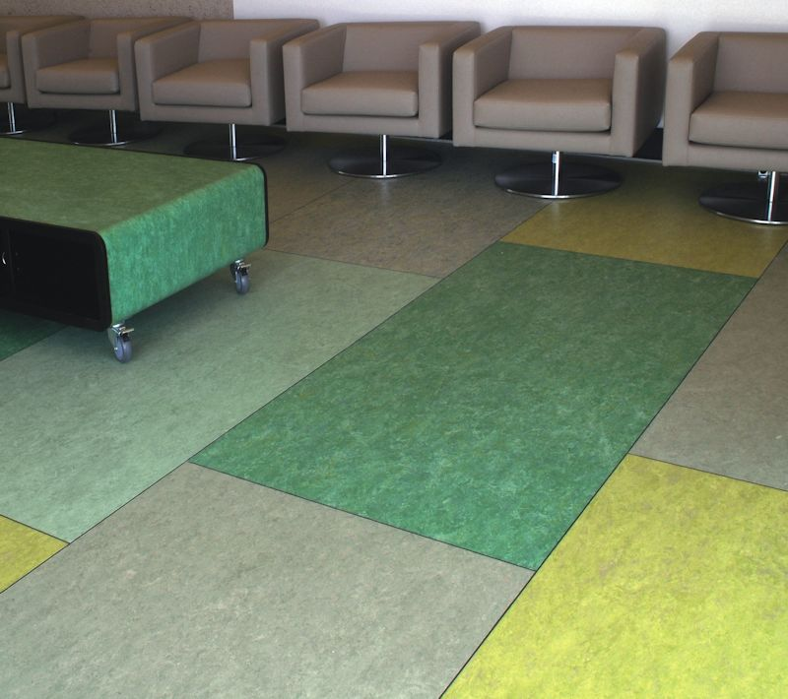
Because linoleum uses linseed oil as one of its ingredients, it sometimes develops an appearance on the surface called ‘drying room yellowing’.
The yellowing occurs when the linseed oil oxidises while it’s drying.
Its final effect depends on the colours in the linoleum – for example, blues and greens tend to look greener, and beige takes on a yellowish hue.

Once the flooring is exposed to light, the yellowing disappears. In bright sunlight, this process will take only a few hours; but in artificial light it can take up to several weeks. Nonetheless, it will still disappear in time, even if you put a floor finish or polish over the yellowing.
If furniture or other objects are placed on the linoleum and the light is blocked out, the yellowing cast may start to reappear. However, you can reassure the client that this isn’t a stain. Once it’s exposed to light, it will fade away again.

Manufacturing process
The diagram below shows the process used to manufacture linoleum sheet flooring. It has been adapted from a drawing developed by Tarkett.
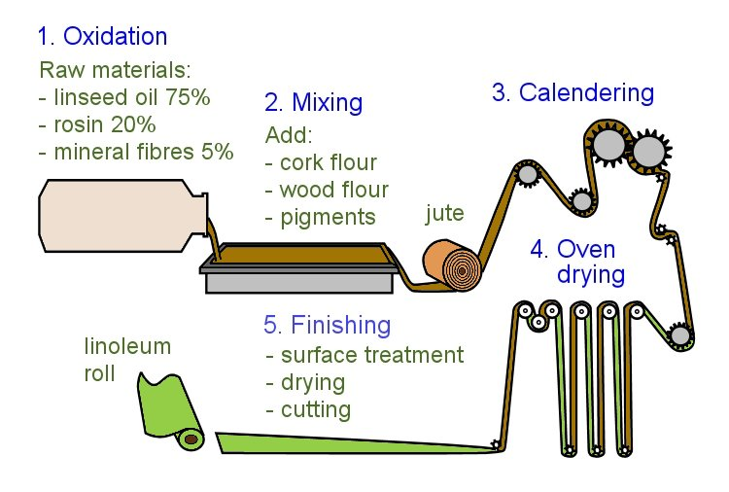

Learning activity
Follow the link below to see a promotional video produced by Forbo on how they manufacture linoleum sheets.
http://www.youtube.com/watch?v=STu33sT7hVo
Watch the video and answer the following questions:
- What brand name is used by Forbo for their linoleum products?
- How long does the linoleum sheet spend in the drying room while it cures?

Cutting and welding
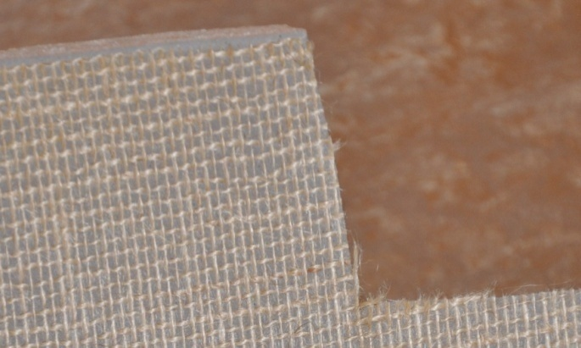
The basic techniques for cutting, fitting and welding linoleum are much the same as for commercial vinyl.
However, linoleum has slightly different properties from vinyl, so there are a few important differences.

Cutting seams
When linoleum is rolled out and placed into the adhesive, the hessian-backed material picks up moisture from the atmosphere and adhesive.
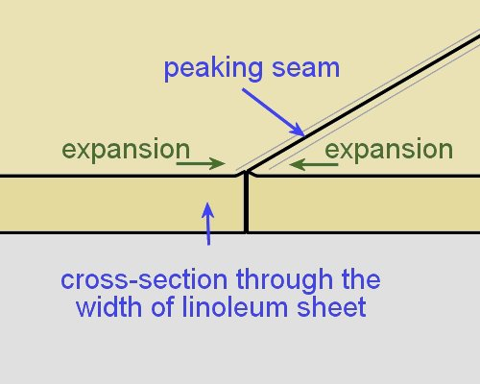
This causes a small amount of expansion across the width of the sheet, which stops when the adhesive starts to cure.
Even though the expansion is only tiny, it can cause the seam to peak if you don’t make allowance for it.
The allowance only needs to be about the thickness of the pin in a pin vice.
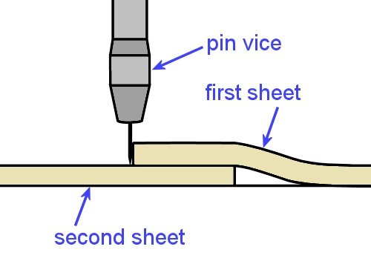
You can accommodate any expansion by using the following procedure:
- Cut the true edge in the first sheet of linoleum as you would for commercial vinyl.
- Lap the second sheet under the first sheet, either matching up the pattern or leaving a 20 mm overlap.
- Score the second sheet with a pin vice, keeping the pin vertical and pressed against the true edge of the first sheet.
- Cut the second sheet with a straight blade and hooked blade.

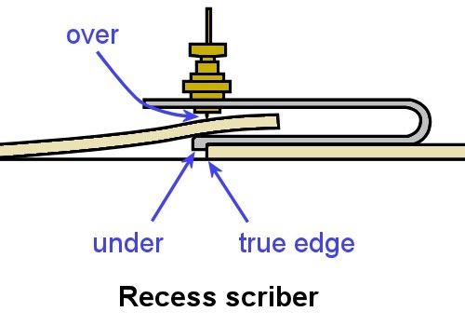
Alternatively, you can use a recess scriber to scribe the second sheet. Run the ‘under’ guide along the true edge of the first sheet and scribe the second sheet with the ‘over’ scribe pin.
But remember to offset the scribe pin by the thickness of the pin to achieve the same result as described before.

Fitting long lengths
If the sheet is long, it will tend to shrink slightly along the length, so you need to make allowance for the shrinkage when you cut the sheet.
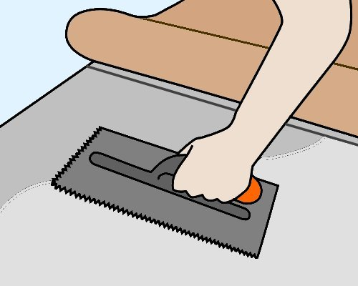
One method of dealing with the shrinkage is to only scribe one end and stick down the sheet up to about the last 2 metres. Then scribe the second end, spread the remaining adhesive and stick that end down.
Note that the whole sheet must be stuck down while the adhesive is still wet. If the first part starts to set before you lay down the last section, any overspread in adhesive might result in bubbles where the two parts meet.

Heat welding
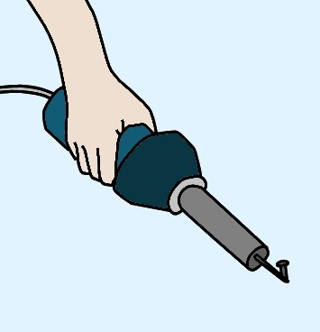
Welded joins are less necessary in linoleum than in vinyl, because well-cut seams are more likely to close up tightly after the material has been stuck down. However, if hygiene or water resistance are important aspects of the job, you should still weld all joins.
The tools used for heat welding are the same for both vinyl and linoleum. However, the welding cable is different, and linoleum is welded at a lower temperature and slower speed.
The chemical reaction that occurs in the welded joint is also different. In vinyl, both the flooring material and welding cable melt and fuse together; but in linoleum, only the cable melts as it bonds to the routed seam.
Linoleum welds should be trimmed almost immediately for the first pass, and soon after for the second. This is different from vinyl, where you should wait a bit longer before doing the first pass, and then let it completely cool before the second pass.

Learning activity
The link below will take you to a Forbo video on the correct use of adhesive when installing Marmoleum.
http://www.youtube.com/watch?v=mvmIm1bFOHs
This video provides a good review on the difference between ‘open time’ and ‘working time’, which we discussed in the unit Commercial vinyl.
It also explains the differences in technique that apply to linoleum, compared to the practices used for commercial vinyl.
Watch the clip and then answer the following questions:
- What conditions will affect the ‘open time’ and ‘working time’ of an adhesive?
- What does ‘fully wet’ mean?
- What does ‘semi-wet’ mean?
- What does ‘flashed off’ mean?
- At what stage of the drying process should you lay the sheet into the adhesive?
- What is one of the most common causes of installation failure in Marmoleum?

Bight marks and end curls
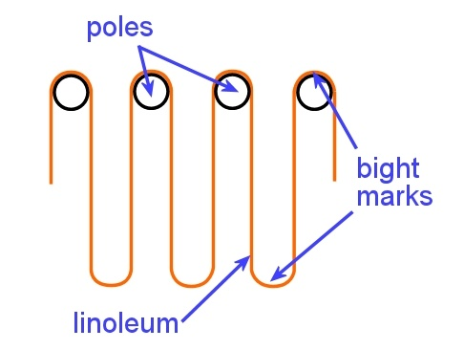
Bight marks occur in linoleum where a continuous sheet loops over poles in the drying oven while it’s curing. The bight marks at the top are cut out at the factory and the discarded material is recycled.
However, the marks at the bottom of each loop are left in the sheet. In the finished roll they often appear as a slight ridge across the sheet, about 150 mm wide.
With products that are 2.0 to 2.5 mm thick, the ridge can be stuck down in the normal way as long as the site is warm and the bight mark is well rolled both across and then along the sheet.
But with 3.2 mm material, or if the temperature is cool, you may need to either cut out the bight mark or use the following technique:
- As you feed the sheet into the wet adhesive and reach the bight mark, lean gently on the mark and rock it in and out of the adhesive, making sure there is a complete transfer of adhesive onto the hessian backing.
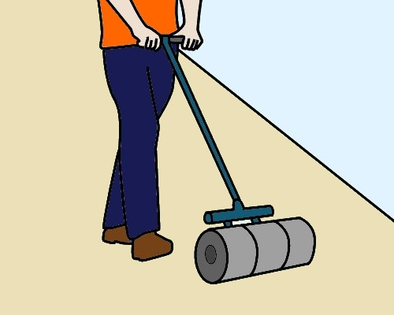
- When the loop of material being fed into the adhesive clears the area of the bight mark, immediately roll it with a 68 kilogram roller and remove any bubbles or trapped air.
- Continue to roll the bight mark every 15 minutes until it has fully bonded to the subfloor.
An alternative method is to use contact adhesive on the subfloor where the bight mark falls. For more information on this process, see the Forbo Installation Guide (referenced in the Introduction section of this Learner guide).

Removing end curl
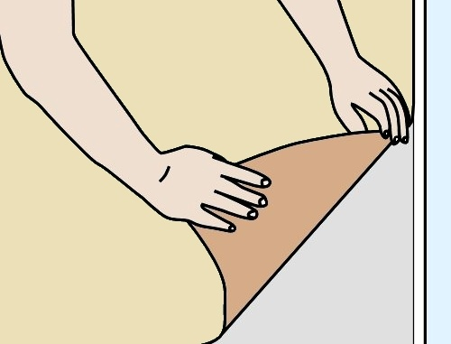
The end of the linoleum sheet also needs to be laid carefully, to make sure that the hessian backing beds well into the adhesive.
If you fold the corner back diagonally and use a ‘bouncing’ action as you place it into the adhesive, it will help to relieve the tension in the end of the length.
Then roll the sheet thoroughly with a floor roller.

Learning activity
Go to the video clip called ‘Forbo marmoleum sheet installation video’ at:
http://www.youtube.com/watch?v=NPgMgoRNM3U
Watch the clip and then answer the following questions:
- When should you roll out the material after it has been laid into the adhesive?
- What would happen to the sheet if you didn’t massage the end curl before you laid it into position?
- What does the presenter suggest you do with the adhesive to help the ‘stove bar’ (bight mark) bond properly to the subfloor?

Border coving
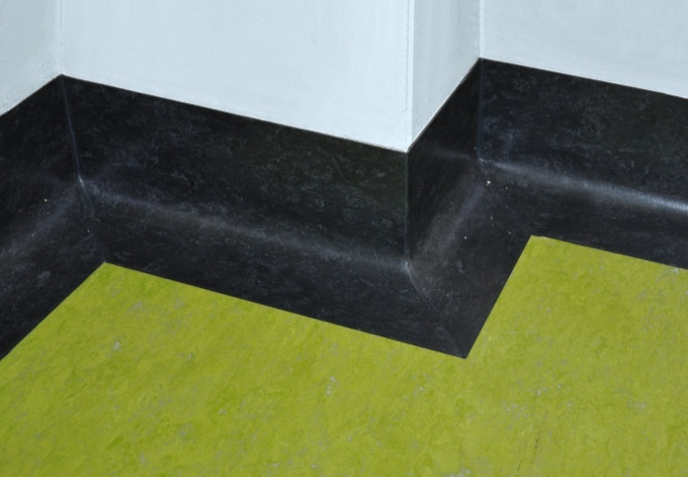
Coving in linoleum is generally installed as a border cove, with a separate piece joined at the floor to the field material.
It can either be the same colour as the field material or in a contrasting feature colour.
Border coving can be formed on-site from field material or installed as preformed pieces.

Using field material to form a border cove
- Lay the field material first.
- Draw a line on the wall to mark the top of the coving. Fit a capping strip and the cove former using contact adhesive.
- Measure the full width of the cove and border using a flexible ruler or a scrap piece of material.
- Cut strips of the correct size from the roll of flooring material.
Note that the strips should be cut lengthwise – if you cut across the end of the roll, the piece is likely to curl inwards in the opposite direction from the way you want to turn it for the cove.
- Butt join each strip against the field material and check that it sits correctly.
- Spread the adhesive and wait the required time. Warm the linoleum with a heat gun to make it easier to curve the material over the cove fillet.
- Carefully place the linoleum into position. Ease the top edge into the capping strip with a screwdriver.

Installing preformed pieces
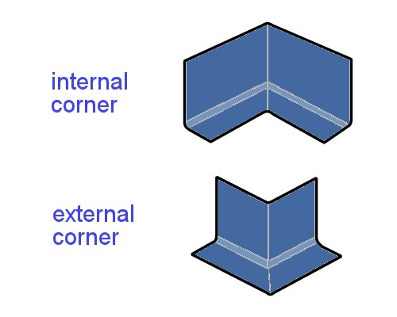
Some manufacturers produce preformed border coving with a reinforced backing. This is supplied in long straight lengths and cut or mitred with a saw on-site.
There are also preformed internal and external corners, which can be used as an alternative to mitre cutting the long lengths. These pieces are placed in position on the floor and heat welded to the adjoining pieces.

Learning activity
The link below will take you to an instruction video produced by an American company called Flashcove, showing how to fit and install their preformed border coves.
‘Installation for Flashcove prefabricated bases’:
http://www.youtube.com/watch?v=GiARlVIM1Sw
Watch the video and answer the following questions:
- How does the installer find the angle for the external mitre cuts with the use of a bevel (rather than a protractor)?
- What tool does he use to push the coving firmly into the adhesive?
- Why is the field material laid after he has installed the flash coving?

Assignment
Go to the Workbook for this unit to write your answers to the questions shown below. If you prefer to answer the questions electronically, go to the website version and download the Word document template for this assignment.
___________________________________________________________________________
- (a) What are the two main raw materials used to make linoleum?
- What is the backing material made from?
- Why is linoleum often considered more environmentally friendly than vinyl?
- (a) What does ‘drying room yellowing’ look like in a linoleum floor?
- What causes this effect?
- What would your advice be to a client who complains about the yellowing in their finished floor?
- (a) Why does linoleum expand slightly across its width when laid into the adhesive?
- How do you avoid the problem of the seams peaking due to expansion?
- How wet should the adhesive be when you lay the linoleum?
- (a) What is the difference in chemical reaction between a heat weld in vinyl and a heat weld in linoleum?
(b) How should you heat weld a linoleum seam in comparison with a vinyl seam (in terms of temperature setting and speed)?
5. (a) What do bight marks look like and how are they caused?
(b) Describe one method for dealing with a bight mark as you lay the linoleum.
6. (a) If you were cutting strips of border coving from linoleum field material, why should you cut them lengthwise along the sheet rather than across the sheet?
(b) How would you make the material more flexible when you are curving it over the cove former?

Practical demonstrations
Your trainer may ask you to keep a log book or diary of the work you do on-the-job that relates to the practical components of this unit. This will help them to determine when you will have had sufficient hands-on practice in these tasks to undertake the assessment events.
When you are ready to be assessed, your assessor will ask you to complete a range of practical demonstrations, including installations of:
- sheet linoleum using custom designs and pattern scribes, with fillet cove internal and external mitres and heat welded seams
- sheet linoleum in a corridor and connecting room using pre-formed coving with internal and external mitres and heat welded seams
- sheet linoleum in a single room or connecting rooms using butt joins.
As part of the demonstrations, you will be asked to use some or all of the following tools:
- spatula knife, utility knife with hook, straight and concave blades
- straight edge, square, chalk, chalk line, tape measure
- notched trowel, serrated trowel
- hammer, rubber mallet, hacksaw
- seam and edge trimmer, wall trimmer
- dividers, recess scriber, preformed linoleum recess scriber, scribing bar
- welding gun and accessories
- gas bottle and gun, hot air gun
- grooving tool, cove gauging tool
- pencil cove roller, hand roller, floor roller
- paint brush, bucket
- linoleum trolley.
In addition to assessing your ability to physically install linoleum flooring, your assessor will also be checking that you can:
- follow all work, health and safety requirements and environmental care procedures
- correctly interpret company documents and work instructions
- communicate and work effectively with other workers in the area
- prevent damage to goods, equipment and products
- work productively and produce a high quality job
- modify activities and techniques used to suit different sites and working conditions.
Make sure you talk to your trainer or supervisor about any of the details you don’t understand, or aren’t ready to demonstrate, before the assessment events are organised. This will give you time to get the hang of the tasks you’ll need to perform, so that you’ll feel more confident when the time comes to be assessed.

