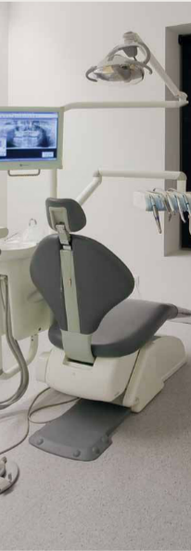
ESD Floors
DRAFT VERSION
October 11
Developed in 2012-2013 for the WELL Program

Supporting:
LMFFL3308A: Install anti-static resilient floor coverings
LMFFL3309A: Install conductive resilient floor coverings

Learner guide

ESD floors
Learner guide

This unit is also available in an e-learning format, which contains additional photos, interactive exercises and a voice-over narration of the text. It can be viewed on CD-ROM, or live on the web at:
www.flooringtech.com.au

Developed by Workspace Training for the 2012-2013
Workplace English Language and Literacy (WELL) Program
Flooring Technology resource development project

Copyright and disclaimer
ISBN: 978-1-925087-05-5
Funded under the Workplace English Language and Literacy Program by the Australian Government through the Department of Industry, Innovation, Climate Change, Science, Research and Tertiary Education
© Commonwealth of Australia 2013
CC BY-NC-SA
This work is copyright. Except where otherwise indicated, and save for the Commonwealth Coat of Arms, the Department has applied the Creative Commons Attribution-Noncommercial-Share Alike 3.0 Australia Licence to this work.
The Department of Industry, Innovation, Climate Change, Science, Research and Tertiary Education must be attributed as the author of the Department’s copyright material.
As far as practicable, material for which the copyright is owned by a third party has been clearly labelled. The Department has made all reasonable efforts to ensure that this material has been reproduced in the print-based resources and accompanying website with the full consent of the copyright owners.
Requests and enquiries concerning the Department’s copyright material should be addressed to:
The Legal Branch
Department of Industry, Innovation, Climate Change, Science, Research and Tertiary Education
GPO Box 9839 Canberra ACT 2601
Email: legalservices@innovation.gov.au
Questions about the design and content of the resource itself should be addressed to the project manager:
David McElvenny
Workspace Training
PO Box 1954 Strawberry Hills, NSW, 2012
Email: david@workspacetraining.com.au

Disclaimer
The content of this Learner guide is provided for educational purposes only. No claim is made as to the accuracy or authenticity of the content. The views expressed in this publication do not necessarily represent the view of the Minister for Tertiary Education, Skills, Science and Research or the Australian Government. The Australian Government does not give any warranty nor accept any liability in relation to the contents of this work.

About this resource
This Learner guide is part of a suite of resources developed for the Flooring Technology project, funded by the WELL Program. The resources support 19 competencies from the Certificate III in Flooring Technology (LMF31208). The project comprises a website and an accompanying set of Learner guides and work books.
The individual competencies are grouped into ‘Learning units’ as shown below. Each one is given a title describing the main theme of that set of integrated competencies.

Learning unit title Competencies covered
Safety at work MSAPMOHS200A: Work safely
LMFFL3002A: Establish and maintain a safe flooring technology work environment
Inspecting and testing subfloors LMFFL2004A: Moisture test timber and concrete floors
LMFFL3101A: Inspect sub-floors
Planning and costing LMFFL3001A: Plan and cost flooring technology work
Subfloor coatings and toppings LMFFL2102A: Prepare, select and apply smoothing and patching compounds
LMFFL2103A: Select and apply appropriate compounds and additives
LMFFL2105A: Select, prepare and apply moisture barriers and damp proof membranes to concrete sub-floors
Concrete grinding LMFFL2107A: Select, operate and maintain grinding equipment
Preparing floor coverings LMFFL2002A: Receive and prepare floor covering materials for installation
Lay flat vinyl LMFFL2301A: Install lay flat vinyl floor coverings
Resilient tiles LMFFL2302A: Install resilient tiles using standard installation practices
Commercial vinyl LMFFL3302A: Install commercial vinyl floor coverings
LMFFL3303A: Install resilient floor coverings using custom designs and decorative finishes
Linoleum LMFFL3301A: Install linoleum floor coverings
ESD floors LMFFL3308A: Install anti-static resilient floor coverings
LMFFL3309A: Install conductive resilient floor coverings
Making measurements MSAPMOPS101A: Make measurements
Working sustainably MSAENV272B: Participate in environmentally sustainable work practices
The purpose of these resources is to help trainee floor layers acquire the background knowledge needed to satisfy the theoretical components of the competencies covered in this project. However, the resources are not designed to replace the practical training necessary to develop the hands-on skills required. Learners will still need to receive extensive on-the-job training and supervision before they will be ready to be formally assessed in the relevant competencies.

E-learning version
All of the content material contained in this Learner guide is also available in an e-learning format, which has additional photos, interactive exercises and a voice-over narration of the text. The e-learning version can be viewed on the web at: www.flooringtech.com.au
The web version can also be purchased on a CD at a cost-recovery price from the project developer:
Workspace Training
PO Box 1954 Strawberry Hills, NSW, 2012
Email: david@workspacetraining.com.au

Acknowledgements

Project team
Project manager: David McElvenny
Instructional designer: Kath Ware
Technical developer (website): Jim Vaughan
Assistant technical developer (and voice-over artist): Alex Vaughan
Quality assurance consultant: Giselle Mawer
Industry coordinator: Gary Dunshea (MSA Industry Skills Council)

Technical Advisory Group

Lead advisors
William Tree – South West Sydney Institute of TAFE
Mark Willis – Council of Textile and Fashion Industries of Australia
Craig Bennett – Hunter Institute of TAFE

Reviewers
Ian Ciesla – Polytechnic West
Robert Cole – Furnishing Industry Association of Australia
Steven Dalton – Marleston TAFE
Shane Eales – SkillsTech Australia
David Hayward – Australian Timber Flooring Association
Bruce Ottens – Holmesglen TAFE
Chris Shaw – Skills Institute Tasmania
Warren West – Australian Resilient Floor Covering Association

Industry advisors
Peter Brack – Forbo Flooring Systems
Don Considine – IKW Consulting Group
Gary Eggers – Tarkett Flooring
Jim Hilston – Hilston Floors
Lionel Jacobs – Epoxy Solutions
Owen Jordian – Choices Flooring
Steven King – Armstrong Floors
Jarka Kluth – Pro Grind Australia
Haydn Reynolds – Floorex Products
Naomi Archer – All Preparation Equipment

Photographs
Most of the photos in this suite of resource were taken by David McElvenny. Additional photos were provided by:
David Beeforth (ParexDavco)
Don Considine (IKW Consulting Group)
Craig Bennett (Hunter TAFE)
David Hayward (Australian Timber Flooring Association)
Gary Eggers (Tarkett)
Lionel Jacobs (Epoxy Solutions)
Jarka Kluth (Pro Grind Australia)
Haydn Reynolds (Floorex Products)
Naomi Archer (All Preparation Equipment)
We would like to thank the following organisations for allowing us to take on-site photos of their employees at work or students in class.
Choices Flooring – Sandgate, Bulleen, Thomastown and Mornington
Lidcombe College of TAFE
Lomac Commercial Flooring
Tarkett
Epoxy Solutions

Graphics
Graphics were drawn by Kath Ware. Many of these graphics are based on line drawings or photographs from installation manuals published by the following flooring manufacturers:
Armstrong: http://www.armstrong.com/flooring/guaranteed-installation-systems.html
Forbo: http://www.forbo-flooring.com.au/Commercial-flooring/Support-installation-and-maintenance/Installation/Installation-technique/
Tarkett: http://professionals.tarkett.com.au/commdocu?field_docu_type_value=
Installation+guide

Financial contributions
This resource was funded by the Workplace English Language and Literacy Program by the Australian Government through the Department of Industry, Innovation, Climate Change, Science, Research and Tertiary Education. Additional financial assistance was provided by Manufacturing Skills Australia (Industry Skills Council).

Table of contents
Introduction 1
Static electricity in floors 3
Anti-static flooring 6
Conductive flooring 8
Assignment 10
Practical demonstrations 11

Introduction
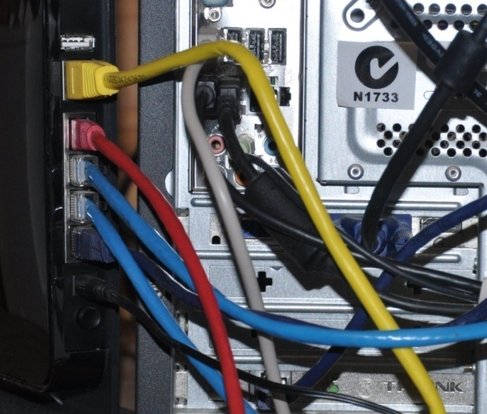
There are some situations where electrostatic discharge (ESD) inside a room can cause problems.
ESD occurs when there is a sudden flow of electricity between two objects.
You can generate static electricity by rubbing certain materials together, or scraping a chair on the floor, or even walking across a floor if your shoes and the floor surface are made of particular materials.

Completing this unit
This unit is designed to be read in conjunction with the following two units:
- Commercial vinyl
- Lay flat vinyl.
All of the general techniques relating to installing resilient sheet products are covered in those units. The preparations you should make before starting an installation are also covered, along with discussions on safety, adhesives and tools.
So in this unit, we’ll look at the specific installation techniques that apply to resilient floor coverings used in ESD environments.
There are three lessons in this unit:
- Static electricity in floors
- Anti-static flooring
- Conductive flooring.
These lessons will provide you with background information relevant to the assignment and practical demonstration requirements.

References
The methods described in this unit are based primarily on the information provided by Forbo and Tarkett in their installation guides. You can download the original PDF documents from their websites via the following links:
Forbo: http://www.forbo-flooring.com.au/Commercial-flooring/Support-installation-and-maintenance/Installation/Installation-technique/
Tarkett: http://professionals.tarkett.com.au/commdocu?field_docu_type_value=
Installation+guide
We have also used a variety of photos provided by Tarkett Australia. You can see these photos in the original document at: http://viewer.zmags.com/publication/6612b1a9#/6612b1a9/22.

Assignment
Your trainer may ask you to submit the assignment as part of your assessment evidence for the unit. You will find a hard-copy template in the separate workbook.
An electronic ‘Word’ template of the assignment is available on the website for this resource, at: www.flooringtech.com.au

Learning activities
Each of the lessons has a learning activity at the end. The Workbook for this unit contains all of the learning activities together with spaces for written answers.
Again, you will find the learning activities on the website version, together with some interactive ‘Just for fun’ exercises.

Practical demonstrations
Your final assessment of competency in this unit will include various practical demonstrations. Their purpose is to assess your ability to install esd floor coverings. To help you get ready for these hands-on assessment activities, see the sample checklist shown in the Practical demonstrations section at the back of this Learner guide.

Static electricity in floors
When an electrically charged object is brought near an object that conducts electricity but is separated from the ground, there will be a discharge as the electrons jump across.
If the charge is strong enough, there may be a spark or ‘crack’ sound. But even a tiny discharge, too small for a person to notice, can disturb sensitive electronic components or cause equipment failures.
This is why floors in areas that house sensitive electronic equipment need to be ‘ESD safe’. In critical applications, ESD floors are used in conjunction with other measures, such as humidity controllers and ‘static controlled’ clothing and footwear.

Dealing with static electricity
Resilient floor coverings can be grouped into three basic categories to describe their ability to deal with the problem of static electricity – anti-static, static dissipative and static conductive.

Anti-static
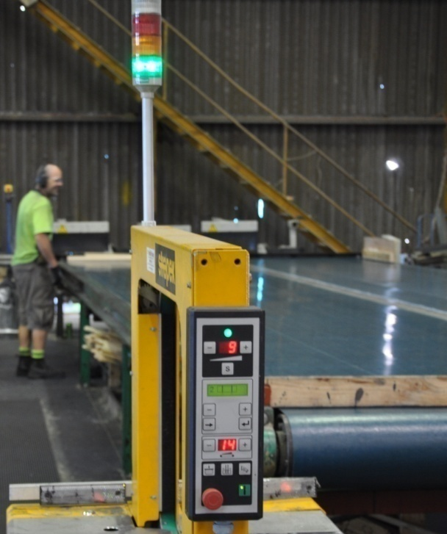
Anti-static floors are made from materials that do not generate a static charge. In that sense, an ordinary linoleum floor is ‘anti-static’ under certain conditions, and so is bare concrete as long as the relative humidity in the floor and air are balanced correctly.
But there is also a wide range of tile and sheet products specifically marketed as anti-static because they do not contribute to the build-up of static electricity, unlike many normal vinyl and carpet products.
They are often used in the picking and packing areas of warehouses and around automated carousels.
Although anti-static floors overcome the problem of people building up a static charge as they walk across the floor, they won’t actively attract or control a charge before it has a chance to discharge somewhere else.
For this reason, they are not classified as ‘ESD flooring’. This term is reserved for static dissipative and static conductive flooring.

Static dissipative
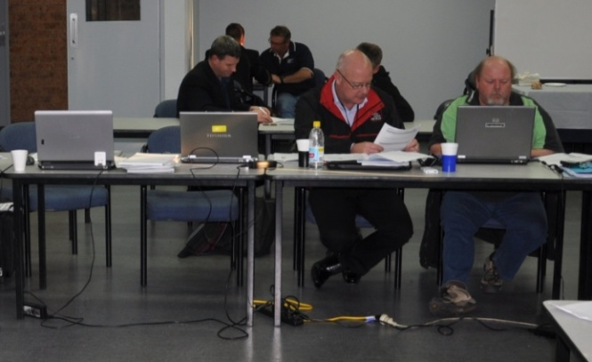
Static dissipative floors allow static electricity to ‘dissipate’, or discharge in a controlled way.
They’re used where a higher level of static control is necessary, such as in computer rooms, x-ray suites, operating theatres and some electronics manufacturing facilities.
In technical terms, a static dissipative floor is defined as having a surface resistance of between 1 x 10⁶ ohms and 1 x 10⁹ ohms. (See below for details on surface resistance in floors.)

Static conductive
These floors are at the top level of ESD flooring, and are more conductive than static dissipative floors. They are used in places where very sensitive components are being handled, such as on electronic assembly lines. Conductivity is improved by installing the floor over a grid of copper tape and earthing it to the ground.
The surface resistance of static conductive floors is defined as being between 4 x 10⁴ ohms and 1 x 10⁶ ohms.

What does surface resistance mean?
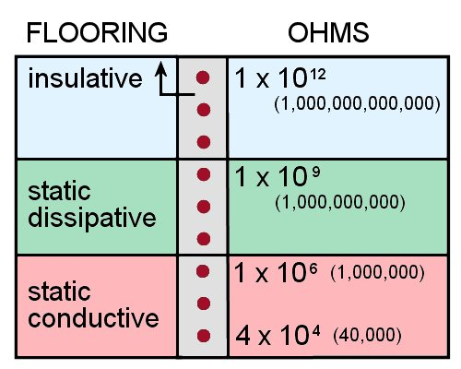
The surface resistance of a floor refers to how easily an electric charge can travel across its surface. The higher the resistance, the more ‘insulative’ it is. The lower the resistance, the more ‘conductive’ it is.
An insulative material is one that has a surface resistance of greater than 1 x 10¹² ohms. 10¹² is another way of saying one trillion (that is: 1,000,000,000,000 – or 1 with 12 zeros after it). An ohm is the unit of measure for the electrical resistance between
two points. Its symbol is Ω.
To remove the problem of electrostatic damage to sensitive equipment, a floor needs to have low electrical resistance so that any static electricity generated is able to be discharged before it has a chance to build up. This is what characterises an ESD floor.
Unlike ESD floors, anti-static floors aren’t officially described in terms of surface resistance, because their purpose is not to control the discharge of static electricity – it’s simply to reduce the build-up in the first place. Nonetheless, the floor coverings that can be classed as anti-static are generally in the range 10¹⁰ ohms to 10¹² ohms.
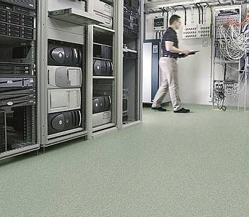
For floors that do need to be ‘ESD safe’, engineers often specify actual surface resistance levels rather than simply calling them ‘static dissipative’ or ‘static conductive’.
For example, hospitals typically have ESD floors specified at somewhere between 5 x 10⁴ ohms and 2 x 10⁶ ohms. Computer companies have varying requirements depending on what they do, but the specifications tend to go up to 1 x 10⁹ ohms.

Learning activity
An American flooring company called StaticWorx has published a set of video clips on ESD flooring at:
http://www.staticworx.com/articles/videos.php
Select the first video called: ‘What is Electrostatic Discharge (ESD)?’
Watch the video and answer the following questions:
- How many volts of electricity are needed for a person to feel a static discharge?
- How many volts are needed for static-sensitive electronic devices to be affected by static discharges?
For a more technical discussion on static dissipative and static conductive floors, see the StaticWorx video called: ‘Static Dissipative vs. Static Conductive Flooring’.

Anti-static flooring
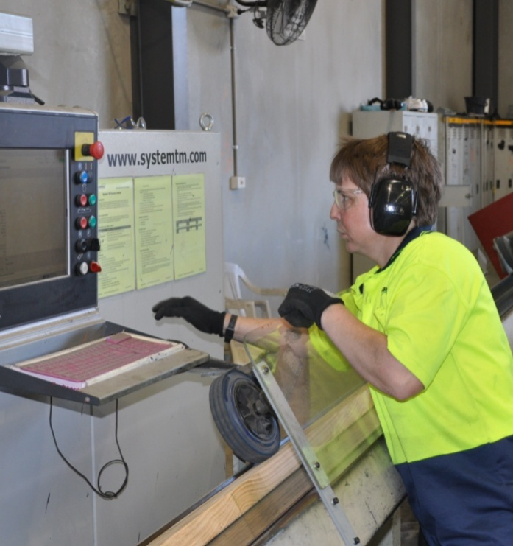
If a client asks you for ‘anti-static flooring’, you need to find out exactly what the purpose of this ‘static control’ is.
If it’s just to stop the problem of people getting a tiny shock when they touch something due to a static build-up, then an anti-static floor covering is the most appropriate choice.
However, if they’re using or handling components that could be damaged by electrostatic discharges, you need to ask more questions and find out what level of protection is required.
The manufacturers of the equipment being used in the room are likely to specify the type of flooring required. In the case of new buildings or facilities, there are sure to be engineering specifications for any ESD-sensitive areas.
The techniques used to install anti-static flooring are the same as for any other tile or sheet installation. However, the composition of the product may be somewhat different, so you should strictly follow the manufacturer’s instructions on the correct adhesive and underlayment to use. The manufacturer may also provide advice on the most appropriate trims and other fittings for this type of floor.

Static dissipative floors
If it turns out that the client needs a static dissipative floor, you can still use the same general installation techniques. However, the following differences will apply:
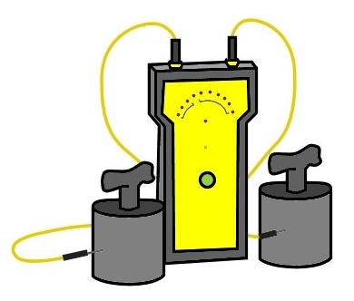
- the flooring material selected must have a surface resistance specification that puts it in the static dissipative category
- the adhesive must also have a low resistance specification and strictly comply with the manufacturer’s requirements

- the levelling compound and subfloor may have to meet certain specifications to ensure that they won’t affect the floor’s ability to dissipate static charges
- under some circumstances, the floor may need to be earthed by a licensed electrician.

Learning activity
Go to the StaticWorx video page at:
http://www.staticworx.com/articles/videos.php.
Select the video clip: ‘Testing your ESD floor’.
Watch the video and answer the following questions:
- Why can’t you use a multimeter with standard probes to test the surface resistance of a floor?
- What type of probes should you use, and how are they different from standard probes?

Conductive flooring
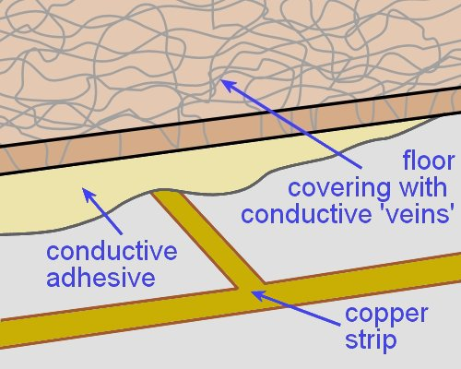
As we discussed earlier (in ‘Static electricity in floors’), conductive floors have a low electrical resistance. This is achieved through adding thousands of tiny conductive fibres or ‘veins’ into the tile or sheet product.
Depending on the brand of flooring, these conductive fibres or chips could be made of carbon, graphite, metal, or a combination of materials.
The structure of the resilient product is homogeneous, to ensure that the fibres are evenly distributed throughout.

Installation method
To install a conductive floor, you should follow the manufacturer’s instructions precisely. There may also be additional building specifications that you need to comply with in the ESD safe area. The general procedure is shown below.
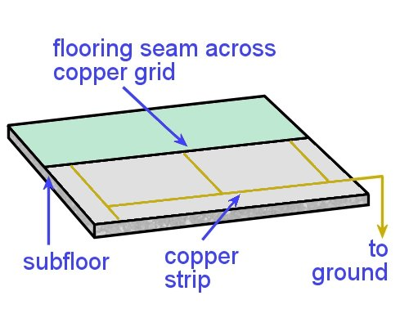
- Apply a primer to the floor with a brush or roller. Depending on the manufacturer and the size of the floor area, you may need to use a conductive primer.
- Stick down the copper strip in the grid pattern specified by the manufacturer, and run it across to the earthing point on the wall.
- Use a conductive adhesive to stick down the flooring, and roll the floor with an appropriate sized roller.
- Check the electrical conductivity, and organise for a licensed electrician to earth the connection.

Learning activity
Go to the video clip produced by Forbo on how to install Colorex SD/EC flooring in ESD sensitive areas, at:
http://www.youtube.com/watch?feature=
endscreen&NR=1&v=FPNLNcE8wbc
Although this particular product is manufactured as a tile, the process of marking out and laying the copper strips is much the same as for sheet flooring.
Watch the video and answer the following questions:
- How does the installer mark out the floor to make sure the copper strip will be laid in a straight line and in the right position?
- How does he draw a guide line on the wall to ensure that the line is an even distance from the floor?

Assignment
Go to the Workbook for this unit to write your answers to the questions shown below. If you prefer to answer the questions electronically, go to the website version and download the Word document template for this assignment.
___________________________________________________________________________
1. Anti-static floors
(a) What are the properties of an anti-static floor?
(b) Where are they typically used?
(c) Why aren’t anti-static floors described in terms of their surface resistance?
(d) Name a product that satisfies the requirements for an anti-static floor.
2. Static dissipative floors
(a) What are the properties of a static dissipative floor?
(b) Where are they typically used?
(c) What are the surface resistance specifications?
(d) Name a static dissipative floor covering (product name and manufacturer)
(e) What adhesive is recommended for this product?
(f) What extra features do you need to build into the installation of this flooring, beyond the normal installation requirements?
3. Static conductive floors
(a) What are the properties of a static conductive floor?
(b) Where are they typically used?
(c) What are the surface resistance specifications?
(d) Name a static conductive floor covering (product name and manufacturer)
(e) What adhesive is recommended for this product?
(f) What extra features do you need to build into the installation of this flooring, beyond the normal installation requirements?

Practical demonstrations
Your trainer will ask you to keep a log book or diary of the work you do on-the-job that relates to one or both of these competencies. This will help them to determine when you will have had sufficient hands-on practice in the tasks to undertake the assessment events.
When you’re ready to be assessed in either or both of these competencies, your assessor will watch you carrying out a range of practical demonstrations. The checklists below set out the sorts of things the assessor will be looking for.
Make sure you talk to your trainer or supervisor about any of the details you don’t understand, or aren’t ready to demonstrate, before the assessment events are organised. This will give you time to get the hang of the tasks you’ll need to perform, so that you’ll feel more confident when the time comes to be assessed.

General criteria
For both competencies, you will need to:
- follow all work, health and safety requirements and environmental care procedures
- correctly interpret company documents and work instructions
- communicate and work effectively with other workers in the area
- prevent damage to goods, equipment and products
- work productively and produce a high quality job
- modify activities and techniques used to suit different sites and working conditions.
Depending on the type of flooring being laid and the nature of the job, you’ll use of some or all of the following tools:
- spatula knife, utility knife with hook, straight and concave blades
- straight edge, square, chalk, chalk line, tape measure
- notched trowel, serrated trowel
- hammer, rubber mallet, hacksaw
- seam and edge trimmer, wall trimmer
- dividers, recess scriber, preformed linoleum recess scriber, scribing bar
- welding gun and accessories
- gas bottle and gun, hot air gun
- grooving tool, cove gauging tool
- pencil cove roller, hand roller, floor roller
- paint brush, bucket
- linoleum trolley.

LMFFL3308A Install anti-static resilient floor coverings
You will be asked to install:
- at least one anti-static resilient floor using a conductive acrylic adhesive system.

LMFFL3309A Install conductive resilient floor coverings
You will be asked to install:
- at least one static conductive resilient floor with an isolating layer using conductive adhesive and an earthing strip.

