Communication
and teams
DRAFT VERSION
October 11
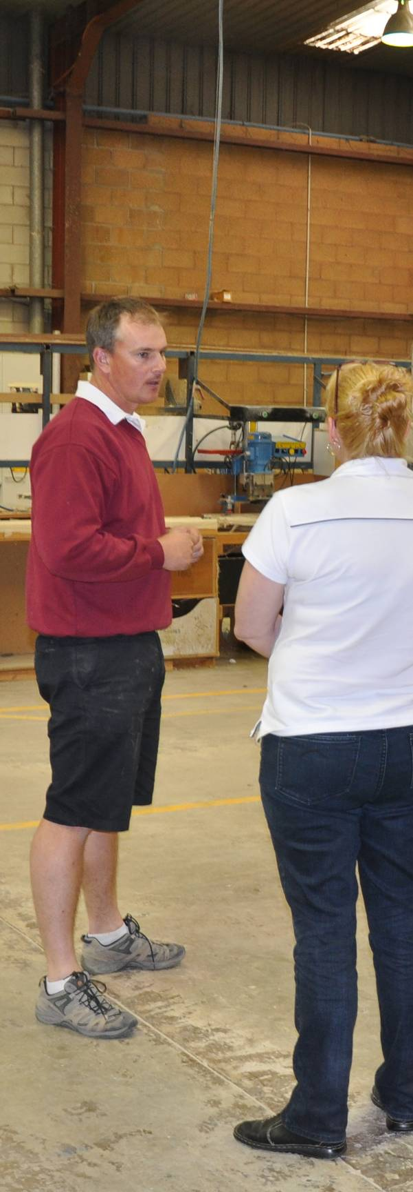
Supporting:
MSAPMSUP102A: Communicate in the workplace
MSAPMSUP106A:
Work in a team

Workbook
Name:

Communication
and teams
Workbook

Containing learning activities and assignments for the units of competency:
MSAPMSUP102A: Communicate in the workplace
MSAPMSUP106A: Work in a team

The assignment templates are also available in an electronic ‘Word’ version, downloadable from the Flooring technology website at:
www.flooringtech.com.au

Developed by Workspace Training for the 2013-2014
Workplace English Language and Literacy (WELL) Program
Flooring Technology resource development project

ISBN: 978-1-925087-11-6
Funded under the Workplace English Language and Literacy Program by the Australian Government through the Department of Industry.
© Commonwealth of Australia 2014

CC BY-NC-SA

This work is copyright. Except where otherwise indicated, and save for the Commonwealth Coat of Arms, the Department has applied the Creative Commons Attribution-Noncommercial-Share Alike 3.0 Australia Licence to this work.
The Department of Industry must be attributed as the author of the Department’s copyright material.
As far as practicable, material for which the copyright is owned by a third party has been clearly labelled. The Department has made all reasonable efforts to ensure that this material has been reproduced in the print-based resources and accompanying website with the full consent of the copyright owners.
Requests and enquiries concerning the Department’s copyright material should be emailed to: media@innovation.gov.au
Questions about the design and content of the resource itself should be addressed to the project manager:
David McElvenny
Workspace Training
PO Box 1954 Strawberry Hills, NSW, 2012
Email: david@workspacetraining.com.au

Table of contents
Introduction 1
Part 1 Learning activities 3
Section 1: Communicating with others 5
Section 2: Working in teams 12
Part 2 Assignments 15
Assignment 1 17
Assignment 2 21

Introduction
Communication and teams is a ‘learning unit’ from the Flooring Technology training resource. It supports the following competencies from the Certificate III in Flooring Technology (LMF31208):
- MSAPMSUP102A: Communicate in the workplace
- MSAPMSUP106A: Work in a team
To be assessed as competent, your assessor will use a range of methods to check your understanding of the concepts presented in the Learner guide for this unit and your ability to apply these principles at work.
These may include:
- written assignments
- practical demonstrations
- on-the-job discussions about how you go about particular activities
- learning activities undertaken while you’re progressing through the unit
- log book or work diary.

Literacy, numeracy and computer skills
Literacy is the ability to read and write. To complete this qualification, you will need sufficient literacy skills to produce a range of workplace documents. You will also need the skills to be able to read and understand documents such as order forms, installation instructions, project briefs and safe operating procedures.
Numeracy is the ability to work with numbers. Flooring installers need to do lots of measure-ups and calculations, so there will be many opportunities for you to learn and practise your numeracy skills.
When it comes to completing the written assignments for this qualification, a certain level of literacy ability is required to read the questions and write down your answers. There will also be times when you are asked to generate documents on a computer.
Obviously, it’s important that you clearly understand what the assignment is asking you to do, and that your work is a good reflection of what you really know. So if you’re having trouble reading the questions, writing down your answers, or using certain computer programs, make sure you speak to your trainer before you hand the assignment in.
There are various ways your trainer can help you. For example, they may be able to ask the assignment questions verbally and help you to write down your answers. They may also be able to show you sample answers to similar questions, which will let you look at the way they’re written and give you hints on how to write your own. You may also be allowed to do the assignment with the assistance of another person.

Applying for RPL
RPL stands for Recognition of Prior Learning. It is a form of assessment that acknowledges the skills and knowledge you have gained through:
- on-the-job experience
- formal training in other courses
- life experience, through your hobbies or other outside activities.
If you believe that you are already competent in some or all of the skills covered in this unit, ask your assessor about how to apply for RPL.

Using this workbook
All of the lessons in the Learner guide for this unit have learning activities at the end. Their purpose is to provide discussion points and questions to help reinforce your understanding of the concepts being presented.
There are also a range of assignments, which appear at the end of each section. These are designed to test your knowledge of the subject matter and ability to submit written responses in an acceptable format.
This workbook reproduces all of the learning activities and assignments in a format that lets you handwrite your answers to the questions.
Note that your trainer may ask you to produce a computer-generated document for all of the formal assignments, either printed out in hard copy or submitted electronically. To do this, go to the website version of the unit and look for the Assignment link in each section. This will allow you to type your answers into the ‘Word’ document and then either print it out or email it direct to your trainer as an attachment.
You may also be asked to share your learning activity answers electronically, especially if you are undertaking this unit by distance learning and are linked up with fellow students in other locations. This might be done through group emails or via a social networking site such as Facebook. In these cases, you should use the website resource rather than this workbook.

Part 1

Learning activities

Section 1: Communicating with others

Verbal communication
Try out the following exercise with a partner.
Think of a topic that interests you, such as something you did on the weekend, a hobby you have, a holiday you’ve been on recently, etc. Talk about the topic to your partner for three minutes. Use your watch to time yourself so that you know when to stop.
During this time, your partner’s only job is to listen – they’re not allowed to interrupt you or ask questions at any time.
When your time limit is up, give your partner two minutes to summarise your story as accurately as possible in their own words. While they’re talking, they are not allowed to ask you any questions, and you’re not allowed to butt in or correct them.
When you’ve finished the exercise, swap roles with your partner and do it again.
Then answer the following questions:
- How accurate were your summaries of each other’s story?
- What’s it like to be the listener and be unable to ask questions?
- Are there any hints from this exercise that you can apply to your own listening skills?

Verbal instructions
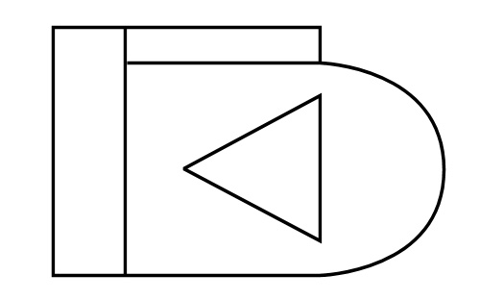
Ask your partner to turn around so they’re facing away from you. Draw a simple diagram of several shapes, like the drawing at right. (You can use this actual drawing if your partner hasn’t already seen it.)
Your task is to provide an exact description in words of the drawing to your partner. Their task is to re-draw it, based only on the verbal instructions you give them.
They are not allowed to see your drawing or ask you any questions. You are not allowed to see their drawing or ask them for any responses.
Once you have finished describing the drawing, ask them to stop and turn back to face you. Compare the two drawings to see how closely they resemble each other. Then answer the following questions:
- How did you both fare – are the two drawings a close match? If not, why not?
- What sort of mental effort was involved when neither of you were able to give each other any feedback?
- What does this tell you about the value of two-way communication when you’re giving or receiving verbal instructions?

Body language
- Have a look at the cartoons below showing a range of different moods. Try to describe in one or two words what emotion each one is portraying.

- It’s important to remember that not all cultures express every emotion in exactly the same way. Can you think of any examples where someone from a non-English speaking culture might portray a basic emotion in a different way?

Signs and hand signals
Below are some common workplace signs. See if you can describe their meanings in a few words.
Write each answer in the box next to its corresponding sign.
Symbol | Meaning | Symbol | Meaning
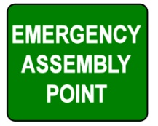

Forms and reports
Think of an incident that you are aware of, or make up an incident that might occur at your workplace if something went wrong.
Fill in the incident report template below as if you were the safety officer investigating the matter. Alternatively, you may use an actual incident report form from your workplace if you have one to hand.
Incident report

Details of incident
Location |  | Time |  | Date
Person
(or people) involved
Description (including any injuries and/or damage to property)

Investigation
Cause of incident

Corrective action recommended

Safety officer investigating
Name |  | Signature |  | Date

Emails
- Which email program do you use?
2. Do you have a signature block? If not, do you know how to set one up?
- Have you used the ‘Request a read receipt’ option before? If not, do you know how to activate it?
If you haven’t used either of these functions previously, go to your email system and find out how they work. For more information, click on the ‘Help’ icon in the email program or ask someone else at your workplace to give you a hand.

Mobile phones
- What annoys you most about other mobile phone users? Write down two or three things that you wish people wouldn’t do.
- Compare your notes with other learners in your group or your work colleagues. Have they come up with any irritations that you recognise in yourself? If so, what are they?

Seeing things from other angles
- Show the picture at right to some other people.
Ask them which image they see first – the young lady or old woman.
Is it the same image as the one you first saw?
What does this exercise tell you about the way other people perceive things, particularly when you’re both sharing the same experience?

- Can you think of an example from your own experience where you interpreted a situation in a certain way, and then realised that someone else might have taken it quite differently? It may have related to a joke you told or a sarcastic comment you made. Try to think of an example that involved a cultural difference between you and the other party.
Describe the situation below.

Section 2: Working in teams

Features of a good team
Think of a good team that you’ve worked in. It might be the one you’re with right now, or it could be a team you were part of in a previous job.
What made it a good team? Write down the characteristics that were most important.

Being a good team player
What are the three biggest time wasters in your day? Write them down below. Beside each one, describe how you could reduce the working time it gobbles up during the day.
The issues you raise might include: getting equipment organised, looking for missing tools, waiting for an offsider to come and help, waiting for the boss to tell you what to do next, answering personal mobile phone calls or SMSs.
Time waster | Solution

Giving and receiving feedback
Below are a range of responses you could give to the feedback that you're being offered.
Rate these responses as 'good' or 'bad', depending on the message they're likely to give the person providing the feedback.
Tick the appropriate box.
- Maintaining a lot of eye contact and nodding.
Good Bad
- Looking at your watch and fidgeting.
Good Bad
- Waiting for the other person to finish making their point, even if you want to butt in and disagree.
Good Bad
- Folding your arms and looking into the distance.
Good Bad

Part 2

Assignments

Assignment 1

Name |  | Date
- What are the three basic types of communication? Give two examples from your own workplace for each type of communication.
1st type of communication
Example 1
Example 2

2nd type of communication
Example 1
Example 2

3rd type of communication
Example 1
Example 2
- What is active listening? Give two examples of ways you can demonstrate active listening when your supervisor is talking to you.
Active listening is:
Example 1
Example 2
- Imagine you were writing down a message for a work colleague. Describe two possible reasons why they might misunderstand what you had written.
For each case, explain what you could do to reduce the chance of that happening.
Reason for misunderstanding | Possible solution
- Below is a verbal instruction that a supervisor is giving to his apprentice. Identify the main problems with this instruction and then re-write it in your own words to make the meaning clearer.
Sam, can you bring in the red toolbox from the truck? Actually, I need the pinch bar, not the toolbox. George was using it yesterday so I hope he put it back in the toolbox. He’s in the next room, so if you can’t find it just ask him. Who knows where it is now?

Main problems with the instruction
Rewritten instruction
- Choose a form from your own workplace that requires written responses to open questions or prompts. The form may be used to report on injuries, incidents, customer complaints, OHS hazards, or any other issues requiring descriptive responses.
Fill in the form with your own details. You may report on an actual event or situation that has occurred at your workplace, or make up a scenario that could possibly happen some time.

Assignment 2

Name |  | Date
Choose a task that you will need to carry out at work. To be suitable for this exercise, the task should:
- involve at least one other member of your work team
- consist of several steps that need to be prioritised
- allow you to make decisions about the way you will manage your own time.
Before you undertake the task, answer the questions below under: 1. Plan. Then carry out the task. Once it’s completed, answer the questions under: 2. Evaluation.

Plan
(a) What is the task? That is, what do you need to do?
(b) How much time have you been given to do the task?
(c) What materials will you require?
(d) What tools and equipment will you require?
(e) Who else will need to be on hand to help you? What will their role be?
(f) What hold-ups or problems might occur? How will you avoid them?
(g) What steps will you follow to carry out the task? Write down the numbered steps, making allowances for any of the problems you need to look out for.

2. Evaluation
(a) Did you complete the job within the timeframe you had allowed?
(b) Did anything not go according to plan? If not, describe what went wrong and how you went about fixing it.
(c) Looking back, is there anything you would have planned differently?

