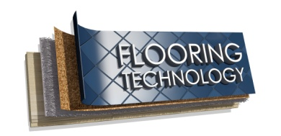
Supporting: LMFFL2001A: Use flooring technology sector hand and power tools

Section 2 Assignment: Power sources
Name |  | Date
Choose two power tools from your workplace that both have the same function but are powered by different energy sources. For example, you may have two drills – one running on mains electricity and the other on battery. You might even have a drill that's driven by compressed air.
Answer the questions following using the table provided on the next page:
- What type of tool are they? State the category of tool your two selections belong to, such as: circular saw, drill, planer, etc.
- What are the two power sources for these tools? These may include: mains electricity, compressed air, rechargeable battery or gas.
- Who is the manufacturer (or manufacturers, if they are made by different companies)? That is, what are their brand names?
- What size is each tool? Describe the size in terms of their drill bit diameter, blade diameter, cutter length, nail length, etc.
- What are the power ratings? State the power ratings in terms of wattage, operating pressure, etc.
- What are the main advantages of each tool? List the advantages, particularly in comparison to the other tool you have selected.
- What are the main disadvantages of each tool? List the main disadvantages, again with particular reference to the other tool.

1. Type of tool
 | Power tool 1 | Power tool 2
2. Power source
3. Manufacturer
4. Size
5. Power rating
6. Main advantages
7. Main disadvantages

