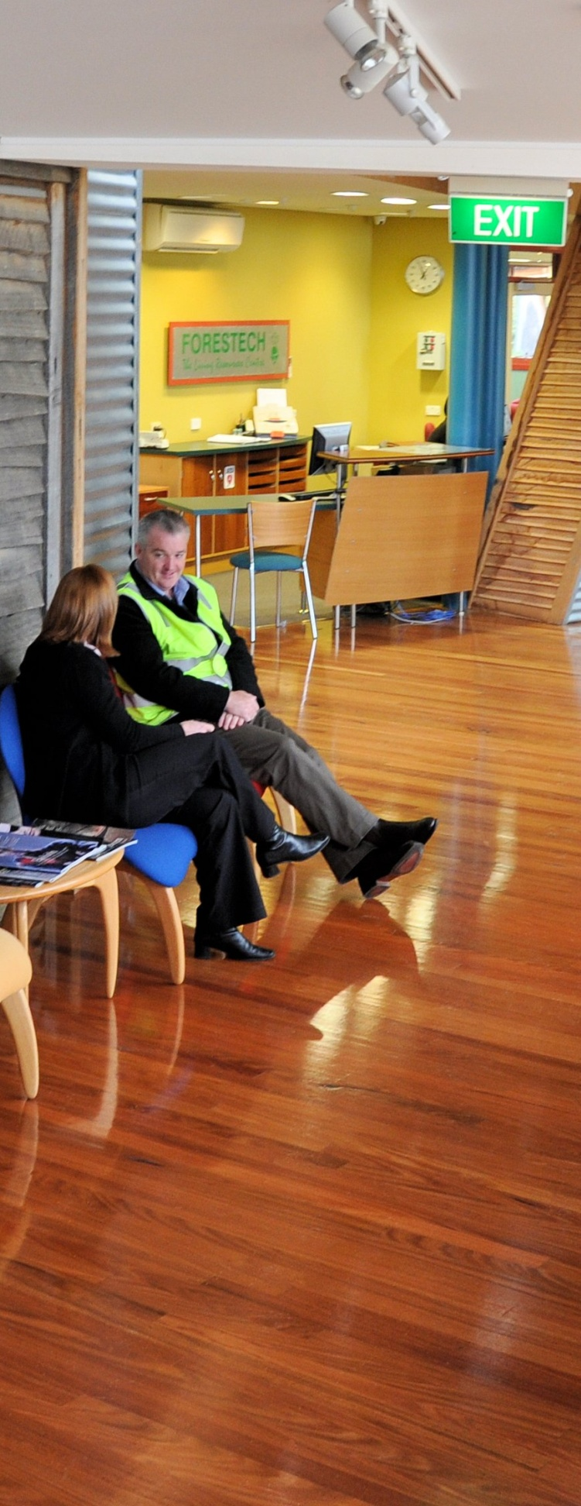
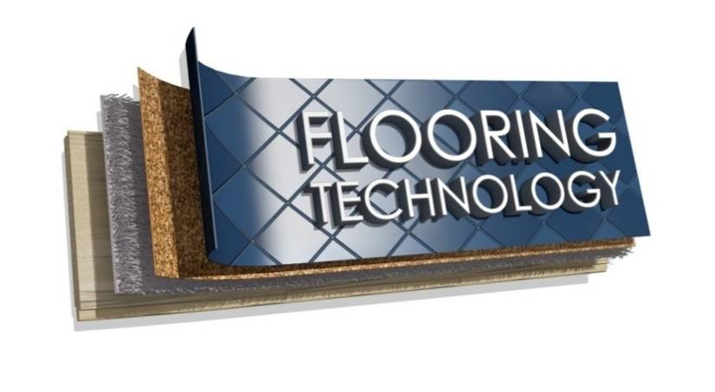
Supporting:
LMFFL3402A: Apply solvent based coatings to timber flooring
LMFFL3403A: Apply water based coatings to timber flooring
LMFFL3404A: Apply oil based coatings to timber flooring
LMFFL3605A: Apply finishes to cork flooring

Timber floor coatings
Learner guide
Developed in 2013-2014 for the WELL Program

Timber floor coatings
Learner guide

This unit is also available in an e-learning format, which contains additional photos, interactive exercises and a voice-over narration of the text. It can be viewed on CD-ROM, or live on the web at:
www.flooringtech.com.au

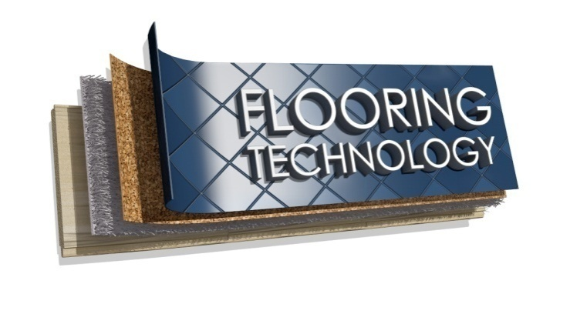

Developed by Workspace Training for the 2013-2014
Workplace English Language and Literacy (WELL) Program
Flooring Technology resource development project

Copyright and disclaimer

ISBN: 978-1-925087-13-0
Funded under the Workplace English Language and Literacy Program by the Australian Government through the Department of Industry.
© Commonwealth of Australia. 2014

CC BY-NC-SA
This work is copyright. Except where otherwise indicated, and save for the Commonwealth Coat of Arms, the Department has applied the Creative Commons Attribution-Noncommercial-Share Alike 3.0 Australia Licence to this work.
The Department of Industry must be attributed as the author of the Department’s copyright material.
As far as practicable, material for which the copyright is owned by a third party has been clearly labelled. The Department has made all reasonable efforts to ensure that this material has been reproduced in the print-based resources and accompanying website with the full consent of the copyright owners.
Requests and enquiries concerning the Department’s copyright material should be emailed to: media@innovation.gov.au
Questions about the design and content of the resource itself should be addressed to the project manager:
David McElvenny
Workspace Training
PO Box 1954 Strawberry Hills, NSW, 2012
Email: david@workspacetraining.com.au

Disclaimer
The content of this Learner guide is provided for educational purposes only. No claim is made as to the accuracy or authenticity of the content. The views expressed in this publication do not necessarily represent the view of the Minister for Industry or the Australian Government. The Australian Government does not give any warranty nor accept any liability in relation to the contents of this work.

About this resource
This Learner guide is part of a suite of resources developed for the Flooring Technology project, funded by the WELL Program. The resources support 27 competencies from the Certificate III in Flooring Technology (LMF31208). The project comprises a website and an accompanying set of Learner guides and work books.
The project has been completed in two stages. Stage 1 (undertaken in 2012-13) supported 19 competencies and Stage 2 (2013-14) supported a further 8 competencies.
The guides developed under Stage 2 of the project are shown below. Note that individual competencies are clustered in ‘Learning units’, with each unit being given a title describing the main theme of that set of integrated competencies.

Learning unit title Competencies covered
Communication and teams MSAPMSUP102A: Communicate in the workplace
MSAPMSUP106A: Work in a team
Work documents LMFGN3001B: Read and interpret work documents
Timber floor coatings LMFFL3402A: Apply solvent based coatings to timber flooring
LMFFL3403A: Apply water based coatings to timber flooring
LMFFL3404A: Apply oil based coatings to timber flooring
LMFFL3605A: Apply finishes to cork flooring
Hand and power tools LMFFL2001A: Use flooring technology sector hand and
power tools
The purpose of these resources is to help trainee floor layers acquire the background knowledge needed to satisfy the theoretical components of the competencies covered in this project. However, the resources are not designed to replace the practical training necessary to develop the hands-on skills required. Learners will still need to receive extensive on-the-job training and supervision before they will be ready to be formally assessed in the relevant competencies.
E-learning version
All of the content material contained in this Learner guide is also available in an e-learning format, which has additional photos, interactive exercises and a voice-over narration of the text. The e-learning version can be viewed on the web at: www.flooringtech.com.au
The web version can also be purchased on a CD at a cost-recovery price from the project developer:
Workspace Training
PO Box 1954 Strawberry Hills, NSW, 2012
Email: david@workspacetraining.com.au

Acknowledgements
Project team
Project manager: David McElvenny
Instructional designer: Kath Ware
Technical developer (website): Jim Vaughan
Assistant technical developer (and voice-over artist): Alex Vaughan
Quality assurance consultant: Giselle Mawer
Industry coordinator: Gary Dunshea (MSA Industry Skills Council)
Technical Advisory Group
Lead advisors
David Hayward – Australian Timber Flooring Association
Jim Hilston – Hilston Floors (QLD)
Reviewers
Craig Bennett – Hunter Institute of TAFE
Ian Ciesla – Polytechnic West (WA)
Robert Cole – Furnishing Industry Association of Australia (NSW)
Steven Dalton – Marleston TAFE (SA)
Shane Eales – SkillsTech Australia (QLD)
Bruce Ottens – Holmesglen TAFE (VIC)
Chris Shaw – Skills Institute Tasmania (TAS)
William Tree – South West Sydney Institute of TAFE
Mark Willis – Council of Textile and Fashion Industries of Australia
Content material
The content material in this resource is largely based on the following publications:
- Timber Flooring, prepared by David Hayward for Forest and Wood Products Australia (2009)
- Timber Flooring Problems – Causes and Remedial Measures, prepared by David Hayward for the Australian Timber Flooring Association (2009)
The advisors and reviewers listed above have also provided additional notes and materials.
Photographs and graphics
Most of the photos in this unit were taken from the following resources:
- Timber Flooring Problems – Causes and Remedial Measures (Aust. Timber Flooring Association)
- Timber flooring DVD (Forest and Wood Products Australia)
Additional photos were taken by David McElvenny.
Financial contributions
This resource was funded by the Workplace English Language and Literacy Program by the Australian Government through the Department of Industry. Additional financial assistance was provided by Manufacturing Skills Australia.

Table of contents
Introduction 1
Section 1 Products and processes 3
Overview 5
Types of coatings 6
Preparing the floor 9
Applying the coating 12
Protecting the finished floor 16
Safety and environmental care 18
Assignment 1 20
Section 2 Problems and causes 21
Overview 23
Inspecting the floor 24
Common problems 26
Assignment 2 32
Practical demonstrations 33

Introduction
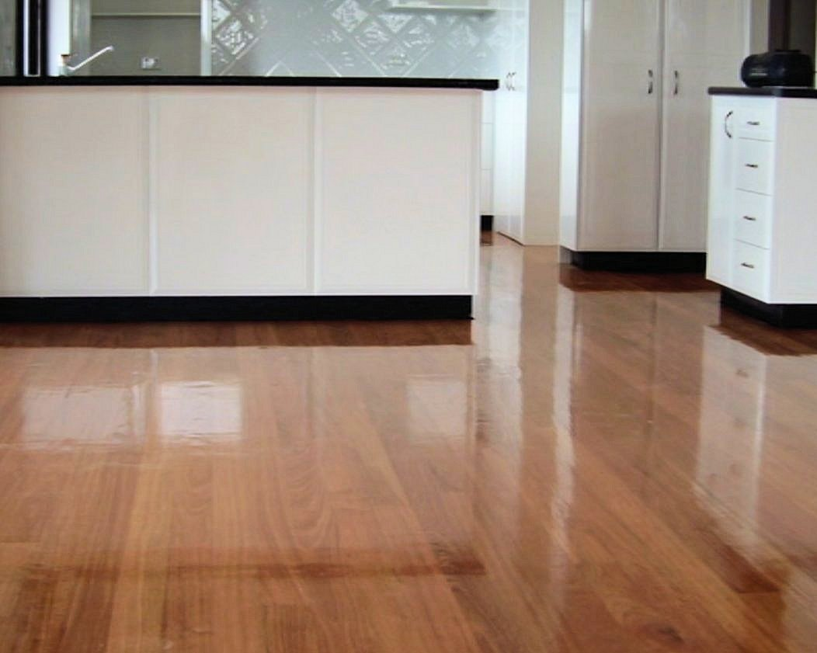
Over the last couple of decades, there has been a great deal of research into the various products used to coat timber and cork floors.
Manufacturers have developed a wide range of coating products to cater for different types of floors and different performance requirements.
Each product has its own chemical composition and its own set of advantages and disadvantages.
In this unit, we’ll look at the main finishes used to coat timber and cork floors. We’ll also discuss methods of applying these finishes and problems that can occur under particular circumstances.

Reference sources
Much of the information presented in this unit is based on material prepared by David Hayward, Technical Manager of the Australian Timber Flooring Association (ATFA), and published in the following booklets:
- Timber Flooring (Version 2, 2009)
- Timber Flooring Problems – Causes and Remedial Measures (Version 2, 2010).
Most of the photos were also taken from these booklets, as well as from the DVD:
- Timber Flooring (Version 1 2005).
These resources can be purchased direct from AFTA. If you are involved in timber flooring installation or finishing, you may also wish to join ATFA as a member. Membership is free for apprentices while they are still undertaking their apprenticeship. For more information, go to the ATFA website at: www.atfa.com.au.

Working through this unit
There are two sections in this unit:
- Products and processes
- Problems and causes.
Each section contains an Overview, an Assignment and Lessons which cover the content material.

Assignments
Your trainer may ask you to submit the assignments as part of your assessment evidence for the unit. You will find hard-copy templates for these assignments in the separate Workbook.
Electronic ‘Word’ templates of the assignments are available on the website for this resource, at: www.flooringtech.com.au

Learning activities
Each of the lessons has a learning activity at the end. The Workbook for this unit contains all of the learning activities together with spaces for written answers.
Again, you will find the learning activities on the website version, together with some interactive ‘Just for fun’ exercises.

Practical demonstrations
Your final assessment of competency in this unit will include various practical demonstrations. Their purpose is to assess your ability to apply a range of coating products to various timber and/or cork floors. To help you get ready for these assessment activities, see the sample checklist shown in the Practical demonstrations section at the back of this Learner guide.

Section 1

Products
and
processes

Overview
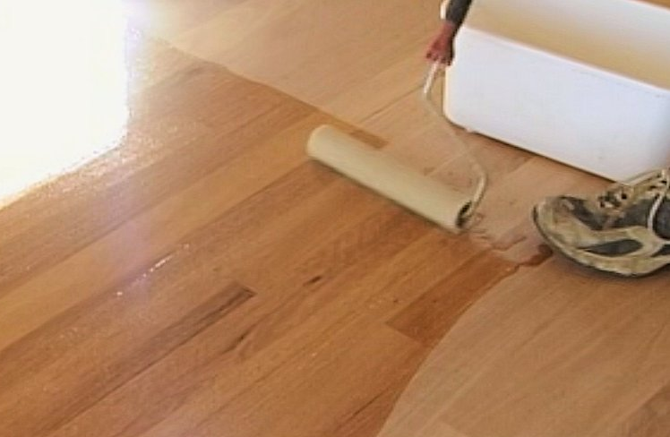
Manufacturers of timber and cork floor finishes have developed a huge variety of products to cater for different client preferences and different performance needs.
In this section, we’ll look at the main categories of coating systems and describe their typical characteristics.
We’ll also discuss the basic processes used to prepare the floor, apply the coatings and complete the job. Note that we’ve only made specific references to cork when the processes are different from solid timber. In general, the finishing process is much the same for all of these surfaces.

Working through this section
The assignment for this section asks you to describe the characteristics of the specific coating products you will be using in the practical demonstration events for this unit.
Have a look at the Assignment on page 20 to see what you’ll need to do to complete it.
There are five lessons in this section:
- Types of coatings
- Preparing the floor
- Applying the coating
- Protecting the finished floor
- Safety and environmental care.
These lessons will provide you with background information relevant to the assignment.

Types of coatings
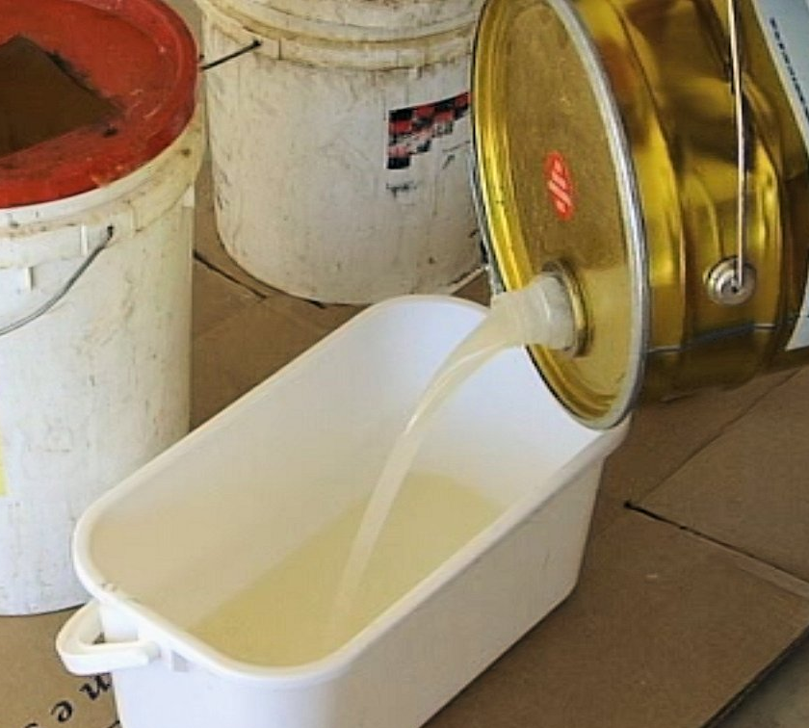
Floor coating systems can be grouped into the following categories, according to their chemical composition:
- oil-based finishes
- composites
- solvent-borne polyurethanes
- water-borne polyurethanes.
Each category has products with surface finishes ranging from matt (or low sheen) up to gloss, and in the case of some polyurethanes, very high gloss.
There are varying Volatile Organic Compound (VOC) levels among the products within each category. VOCs are chemicals that evaporate easily into the air. Unfortunately, many VOCs have been found to cause long-term health and environmental problems. The issue for manufacturers is that often the best performing solvents are also the most harmful. As a result, manufacturers now try to balance good performance characteristics with acceptable levels of VOC emissions.
Let’s look at each of the main categories in more detail.

Oil-based finishes
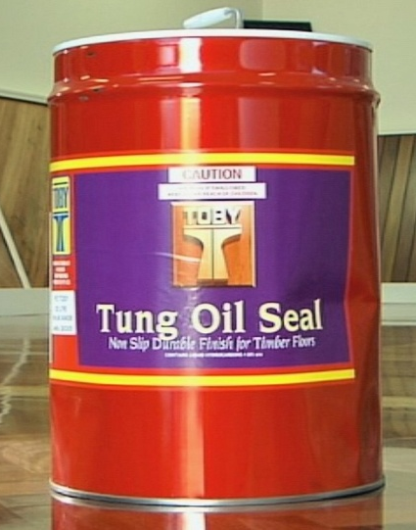
Clients choose oils and waxes when they want a ‘natural’ look.
Curing oils are dissolved in mineral turpentine or white spirits and contain added curing agents called ‘metal driers’. Products include tung oil and linseed oil, which are generally cheaper than other coating systems.
These oils produce a rich timber colour, although they will darken with age, and in some areas may develop a yellowish hue. They also require frequent maintenance with polishes.
Alkyds are based on curing oils, but are combined with a synthetic resin to improve their durability. As a result, they require less maintenance than the curing oils.

Composites
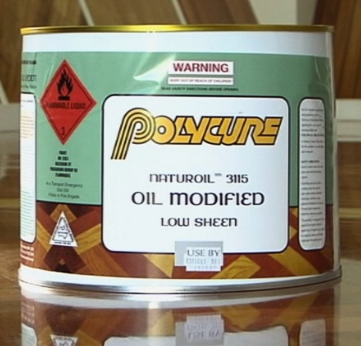
The most common composite solutions are oil modified urethanes (OMUs), which combine an oil with urethane.
Products that have higher proportions of urethane have higher levels of durability. The downside is that urethane also reduces the product’s flexibility, which makes it less resistant to edge-bonding. We’ll talk more about edge-bonding in Section 2: Problems and causes.
Most OMUs are solvent-borne and have high VOC emissions. However, new water-borne products are starting to come onto the market, which have much lower VOC emissions, although they’re generally more expensive.
All OMUs tend to yellow with age. They also cure slowly in cold weather. But they are still quite popular because of their reasonable cost, good edge bonding resistance and intermediate durability.

Solvent-borne polyurethanes
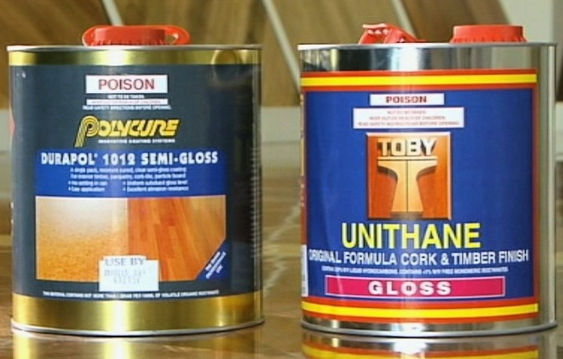
If your client is looking for maximum durability and a high gloss sheen, solvent-borne polyurethanes will provide the best results of all coating products.
The main trade-off for their excellent performance is that they have a strong solvent smell and high toxicity levels while they’re curing.
The toxicity comes from the isocyanates in the solution, which can cause eye, nose and lung irritations. Two-pack systems tend to have higher isocyanate levels than one-pack products. However, as long as the area is properly ventilated and you use an appropriate face mask, the health risks can be minimised.
Solvent-borne polyurethanes also have poorer edge-bonding resistance than other floor coating products, so you need to assess the floor before you start and advise the client if you think the boards might continue to shrink.

Water-borne polyurethanes
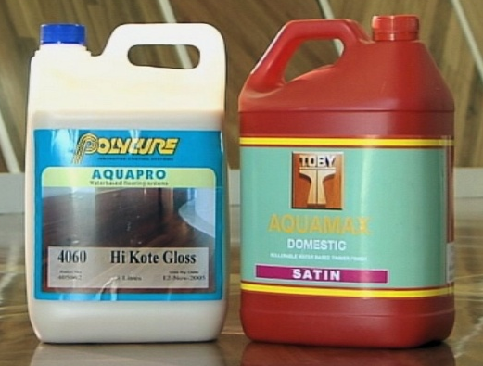
Water-borne polyurethanes come in a wide
range of sub-categories, including acrylic and
resin blends.
Products that don’t contain acrylic provide a better wear resistance.
They come in two-pack or one-pack options and are available in matt through to gloss finishes.
Although they’re in the highest cost bracket of all flooring coatings, they are often the preferred choice of contractors and clients because they don’t give off the strong smell that solvent-borne polyurethanes do. They also provide a much better resistance to edge bonding.

Learning activity
Each of the categories of floor finishes described above has a photo of a particular brand-name example.
See if you can identify at least one more brand name for each category. Write down the name of the product and its manufacturer in your workbook for this unit. Also provide a brief description of the product’s chemical make-up.
If you don’t have access to these products at your own workplace or in a store room, do some research on the internet. Type the category of each coating system into your search engine and see what listings come up.

Preparing the floor
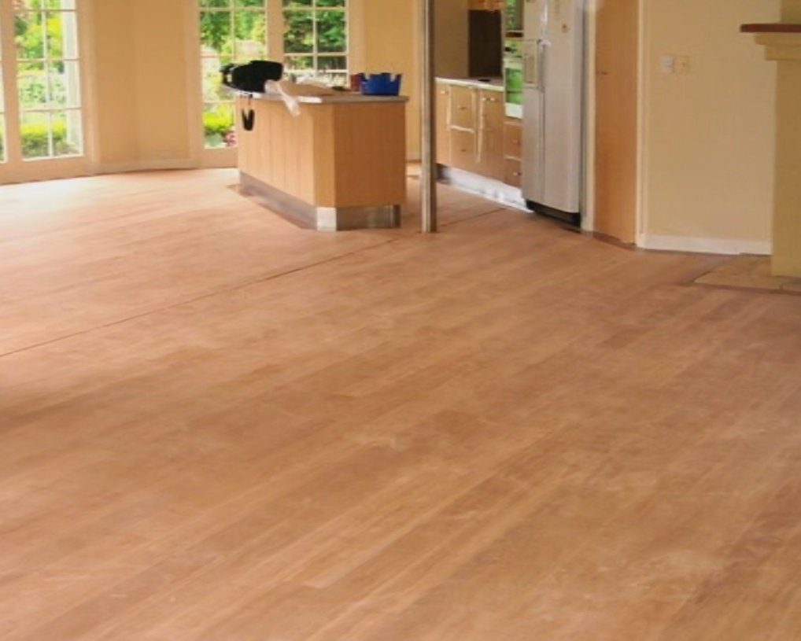
Every timber surface needs to be properly prepared before you put a paint, stain or other coating on it.
Timber flooring is no exception. The better your preparations are, the better the finished job will be.
As is always the case with any new job, it’s imperative that you carefully inspect the substrate to make sure there are no underlying issues that might cause problems later.
Most of the serious problems occurring in timber floors are related to moisture content. You’ll find more information on these issues in the unit: Inspecting and testing subfloors.
If you do find something that looks like it might cause trouble later, don’t ignore it. Remember, as a professional installer, it’s your responsibility to decide whether the job is ready for you to proceed. You’ll be doing everyone a favour in the long run, including the owner, the original floor layer and yourself, if you raise any potential problems before you start, so they can either be fixed by the previous contractor or inspected by a specialist.
Below are the main preparations that either you or the floor sander should have completed before the floor can be coated.

Filling nail holes and voids
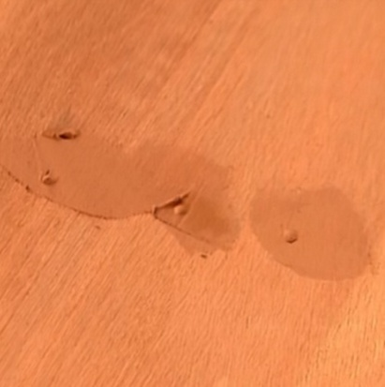
Some contractors like to fill the nail holes before they sand the floor, so that the filler is sanded flush as part of the overall process.
But others prefer to wait until after the first coat of finish is applied, particularly when using oil-based fillers. This avoids the problem of the filler bleeding into surrounding wood fibres, or drying out too quickly as the timber sucks moisture out of the filler.
Either way, it’s important to make sure that the filler is compatible with the coating system that will be applied. Check that the filler completely fills the hole, so it doesn’t later crack or come loose.

Sanding the floor
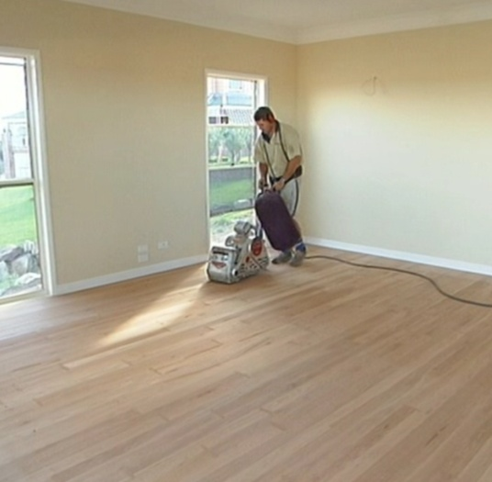
The sanding process is carried out with a range of machines, such as:
- drum sander, for the level or basic sand, which is designed to remove high points and ridges
- disc sander or ‘edger’, for working around skirting boards and into corners
- rotary or orbital sander, for the finish sand, which smooths off any coarse sanding marks and smooths the floor, ready for coating.
The number of passes required, and the grades of sandpaper used to complete each stage, will depend on the condition of the floor and the hardness of the timber species.
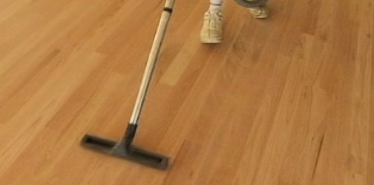
Between each sanding pass, the floor needs to be vacuumed thoroughly to remove all dust and dirt.
Special attention must be paid to cracks or other dust traps that might hold particles.

Sanding cork floors
Cork is much softer than timber and the tiles are much thinner, so it is normal practice to sand the floor with a plasterboard sander, also called a ‘drywall’ sander. You can either use a power sander, which has a rotary action, or a hand sander on the end of a pole.

Learning activity
There are several competencies in your Flooring Technology course that cover the various processes involved in sanding timber and cork floors.
If you haven’t undertaken any of these units yet, you may not be familiar with the different machines and techniques used.
In this case, watch the video clip linked below and answer the questions underneath. If you have done this sort of work before, you may answer the questions from your own experience.
Video clip:
‘How to sand a timber floor using Hiretech floor sanders’: http://www.youtube.com/watch?v=KFWEcuzNazY
- How do the workers stop dust from floating into other rooms?
- What grade of sandpaper is recommended for the first cut with a drum sander if the floor is old and in poor condition?
- What grade of sandpaper should be used on the first cut if the floor is new?
- What range of grades are recommended for the finish sand with the orbital sander?

Applying the coating
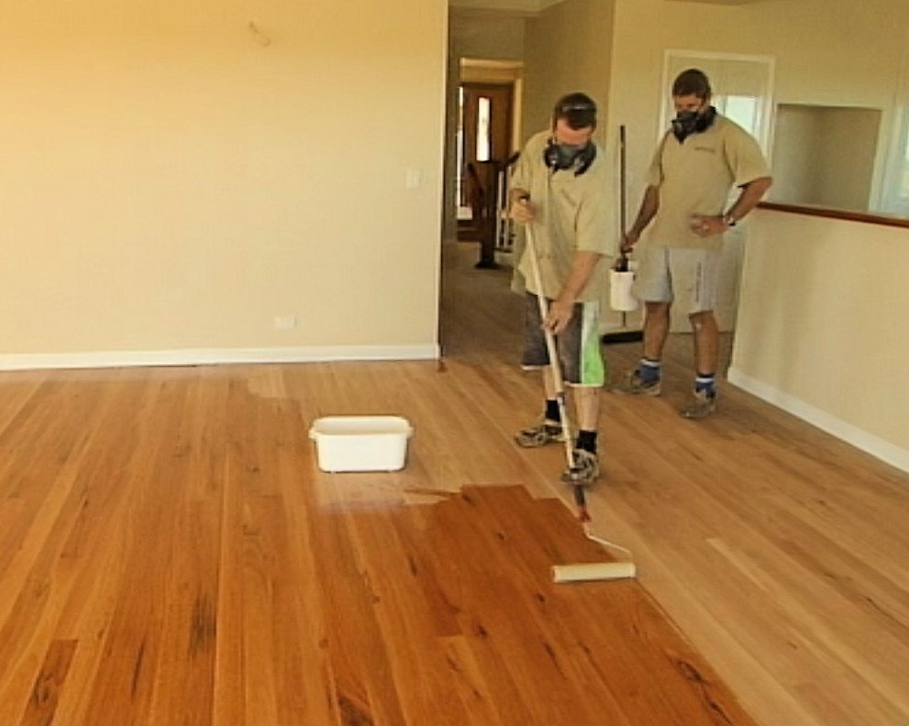
The process of applying a coating to the floor is basically the same for all finishing products.
The main differences between systems relate to the mixing methods, drying times, sanding between coats and the personal protective equipment required.
The first step is to isolate the area from all building occupiers, pets and any nearby activity that might allow water, dust or other contaminants to enter.
The area should remain out of bounds until the job is finished and you’ve given the all clear for people to enter.
Below is a description of the general application process. However, you should always follow the manufacturer’s instructions, because there may be specific techniques that apply to particular products.

Cleaning the floor
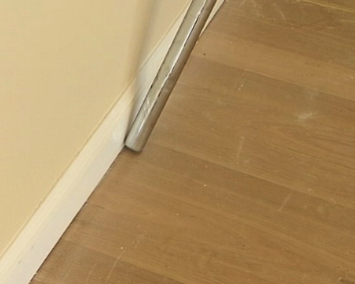
Before you start, the floor must be completely free from dust, dirt and other contaminants. Make sure you vacuum right into corners, cracks and any other recesses.
Also wipe off any surfaces that may have gathered dust during the sanding process, such as window sills, picture rails, skirtings, power points, light fittings and handrails.
All floor finishing products require good ventilation, but take special care with solvent-based polyurethanes. Having said that, you need to avoid creating a draught that might allow contaminants to blow in from outside.
Check that the lighting is good, and that the floor will be well lit for the full duration of the activity. This could mean setting up extra floodlights at the outset, so they’ll be ready to turn on when needed.
Some products benefit from a sealer coat before the main coat is applied. The manufacturer will indicate whether a sealer is recommended and what the best products are. Sealers are often used to enhance the depth of colour in the floor and to reduce the risk of edge bonding. The application method is generally the same as for the main coat.

Mixing the product
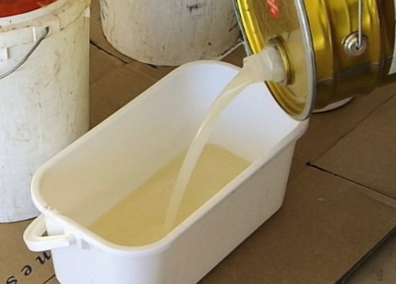
Depending on the type of coating, you may need to mix two parts together or simply stir a one-pack solution until it is well mixed.
Keep stirring until all solids are blended through the body of the liquid. But be careful not to stir too quickly or roughly, because this could introduce air bubbles which could affect the final finish on the floor.

Cutting in around the walls
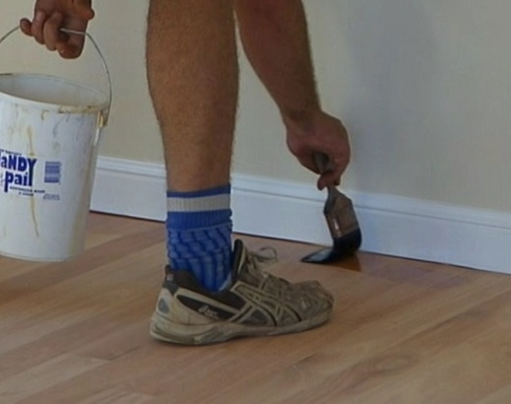
Do the cutting in first, because this will let you walk around on the body of the floor. Use a clean, good quality brush to cut in around the perimeter walls and in difficult to access places.
Extend the coating out about 150 mm from the wall, so that the applicator will be well clear of the skirtings and obstructions when you do the main body of the floor.
If any bristles fall out of the brush into the finish, remove them immediately so they don’t get stuck as the coating dries.

Using the applicator
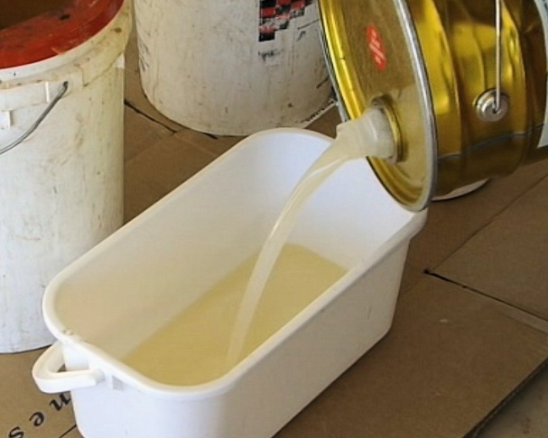
There are various techniques used to apply floor finishes. The manufacturer will specify the most appropriate applicator for the product you’re using, but contractors commonly use a mohair roller with a 6 mm pile or nap.
The nap of a roller is the fuzzy material bonded to its core. A ‘short nap’ of 6 mm doesn’t hold as much coating product as longer naps, but it produces a thin, smooth finish, which is just what you want for a floor coating.
For most products, a roller and tray are used in the same way as you would for painting a wall. Some people call this the ‘lay on lay off’ technique:
- lay on the coating in a reasonable thickness, without worrying too much about grain direction or roller marks
- lay off the coating by rollering the area you’ve already covered, working in the direction of the grain and smoothing out any ridges.

Filling and stopping
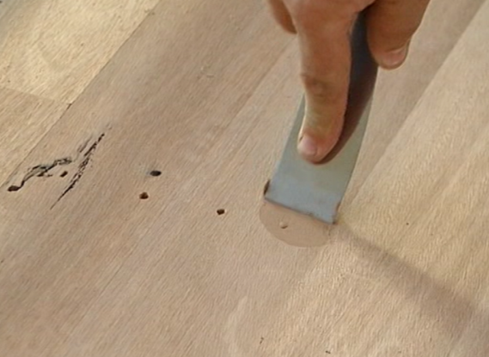
Any nail holes and cracks that haven’t already filled should be filled, or ‘stopped’, once the first coat is dry. Use a clean-bladed putty knife or applicator to push the filler fully into the hole.
Leave it slightly overfull and clean off any excess on the surrounding floor. The raised surface will be sanded flush when you sand the floor prior to the next coat.

Sanding and cleaning
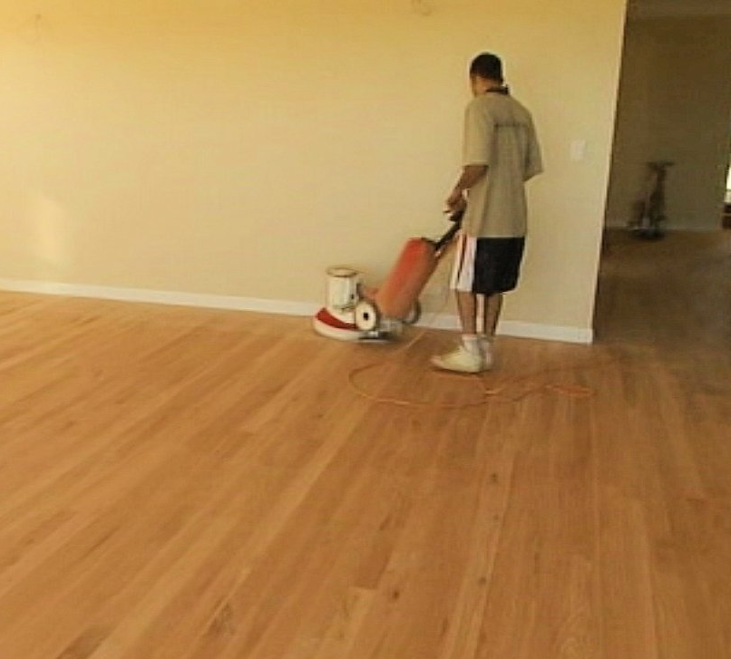
The first coat typically causes the timber grain to rise and give it a slightly furry feel. The amount of roughness depends on the timber species and type of finish being applied.
To remove this roughness, you’ll need to sand the floor with a rotary sander or an equivalent machine. The sand paper should be 150 grit or finer. Make sure you avoid cutting back to the bare timber – all you want to take off is the raised grain, not the coating itself.
Use an orbital sander or sanding block around the edges.
In addition to smoothing the surface, sanding also improves the ‘key’ for the second coat. This helps the new coat to bond to the surface of the first coat.
Once the sanding is finished, vacuum the floor thoroughly, paying particular attention to corners and dust traps. You can also use a tack rag to remove any dust left behind by the vacuum cleaner.

Second and third coats
Most manufacturers recommend three coats for their products. The process is exactly the same for each coat – apply the product, wait for it to dry, lightly sand the surface, clean the floor thoroughly, then apply the next coat.
Solvent-based systems tend to require heavier grit sandpaper than water based and oil based products, but the manufacturer will provide this advice in their guidelines.

Learning activity
We’ve covered the processes involved in calculating coating volumes in the following lessons from other units in the Flooring Technology resource:
- ‘Estimating quantities’ – Subfloor coatings and toppings
- ‘Primers and adhesives’ – Planning and costing.
You’ll recall from these lessons that the formula for working out the amount of coating product needed to cover a floor is:
Area of floor (m²) ÷ coverage of product (m²/L) = volume required (L)
Choose a specific floor finish and look up its rate of coverage. Calculate how many litres will be required to apply the recommended number of coats to the floor area shown below.
Write up the following information in your workbook:
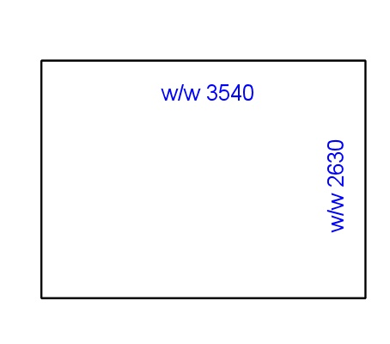
- Total floor area in square metres.
- Product name and manufacturer.
- Coverage in m²/L (state the range, if upper and lower rates are provided).
- Number of coats recommended by the manufacturer.
- Estimated total volume of coating product required to finish the floor, expressed in litres.
- Number of containers required, based on the sizes available for that product.

Protecting the finished floor
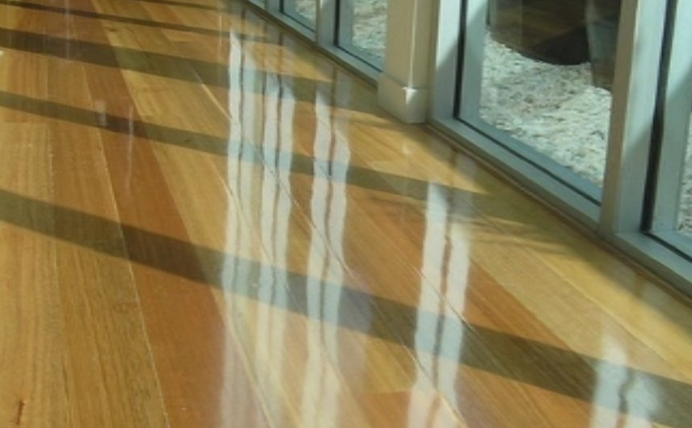
As the floor coating dries, it will ‘cure’ or harden. Curing times vary, depending on the product’s chemical composition, air temperature, ventilation, number of coats applied, and so on.
The manufacturer will provide accurate curing times for their coating systems, based on certain temperatures and environmental factors.
Some systems take up to two weeks to fully harden. Although the floor can be walked on after the initial drying period, it is much more prone to scratching and scuffing until it is fully cured. So although the client might want to rush in and put their furniture in place, you should advise them to be very careful until the manufacturer’s recommended waiting time has elapsed.
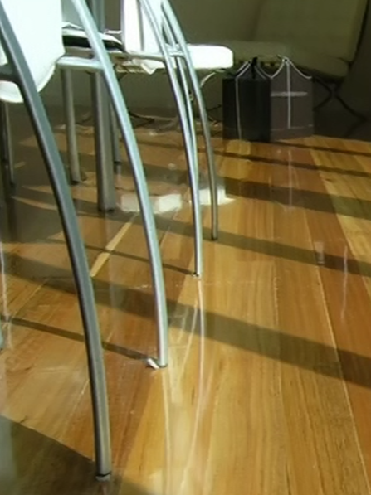
Light furniture can generally be put in place before the floor has fully cured as long as felt pads have been applied to all the feet.
Chairs and tables with castors, however, shouldn’t be rolled on a freshly finished floor. Preferably, they shouldn’t be used at all, especially if the timber species is soft, because they are more likely to scratch and indent the floor surface.
Rugs with rubber backings should also never be used, because they sometimes leave a permanent stain on the finish.

General care
Timber floors will look great for many years as long as they’re well cared for. However, one of the worst enemies is sand or grit. These abrasive particles tend to get walked onto the floor on the underside of people’s shoes, and act like sandpaper as they’re rubbed on the surface.
You should advise the client that an easy remedy is to put a mat outside each door that leads into the room. For high traffic areas, they can put a runner or rug on the floor, so that people aren’t walking directly on the timber surface.
Direct sunlight can also cause problems over time. If it’s intense, it can result in gapping or cupping of the boards. It also tends to darken the floor’s colour or give it a yellowish hue. The best solution is to shade the floor from direct sunlight, either with an awning or window drapes. Rugs will help to reduce the problems.

Ongoing maintenance
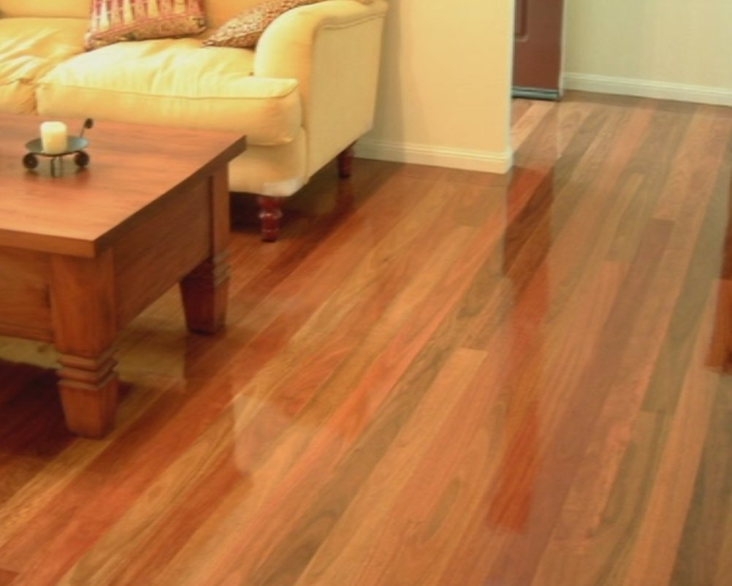
The manufacturer’s brochures will recommend various cleaning and polishing schedules designed to keep the floor in good condition.
They’ll probably also recommend specific cleaning products that won’t damage the coating or cause chemical reactions.
The general advice for maintaining a domestic floor is to clean it regularly with an antistatic mop to pick up any dust or grit on the surface.

Learning activity
Select two floor finishing products with different chemical make-ups. Look up the drying times on the side of the container (or in the installation guidelines).
Write down the following information in your workbook for each of these products:
- Brand name and manufacturer.
- Recoat time (drying time between coats).
- Drying time for final coat (before the floor can take light foot traffic).
- Full curing time (before the floor can take normal wear).
- Temperature (and relative humidity, if quoted) applicable to the above drying times.

Safety and environmental care
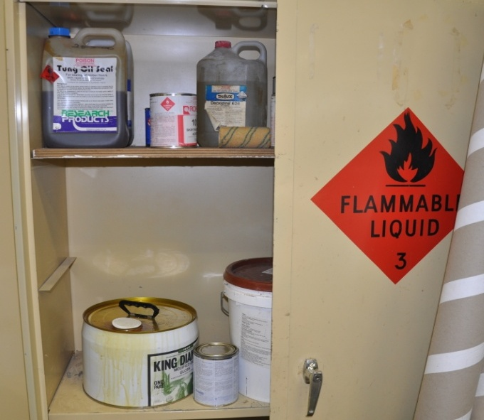
Many floor coating products are classified as ‘hazardous substances’, because they have the potential to cause harm to people’s health or the environment.
The products you need to be most careful with are the solvent-borne finishes with high VOC emissions.
But you should handle all coating products with care, and take the time to read the safety directions on the side of the container if you’re not familiar with it.
Each product will also come with a material safety data sheet (MSDS). This will provide more information on safety precautions and environmental care procedures, including details on long term health effects, what to do in the event of a spill and how to dispose of the product safely.

Ventilation and fumes
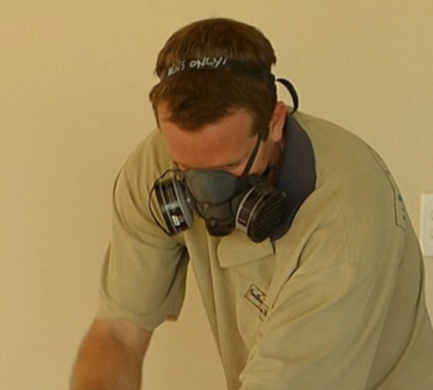
Fumes are a particular problem with some products. The manufacturer will specify the ventilation requirements and the type of respirator you should use.
Note that the mask you normally use to filter out airborne dust while sanding the floor may not be suitable for chemical fumes. So you need to check that you’ve got the right cartridge type for the product being applied.

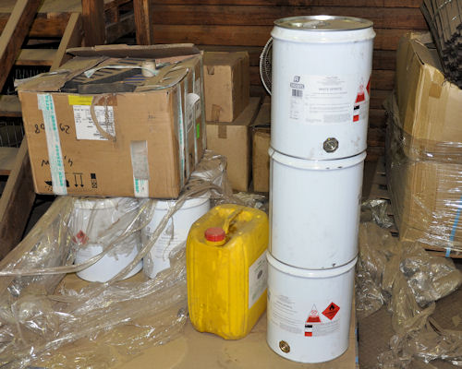
Handling and storage
The MSDS will describe any specific handling
and storage requirements, but here are some general guidelines that apply to all hazardous products:
- Store chemicals in their own area, away from stormwater drains and out of the weather.
- Never use plain drink bottles or other unmarked containers to store chemicals.
- Clearly label all containers with the name of the product it contains if it is no longer in its original packaging.
- Keep 'incompatible' chemicals well away from each other, that is, chemicals that are likely to react with each other.
- Make sure that all vehicle activity is carried out well clear of the chemical storage area.

Disposal
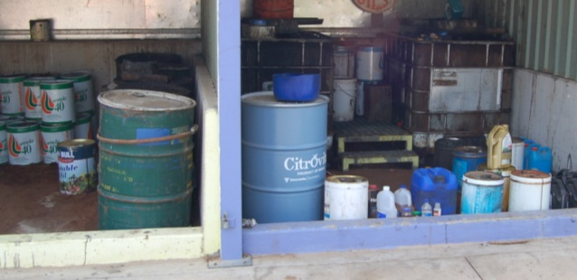
Liquid waste should never be put into the waste bin. Materials in the waste bin generally go to landfill, so it should only be used for dry, solid waste.
Left-over coating products should be poured back into a container and resealed.
You can then stockpile the containers while you wait for a licensed waste disposal contractor to pick them up. Alternatively, you can take them to a waste transfer station yourself and leave them in the area set aside for paints and other chemicals.

Learning activity
Choose one solvent-borne coating product and get a copy of its MSDS.
Write down the following information about the product in your workbook.
- Brand name and manufacturer.
- Items of PPE that should be worn when mixing and applying the product.
- Ventilation requirements in the room while you’re working with the product.
- Disposal procedure for used applicators and leftover liquid products.

Assignment 1
This assignment should be completed in conjunction with the practical demonstration assessment events for the unit. You can see the practical demonstration performance criteria at the end of this Learner guide.
There is a hard copy template for this assignment in the Workbook for the unit. If you prefer to answer the questions electronically, go to the website version and download the Word document template.
___________________________________________________________________
Provide the following information for each of the coating products you have used in your practical demonstrations.
- Brand name and manufacturer.
- Category of finish (according to its chemical composition).
- Main features (that is, characteristics that the client might be looking for when they choose this product).
- PPE required while mixing and applying the product.
- Number of coats required and total quantity of coating product needed (including calculations showing square metreage of the floor area and rate of coverage).
- Recoat drying time, final coat drying time and full curing time.
- Any special limitations specified by the manufacturer (such as temperature range for usage or compatibility problems with other products).
- Grade of sandpaper and machines used to sand the floor in between coats (where applicable).
- Advice to be given to the client on how to protect the floor while it is still curing.
- Advice to be given to the client regarding on-going maintenance.

Section 2

Problems
and
causes

Overview
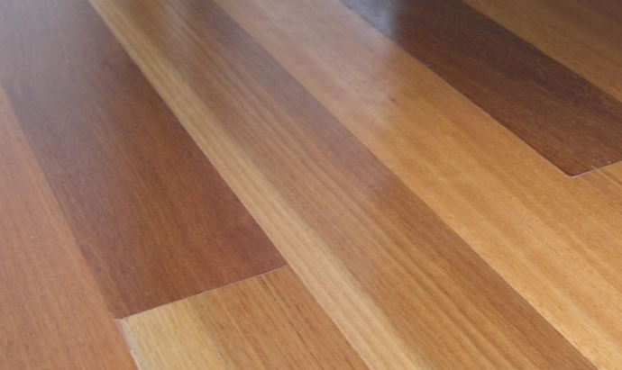
Solid timber floors are at the top end of the flooring market in terms of cost and prestige, so clients tend to have high expectations of the finished project.
Occasionally, you may come across a client who imagines that their floor will have a blemish-free mirror finish like a dining room table.
If you suspect that a client might have this perception, it’s best to ‘manage’ their expectations from the start, because it’s not possible to achieve a furniture finish in a typical building environment. Nonetheless, it is reasonable for clients to expect the floor to have a high quality, even finish, and to maintain its appearance over time with normal care and maintenance.
In this section, we’ll cover the main types of problems that can occur in timber and cork coating systems and discuss ways of avoiding them.
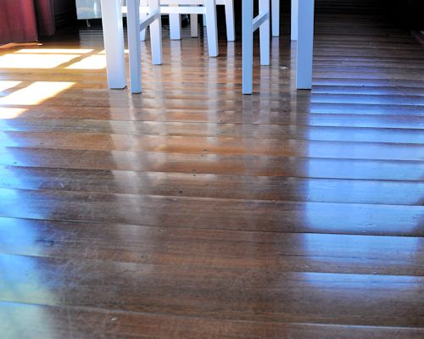
Note that we won’t discuss the wide range of issues caused by poor installation practices or moisture content problems in the flooring material itself. These include cupping, tenting and gapping of boards.
For more information on these matters, consult the two Australian Timber Flooring Association booklets referenced in the Introduction section of this Learner guide.

Working through this section
The assignment for this section asks you to describe two potential problems you have taken steps to avoid in your own coating applications. Have a look at the Assignment on page 32 to see what you’ll need to do to complete it.
There are two lessons in this section:
- Inspecting the floor
- Common problems.
These lessons will provide you with background information relevant to the assignment.

Inspecting the floor
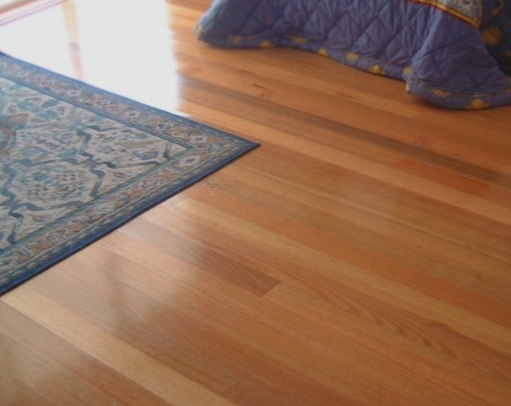
To a certain extent, the judgement of how serious an imperfection is in a finished timber or cork floor will be in the eye of the beholder.
Some imperfections are only visible when the light is directly on them. Others become less visible and can even disappear as the floor progressively wears under normal usage.
Irregularities in colour can also appear over time, such as yellowing from the sun, or lighter patches where rugs or furniture have been positioned.
If the client is unhappy with the appearance of their newly finished floor, your first response should be to look at the floor with them and discuss their concerns. Be polite and understanding, and don’t try to argue with them or tell them that they’re wrong.
If you can’t convince the client that the issues troubling them will diminish and become more acceptable over time, you may need to call in a professional inspector. In this case, an independent expert will look at the floor and provide a formal report on any problems.
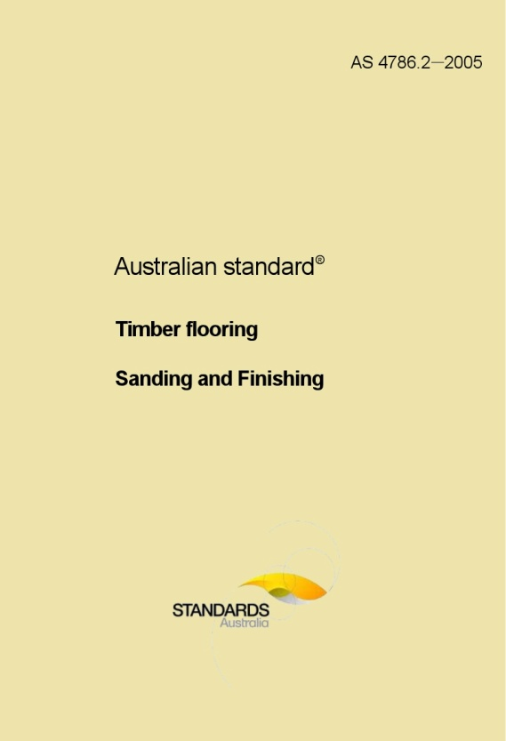
The Australian Standard that deals with the finishing of timber floors is AS 4786.2 – Timber Flooring – Sanding and finishing.
It includes an appendix which provides guidance on how to inspect a finished floor and what to look for when assessing its quality and acceptability.
However, AS 4786 does not provide precise specifications on individual imperfections. Instead, it says that: ‘assessment relies on judgement, and the outcome will vary from situation to situation’.
Below are some tips on how to inspect a floor’s finish once the project has been completed.

Carrying out an inspection
The quality of a finished floor should be evaluated in terms of what the homeowners or occupiers will see under normal conditions.
It’s best to carry out your inspection during daylight hours with the internal lights turned on. Curtains and blinds should be in their usual position. Stand in various locations that residents are likely to be in, and take into account the light reflections in areas that are not obscured by fixtures or furniture.
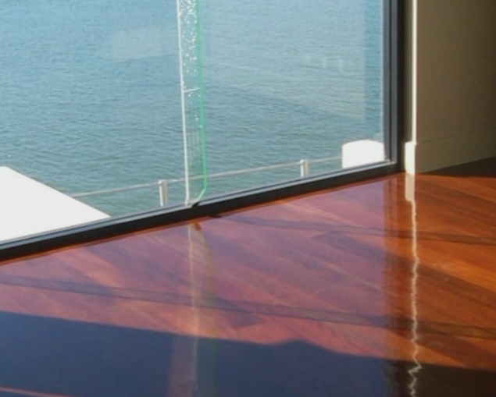
Keep in mind that some lighting conditions can accentuate particular problems when they’re viewed from certain angles.
This especially applies to hallways with harsh down lights and floor areas that face glass sliding doors with daylight outside.
Consider the effect of foot traffic over time and the likely positioning of furniture and rugs.
In general, the floor should have an even appearance and be free from heavy sanding marks or frequent air bubbles. Minor imperfections, such as slight sanding marks or small depressions in the finish at the edges of boards and in nail holes are generally acceptable. These imperfections are likely to be more common in corners and other areas that are awkward to access.

Learning activity
Have you got access to a copy of AS 4786? If you don’t have your own, ask your trainer or boss to lend you a copy.
Alternatively, you can purchase the document via the Standards Australia website at:
http://infostore.saiglobal.com/store/default.aspx
Have a look at the different sections in the document. In particular, read through the ‘Assessment of quality of finish’ in Appendix B.
What are the main suggestions on how to inspect the floor, and the conditions under which it should be inspected?

Common problems
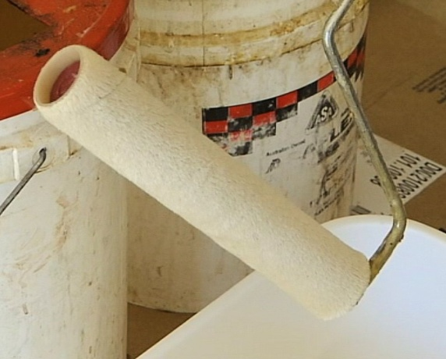
The best way to avoid problems in the coating finish is to be aware of what can go wrong under certain conditions or with particular products, and take steps to minimise or eliminate the risks before you start.
The manufacturer of each product will provide guidelines on how to apply their coating system properly.
They’ll also indicate which timber species, other finishing products and environmental conditions will give the best results.
Below are some of the most common problems relating to floor finishes.

Edge bonding
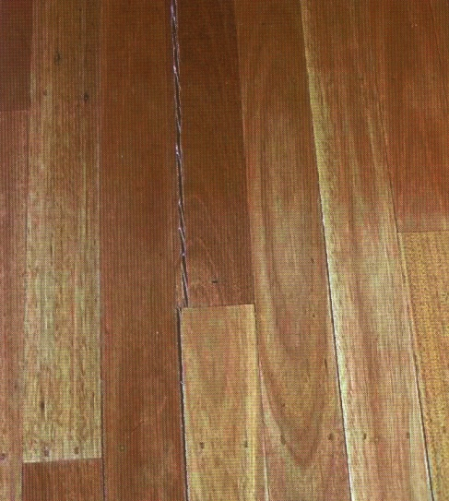
Edge bonding happens when a coating product seeps into the gaps between boards and glues them together.
If the timber hadn’t been properly dried before the coating was applied, the group of boards will shrink together.
This means that instead of a tiny gap opening up between individual boards, the whole panel of stuck-together boards will shrink away from the next panel, increasing the gap size between them.
Apart from the unsightly gap formed between panels, edge bonding can also cause tongues and grooves to split.
The best solution is to make sure the floor has reached equilibrium moisture content with the surrounding environment before the coating is applied. You’ll find more information on this topic in the unit: ‘Inspecting and testing subfloors’, in the lesson: Drying timber to EMC.
If a floor looks like it might be susceptible to edge bonding, you should advise the client to choose a coating system that has more flexibility and a low risk of edge bonding. Indicators of a problem floor include boards that aren’t laid tightly, and heating or cooling systems that could have an effect on shrinkage levels.

Blooming
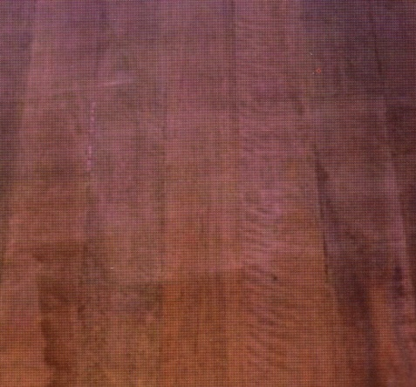
Timber species that have high levels of ‘extractives’, such as waxes, oils and resins, can sometimes develop a condition known as blooming.
This is a haze that occurs on the coating when the weather is cold and damp.
Solvent-based polyurethanes are more prone to blooming, because the extractives can dissolve into the coating system.
If you notice a haze on the floor in between coats, clean it off with thinners and add an anti-rejection additive to the next coat. Also make sure the ventilation is adequate, so that the solvent can’t build up in the air above the floor.
If the blooming is in the finished floor, you may be able to remove it by waiting three days and then washing it with diluted dishwashing liquid in lukewarm water.

Bubbling
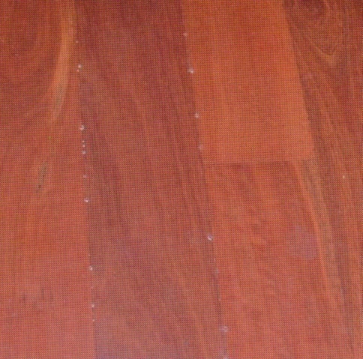
Bubbling along the board edges occurs mainly with direct stick boards, because of the limited space underneath the flooring. It tends to happen in hot weather as the floor heats up and forces air out at the joints.
One solution to the problem is to avoid coating the floor on a hot afternoon. Another is to use a slower drying coating product, to give the bubbles more time to escape and burst rather than skin over on the surface.

Cold weather crystallisation
Crystallisation appears as a white discolouration in the coating. It can occur in cold weather with water-based polyurethanes and fast-dry sealers as they dry.
To avoid the problem, always follow the manufacturer’s directions relating to minimum temperatures for application. For most products, this is 10° C.

Changing colours
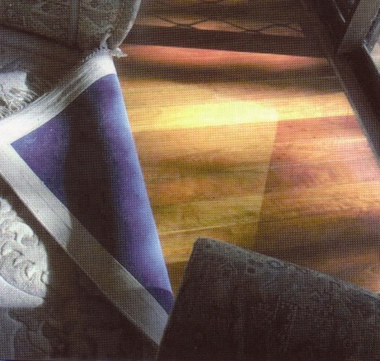
Exposure to ultra-violet light will gradually change the colour of timber as well as the coating. Areas that are under floor rugs or furniture may end up being darker or lighter than the surrounding floor. Solvent-based coatings generally darken more than water-based ones.
The best advice you can give clients is to avoid putting down rugs for six months or so, to give the floor time to gradually change colour more evenly.

Contaminants
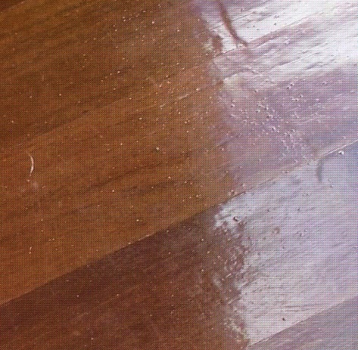
There are lots of contaminants that can float in the room and settle on the floor while it’s drying. They include dust particles, hair, insects and grit.
It’s common for some dust to appear around doorways and stairwells, and little amounts are acceptable. Small particles will generally wear off with normal foot traffic over time. If the particles are larger or cover broader areas, the floor may have to be sanded back and recoated.

Delamination
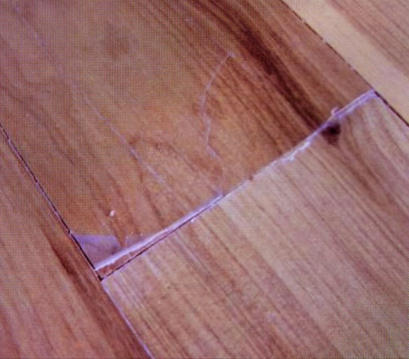
‘Laminate’ means layer, so delamination is the peeling or lifting of the floor coating away from the timber surface. It can occur at the edges of boards if the tongues and grooves don’t fit tightly.
As people walk on the boards, the vertical movement between them stretches the coating and fractures it. Flexible coatings are less prone to delamination under these conditions.
Delamination can also occur between coats if an incompatible product is put on top, or if there is insufficient keying into the previous coat. In these cases, the floor generally needs to be sanded right back to raw timber and the finishing process started again.

Gloss variation
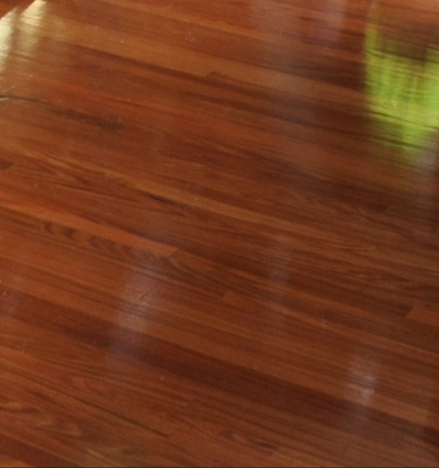
Solvent-based polyurethanes sometimes show variations in gloss levels. This can happen if the base coat wasn’t sufficiently cured or sanded to a uniform finish prior to the final coat being applied.
Satin finishes can also show variations in gloss levels if some areas have dried more quickly than others. This can occur under doorways where there is a draft, or in areas that experienced warmer temperatures because they were finished at different times of the day.
Faster drying times result in glossier finishes. Most clients accept some difference in gloss levels between rooms, but if there is a significant variation within the room the floor may need to be recoated.

Lap of roller marks
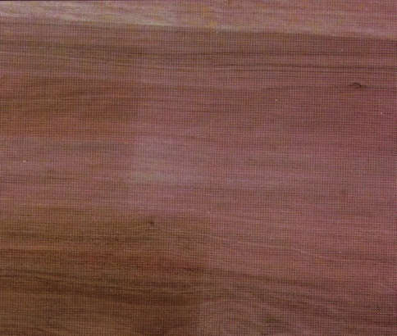
A small amount of lap marking is acceptable, because the slight variations in colour toning are very difficult to avoid when you overlap the roller applications. It also tends to be less noticeable over time as the colours change in the timber and coating.
The best way to minimise lap marking is to coat along the boards, in the direction of the grain, and avoid patchwork application.

Orange peel
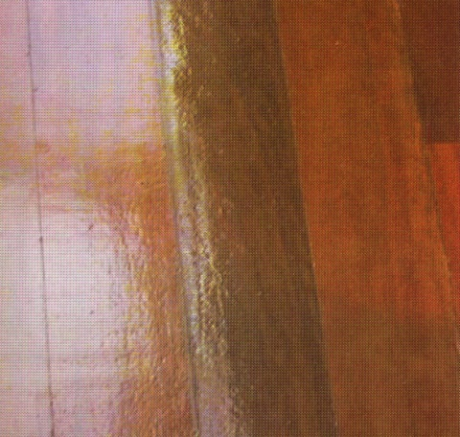
Orange peel has a slightly rough, orangey appearance. It happens when the solvent evaporates before the solids in the solution have time to spread evenly over the surface.
To avoid this problem, don’t apply the coating during hot weather, and don’t spread it too thinly.
You can also use a ‘wet edge extender’ in the mixture to slow down the evaporation time.

Patchy stain
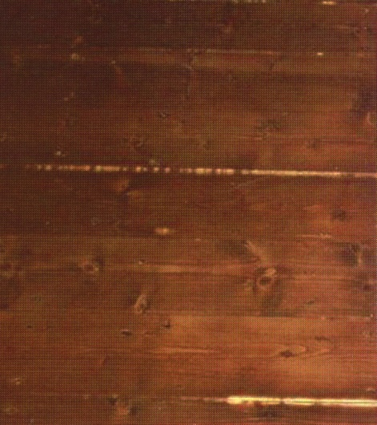
Stains can appear patchy if they’re absorbed at different rates in the timber surface, or are applied in different thicknesses.
As the floor ages, the colour variation is likely to reduce, but if the problem is serious it will still be noticeable.
To avoid the problem in stains that are applied directly to the floor, make sure it is wiped on and wiped off evenly. Also be careful to sand the floor evenly.
The ends of boards tend to take up more stain, so end joints should be filled before the stain is applied. Dye stains that are mixed into the coating before application are less prone to giving a patchy appearance.

Quilting
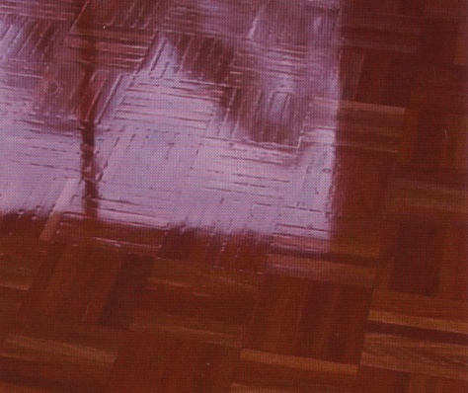
Quilting is mostly a parquetry problem. It results from the coating not flowing evenly over fine gaps at the edges and ends of the individual blocks.
To avoid the problem, the coating should be ‘flood’ filled onto the floor, rather than applied thinly.
Low viscosity (more runny) coatings are less prone to quilting.

Rejection
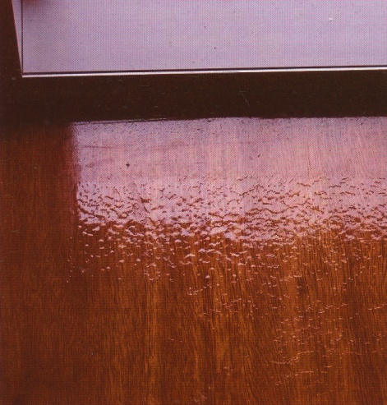
When a coating is not compatible with the surface being coated and ‘pulls back’ rather than flowing over the surface smoothly, the problem is called rejection.
In some cases, rejection is caused by contaminants on the surface, such as silica, household chemicals or waxes. In other cases, it could be due to an incompatibility between different coating products.
Always check that a particular product is compatible with the flooring surface you’ll be coating as well as any other products you’re planning to use. Also follow the manufacturer’s directions regarding surface preparation and waiting times between coats.
For floors with specific problems, there are sealers and anti-rejection additives that can help to minimise the risk of pull back in the coating.

White lining or tram lining
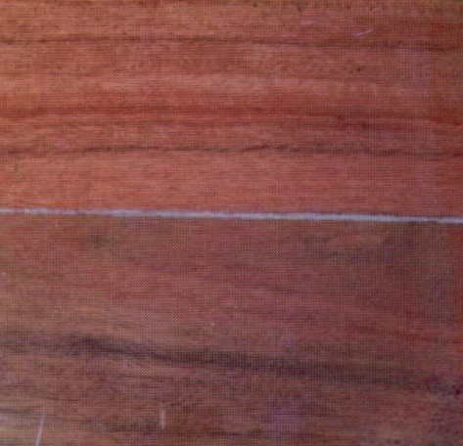
White lining is associated with the movement of board edges as they shrink, causing the coating to stretch across the gap. It tends to occur with water based finishes and vinyl fast dry sealers. In severe cases, the finish may split and delaminate.
Flooring can shrink if it is not correctly acclimatised before installation. It can also shrink if there is a change in air humidity levels after installation, such as through having a heating or cooling system turned on.
These issues need to be addressed by the flooring installer before the floor is laid, because once the boards have been fixed in position there is a limit to what you can do as the finisher. However, if you are think that white lining may be a potential problem in a floor, you can advise the client to wait until the boards have shrunk before putting the coating on the floor, and to choose products that are less susceptible to white lining.

Learning activity
Carry out your own inspection of a finished timber floor. It may be a job you’ve completed yourself, or an existing floor you have access to.
Find two different types of imperfections in the coating system.
Name each one, using the correct terminology, and briefly describe how the problem might have occurred. You can also take digital photos to go with the descriptions.

Assignment 2
This assignment should be completed after you have carried out your practical demonstration assessment events and completed Assignment 1.
You’ll find a hard copy template for this assignment in the Workbook for the unit. If you prefer to answer the questions electronically, go to the website version and download the Word document template.
___________________________________________________________________
In Assignment 1, you provided descriptions of the coating products you used in the practical demonstrations.
For each of these products, provide the following information:
- Name the type of floor and species of timber that the coating product applied to. (That is, was it blackbutt strip flooring, tallowwood parquetry flooring, cork tiles, etc?)
- Describe two possible problems that this floor and coating system combination would be susceptible to. (That is, what sorts of things could go wrong if you weren’t careful?)
- Explain how you minimised the risk of these potential problems occurring. (What did you look out for, what techniques did you use, or what were you careful to avoid?)

Practical demonstrations
Before you are signed off as competent, you will be asked to demonstrate your practical skills in applying coatings to timber or cork floors.
Your trainer may ask you to keep a log book or diary of the work you do on-the-job that relates to the practical components of these competencies. This will help them to determine when you will have had sufficient hands-on practice in these tasks to undertake the assessment events.
Set out below are the basic performance requirements for each of the competencies covered in this Learner guide. For each performance, you will be asked to demonstrate the following aspects of the installation process:
- preparation and inspection of the floor prior to applying the coating system
- selection of the correct coating system, tools and other materials
- application of the coating system, together with any intermediate steps, such as sanding and cleaning the floor in between coats
- cleaning up of tools, correct disposal of waste materials, removal of barriers, completion of paperwork
- inspection of the floor once the project has been completed.
The tools and equipment you’ll need to use in the demonstrations include:
- orbital sander, rotary sander and hand sander
- vacuum cleaner
- brushes, applicators, rollers and roller tray
- hammer, nail punch and spatula
Make sure you talk to your trainer or supervisor about any of the details you don’t understand, or aren’t ready to demonstrate, before the assessment events are organised. This will give you time to get the hang of the tasks you’ll need to perform, so that you’ll feel more confident when the time comes to be assessed.

Solvent based coatings
LMFFL3402A: Apply solvent based coatings to timber flooring
Apply two different solvent based products to two different timber species.
Products may include: resin solutions, one-pack or two-pack epoxy resins, two-pack polyurethanes and moisture curing polyurethanes.

Water based coatings
LMFFL3403A: Apply water based coatings to timber flooring
Apply two different water based products to two different timber species.
Products may include water based polyurethanes with a matt, satin or gloss finish.

Oil based coatings
LMFFL3404A: Apply oil based coatings to timber flooring
Apply two different oil based products to two different timber species.
Products may include waxes, oils, oleoresins and one-pack urethane oils.

Cork finishes
LMFFL3605A: Apply finishes to cork flooring
Apply two finishes with different bases to two different cork floors.
Products may include: waxes, oils, oleoresins, one-pack methane oils, resin solutions, one-pack or two-pack epoxy resins, two-pack polyurethanes, moisture curing polyurethanes and water-based polyurethanes.

