
Supporting: LMFFL2004A Moisture test timber and concrete floors
LMFFL3101A Inspect sub-floors

Section 1 Assignment: Subfloor systems
Name |  | Date
Provide short answers to the following questions:
- What is the difference between underlay and underlayment?
- What does DPC stand for, and what is its purpose?
- Briefly describe the characteristics of a ‘stiffened raft’ concrete slab.
- Name two structural flooring products commonly used in platform floors.
1.
2.
- Why do builders sometimes use a ‘cut-in’ floor system?
- List four different types of hard underlay.
1.
2.
3.
4.

- Fill in the correct terms in the drawing below.
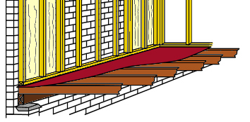

- What type of flooring system is shown in the drawing above?

