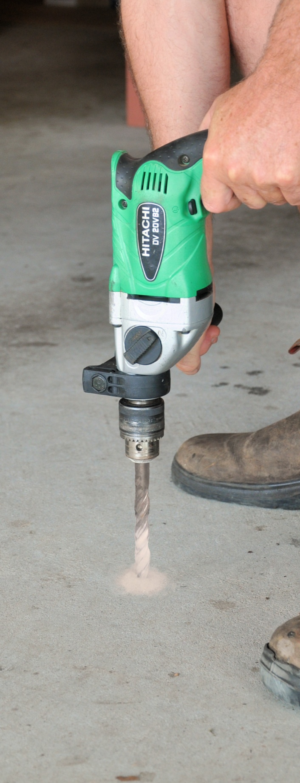
Inspecting and
testing subfloors
DRAFT VERSION
October 11
Supporting:
LMFFL2004A: Moisture test timber and concrete floors
LMFFL3101A: Inspect sub-floors
Workbook
Name:

Inspecting and
testing subfloors
Workbook
Containing learning activities and assignments for the units of competency:
LMFFL2004A: Moisture test timber and concrete floors
LMFFL3101A: Inspect sub-floors

The assignment templates are also available in an electronic ‘Word’ version, downloadable from the Flooring technology website at:

www.flooringtech.com.au

Developed by Workspace Training for the 2012-2013
Workplace English Language and Literacy (WELL) Program
Flooring Technology resource development project

ISBN: 978-0-9873327-7-6
Funded under the Workplace English Language and Literacy Program by the Australian Government through the Department of Industry, Innovation, Climate Change, Science, Research and Tertiary Education
© Commonwealth of Australia 2013

CC BY-NC-SA

This work is copyright. Except where otherwise indicated, and save for the Commonwealth Coat of Arms, the Department has applied the Creative Commons Attribution-Noncommercial-Share Alike 3.0 Australia Licence to this work.
The Department of Industry, Innovation, Climate Change, Science, Research and Tertiary Education must be attributed as the author of the Department’s copyright material.
As far as practicable, material for which the copyright is owned by a third party has been clearly labelled. The Department has made all reasonable efforts to ensure that this material has been reproduced in the print-based resources and accompanying website with the full consent of the copyright owners.
Requests and enquiries concerning the Department’s copyright material should be addressed to:
The Legal Branch
Department of Industry, Innovation, Climate Change, Science, Research and Tertiary Education
GPO Box 9839 Canberra ACT 2601
Email: legalservices@innovation.gov.au
Questions about the design and content of the resource itself should be addressed to the project manager:
David McElvenny
Workspace Training
PO Box 1954 Strawberry Hills, NSW, 2012
Email: david@workspacetraining.com.au

Table of contents
Introduction 1
Part 1 Learning activities 3
Section 1: Subfloor systems 5
Section 2: Moisture in subfloors 9
Section 3: Inspecting subfloors 11
Section 4: Measuring moisture and pH 14
Part 2 Assignments 17
Assignment 1 19
Assignment 2 21
Assignment 3 23
Assignment 4 27
Practical demonstration 31

Introduction
Inspecting and testing subfloors is a 'learning unit' from the Flooring Technology training resource. It supports the following two competencies from the Certificate III in Flooring Technology (LMF31208):
LMFFL2004A: Moisture test timber and concrete floors
LMFFL3101A: Inspect sub-floors
To be assessed as competent, your assessor will use a range of methods to check your understanding of the concepts presented in the Learner guide for this unit and your practical ability to inspect and moisture test sub-floors.
These may include:
- written assignments
- practical demonstrations
- on-the-job discussions about how you go about particular activities
- learning activities undertaken while you’re progressing through the unit
- examples of tasks you have undertaken
- log book or work diary.

Literacy, numeracy and computer skills
Literacy is the ability to read and write. To complete this qualification, you will need sufficient literacy skills to produce a range of workplace documents. You will also need the skills to be able to read and understand documents such as order forms, installation instructions, project briefs and safe operating procedures.
Numeracy is the ability to work with numbers. Flooring installers need to do lots of measure-ups and calculations, so there will be many opportunities for you to learn and practice your numeracy skills.
When it comes to completing the written assignments for this qualification, a certain level of literacy ability is required to read the questions and write down your answers. There will also be times when you are asked to generate documents on a computer.
Obviously, it’s important that you clearly understand what the assignment is asking you to do, and that your work is a good reflection of what you really know. So if you’re having trouble reading the questions, writing down your answers, or using certain computer programs, make sure you speak to your trainer before you hand the assignment in.
There are various ways your trainer can help you. For example, they may be able to ask the assignment questions verbally and help you to write down your answers. They may also be able to show you sample answers to similar questions, which will let you look at the way they’re written and give you hints on how to write your own. You may also be allowed to do the assignment with the assistance of another person.

Applying for RPL
RPL stands for Recognition of Prior Learning. It is a form of assessment that acknowledges the skills and knowledge you have gained through:
- on-the-job experience
- formal training in other courses
- life experience, through your hobbies or other outside activities.
If you believe that you are already competent in some or all of the skills covered in this unit, ask your assessor about how to apply for RPL.

Using this workbook
All of the lessons in the Learner guide for this unit have learning activities at the end. Their purpose is to provide discussion points and questions to help reinforce your understanding of the concepts being presented.
There are also a range of assignments, which appear at the end of each section. These are designed to test your knowledge of the subject matter and ability to submit written responses in an acceptable format.
This workbook reproduces all of the learning activities and assignments in a format that lets you handwrite your answers to the questions.
Note that your trainer may ask you to produce a computer-generated document for all of the formal assignments, either printed out in hard copy or submitted electronically. To do this, go to the website version of the unit and look for the Assignment link in each section. This will allow you to type your answers into the ‘Word’ document and then either print it out or email it direct to your trainer as an attachment.
You may also be asked to share your learning activity answers electronically, especially if you are undertaking this unit by distance learning and are linked up with fellow students in other locations. This might be done through group emails or via a social networking site such as Facebook. In these cases, you should use the website resource rather than this workbook.

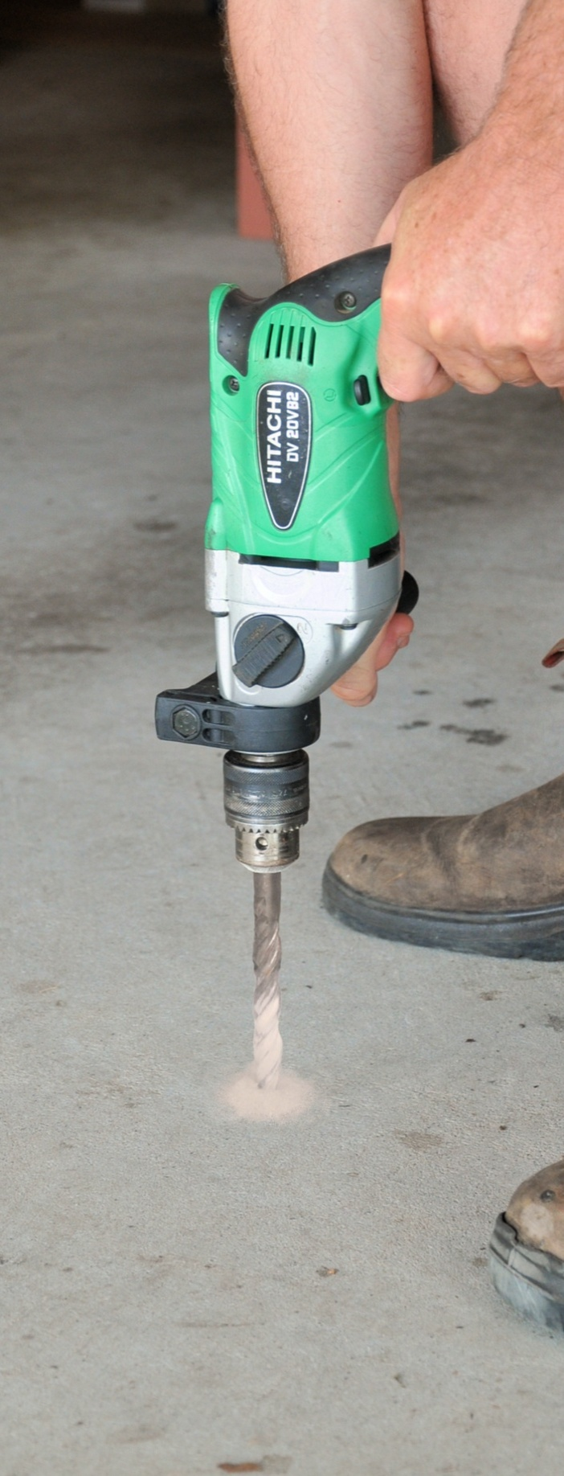

Part 1

Learning activities

Section 1: Subfloor systems

Subfloor terminology
See if you can name a suitable floor covering and underlay or underlayment for the following two situations. State the brand name and describe the type of product it is for each item you choose.
- Vinyl tiles to go on a concrete floor
Brand name:
Type of product:
- Carpet to go on a particleboard sheet floor.
Brand name:
Type of product:

Concrete slab subfloors
Flashing is sold in rolls and comes in a variety of materials. It’s not only used at floor level in a wall, but is built into the structure under window sills, on roofs (especially around chimneys, skylights and vents) and in various other places where joints might allow water to penetrate.
- Do you know what materials flashing is made from? See if you can name at least three different types of material.
- Which material is most common around the base of an external brick wall?

Timber framed subfloors
Traditionally, bearers and joists in timber framed buildings were always solid timber. Ground floors typically used hardwood, and upper floors used oregon (also called Douglas fir) because of its excellent strength-to-weight ratio.
These days, however, the availability of timber species has changed a lot. Australian hardwoods and imported oregon are much more expensive and in shorter supply, while plantation pines have become readily available and more economical.
In addition, there are many engineered products now on the market that are suitable for use as joists or beams.
Can you name three different engineered products used as floor joists? What materials are they made from and what components are used in their structure?
If you have trouble coming up with the names of three products, have a look at the website for the Engineered Wood Products Association of Australia, at:
www.ewp.asn.au/.
This site contains a lot of information on these types of products.
Product | Materials | Components

Structural sheet flooring
For more information on particleboard and plywood, go to the Engineered Wood Products Association of Australia (EWPAA) website at:
www.ewp.asn.au/.
If you click on the ‘Library’ menu link, you will see a wide range of downloadable technical guides, fact sheets and video clips.
Have a look now at the topics available and follow up on the ones that interest you.
Which of these topics are most relevant to the work you do?

Underlay board products
When you’re inspecting subfloors in older homes, it’s likely that you’ll come across asbestos fibro sheeting from time to time. Some homes also used asbestos-backed vinyl tiles and carpet underlay. These products are safe while they’re left undisturbed, but you need to take special precautions if you plan to pull them up or do any work that might damage them.
We’ll look in more detail at how to work safely around asbestos-based products in the unit: Safety at work. But for now, see if you can answer the following questions:
- What types of safety precautions are needed to remove asbestos-based products?
- Where should these products go once they have been removed?

Section 2: Moisture in subfloors

Relative humidity and moisture
The map in the Learner guide uses mathematical signals to express ‘more than’ and ‘less than’. For example:
- ‘< 60%’ means less than 60%
- ‘> 60%’ means more than 60 %.
See if you can find where your own town or city is located on the map. What climatic zone does it fall into? What is the average RH at 9 am?
Climatic zone
Average RH at 9 am
If you live in a regional area and you’re having trouble deciding which band it falls into, go to the BOM map at the web address shown in the Learner guide. It shows many more towns and has more detailed zone bands.

Moisture in wood
Here’s a moisture content question for you to work out. Let’s say a piece of hardwood flooring weighs 4.4 kg, and the woody fibres in the board weight 4.0 kg.
- What is the weight of the moisture in the board?
- What is the moisture content of the board expressed as a percentage?

Drying timber to EMC
We said earlier that seasoned timber generally has a moisture content of 10 to 15%, unless otherwise specified.
If the air temperature was 30º C, what would this equate to in terms of relative humidity? Use the graph in the Learner guide to work out your answer as an approximate percentage range.

Moisture in concrete
For more details on how concrete is made and how to work with it, go to the information manual published by Cement Concrete and Aggregates Australia (CCAA) called: Concrete Basics: A guide to concrete practice.
You can download it from the CCAA’s website at:
http://www.concrete.net.au/publications/pdf/concretebasics.pdf

Drying concrete to EMC
Have another look at the bar graph in the Learner guide, showing the strength of concrete in relation to curing time.
How much strength will the concrete have achieved if it is cured for 28 days?
(Note that this figure will be a ‘relative’ strength compared to concrete that has been cured for 180 days.)

Section 3: Inspecting subfloors

Site safety
Below are some common safety signs used on building sites. Do you know what each one means? Write the meanings in the spaces provided below.
Sign | Meaning

Australian Standards
Which Australian Standards and industry standards apply to your work? If you’re not sure, ask your supervisor what they are and where you can get copies to read.
Note that you can buy your own copy of the Australian Standards by going to:
www.siaglobal.com.au.
Write down the full title of each document that you need to be familiar with.

Inspecting concrete subfloors
Even if you’re not familiar with expansion joints in concrete, you’re sure to have walked over the top of many joints in slab floors – such as in shopping centres, supermarkets and warehouses.
Next time you’re in a shopping centre or other large building, have a look for the expansion joints in the floor. Take photos on your mobile phone and share them with your trainer and other learners in your group.
To get an idea of the range of expansion joint designs and cover plates used on concrete floors, do an 'image' search on the internet to see some examples of available products.

Inspecting timber subfloors
In addition to termites, there are various other organisms that attack building timbers. These include decay fungi and borers. One of the main ways of minimising the chance of attack is to use good building practices, such as providing adequate subfloor ventilation. We’ll talk more about this in the next lesson.
For more information on the organisms that attack timber and the types of damage they cause, have a look on the internet at some of the pest controllers’ websites. Simply type ‘termites’ or ‘timber pest control’ or any other suitable key words into your search engine to see the huge range of sites available.
Once you’ve looked at the types of insect attack and fungal decay that tend to affect timber subfloors, see if you can find some examples of your own. Do a ‘pest inspection’ of your own home or of another building with a raised timber floor. Also look for other problems that would need to be fixed if you were going to put a new floor covering on top.
Take digital photos of any problems you find. Share the photos with your trainer and other learners in your group. If you’re uploading the photos to a social media site or sharing them via email, make sure you provide a brief written description of the problem that you have discovered and how you think it has occurred.

Checking subfloor ventilation
See if you can calculate the number of vents needed in a wall.
Let’s say you’re inspecting a building in Climate Zone 2 and the subfloor walls have wire mesh air vents. The wall is 12 metres long, and the opening size of each vent is 14,200 mm².
How many vents are needed?
When you’ve finished the calculations, check the answer with your trainer to see if you’re right.
Note that there are many different designs and styles of subfloor air vents. What types of vents are used in the building you’re in right now? Go outside and have a look. If you’re not in a building that has a raised floor, see if you can find a nearby building with subfloor air vents.

Section 4: Measuring moisture and pH

Principles of moisture testing
Most flooring installers use a template-style checklist to record the details of their site assessment. Does your company have a checklist? If you’re not familiar with it, ask your supervisor whether you can have a copy to look at.
On pages 64 and 65 of the Learner guide is a sample template of a moisture test report. You’ll notice that it has space for recording the important details relating to the subfloor. It also has a grid for drawing a floor plan and marking where the moisture tests were carried out.
Compare your own company’s checklist with this template version. Are there any parts in your company’s checklist that aren’t covered in this template? Are there any parts in this template that your one doesn’t have? List these below.
(Note that if your own checklist is a full site assessment form, you only need to look at the section relating to moisture testing.)

Insulated hood test
There are lots of YouTube video clips produced by the manufacturers of moisture testing equipment. These videos are designed to promote the company’s own products, so naturally they show them in the best possible light. However, as long as you keep this in mind, the videos are very helpful in demonstrating how particular systems works.
The link below will take you to a clip produced by Tramex demonstrating their ‘Hygrohood’.
http://www.youtube.com/watch?v=EoNzaG7YLoU
Have you used the hood method to measure RH in a slab? What brand of hygrometer did you use? Write the model details and manufacturer's name in the space provided below.
If you haven’t used one before, do you know of any other manufacturers of hygrometers? Find out as much information as you can about the hygrometer you’ll be using in preparation for the practical assessment demonstrations.

In-situ probe test
The Rapid RH probe shown above is manufactured by Wagner Electronics. You can see an instructional video clip on how it works at:
http://www.wagnermeters.com/video-install.php
Have you used an in-situ probe before? If so, write the model details and manufacturer's name in the space provided below.
If you haven’t used one before, do you know of any other manufacturers of these RH probes? Do a web search and find a manufacturer. Name the brand and briefly describe how the probe is used.

Electrical resistance meters
The link below will take you to a clip produced by Delmhorst descibing their BD-10 ‘pin type’ moisture meter.
http://www.youtube.com/watch?v=XUc2lHZ5WD0&feature=relmfu
Have you used an electrical resistance meter to measure moisture content in wood or concrete? If so, write the model details and manufacturer's name in the space provided below.
If you haven’t used one before, do you know of any other manufacturers of these types of moisture meters?

Other moisture testing methods
Wagner Electronics have produced a video clip that explains the problems with the calcium chloride test. It’s called: ‘Calcium chloride shown to give false readings’, and you can see it at:
http://www.youtube.com/watch?v=Rpi-DZy3HOg&feature=relmfu
Although the capacitance meter also has its problems, it is still widely used for quick moisture checks, especially when you’re looking for the most appropriate places to put an in-situ probe. Have you used a capacitance moisture meter before? What brand was it? Write the details in the space provided below.
If you haven’t used one before, do you know of any other capacitance meter manufacturers?

Measuring pH levels
Flooring Resources have produced a video clip called ‘pH test for concrete’ which describes how their pH test kit works. The link below will take you to the clip:
http://www.youtube.com/watch?v=EC0-enQTD6o&feature=related
pH testing is still quite new for concrete floors, but there are other pH tests that people do all the time, including in their own homes. One example is testing pH levels in swimming pools. Another is testing the soil in vegetable gardens, especially when certain types of vegetables aren’t growing as well as they should.
Have you used a pH test kit before? What were you testing? How did the system work?

Part 2

Assignments

Assignment 1

Name |  | Date
- What is the difference between underlay and underlayment?
- What does DPC stand for, and what is its purpose?
- Briefly describe the characteristics of a ‘stiffened raft’ concrete slab.
- Name two structural flooring products commonly used in platform floors.
1.

2.

- Why do builders sometimes use a ‘cut-in’ floor system?
- List four different types of hard underlay.
1.

2.

3.

4.

- Fill in the correct terms in the drawing below.

- What type of flooring system is shown in the drawing above?

Assignment 2

Name |  | Date
- If the atmosphere has an RH of 50%, what does this mean?
- What does EMC stand for, and what does the term mean?
- What is the general moisture content range for timber that is ‘seasoned’?
- When might you find that the EMC inside a building is below the normal ‘seasoned’ range?
- Why do builders like to slow down the curing process in concrete?
- What ‘rule of thumb’ is used by concreters to estimate the time it will take concrete to dry to EMC?
- Give three reasons why this rule of thumb may not be accurate for a particular slab.
1.

2.

3.

- What is the purpose of an expansion joint in concrete?

Assignment 3

Name |  | Date
- What is a ‘White Card’ and who needs to have one?
- Name four items of personal protective equipment you may need to take on-site when you carry out a subfloor inspection.
1.
2.
3.
4.
- Why is it important for flooring installers to have a good understanding of the Australian Standards that relate to their work?
- How should you advise the client if you found a problem with the subfloor that needed to be fixed?
- What is the purpose of a curing compound on a concrete slab?
- Describe a simple test for finding out whether the surface has a curing compound on it.
- What does ‘laitance’ mean and why is it a problem?
- State the tolerance for ‘planeness’ in a concrete floor (as specified in AS 1884).
- State the tolerance for ‘smoothness’ in a concrete floor (as specified in AS 1884).
- Name two causes of ‘blown’ timber floor boards.
1.

2.

- What should you do if you find live termite activity in a timber subfloor?
- Give two reasons why good subfloor ventilation is important.
1.

2.

Assignment 4

Name |  | Date
- How do capacitance moisture meters work?
- Why are capacitance meters not very accurate at measuring moisture in concrete?
- When you carry out a ‘surface mounted hood test’, exactly what are you measuring?
- What is the maximum RH permitted in a concrete slab when measured with a surface mounted hood?
- When you carry out an ‘in-situ probe test’, exactly what are you measuring?
- What is the maximum RH permitted in a concrete slab when measured with an in-situ probe?
- Why is it useful to have a capacitance meter on hand when you’re carrying out in-situ-probe or surface-mounted hood tests on a concrete slab?
- How does an electrical resistance moisture meter measure the amount of water that’s present in timber?
- What is the normal allowable moisture content range for timber in a subfloor?
- Why is the ‘calcium chloride test’ no longer used by flooring installers to measure moisture content in concrete?
- How many moisture tests should be carried out on a 100 m² floor?
- List the types of details you should record when you carry out a set of moisture tests on a subfloor (as recommended by the Australian Standards).
- Why is it important to know what the pH level is on the concrete surface before you start a vinyl flooring installation?
- What is the recommended pH range for a concrete subfloor, as stated in AS1884-2012?

Practical demonstration
The sample checklist below sets out the sorts of things your assessor will be looking for when you undertake the practical demonstrations for this unit.
Make sure you talk to your trainer or supervisor about any of the details you don’t understand, or aren’t ready to demonstrate, before the assessment events are organised. This will give you time to get the hang of the tasks you’ll need to perform, so that you’ll feel more confident when the time comes to be assessed.
Your trainer may also ask you to keep a log book of the work you do on-the-job that relates to these tasks. This will help them to see whether you have had sufficient practice in the full range of activities required for the competency, and to determine when you will be ready for the assessment events.

Sample checklist
- Follow all company safety policies and procedures while at work
- Carry out a visual inspection of a timber subfloor using a template checklist and correctly fill in the required details, including:
- planeness and smoothness of the surface
- any problems in bearers, joists, structural flooring or other elements that might affect the floor covering installation
- any problems in the subfloor ventilation
- recommendations on work that will need to be done in preparation for the installation.
- Carry out a visual inspection of a concrete subfloor using a template checklist and correctly fill in the required details, including:
- moisture content readings taken in appropriate places
- pH readings taken in appropriate places
- planeness and smoothness of the surface
- whether there are curing compounds or other contaminants on the surface that will need to be removed
- whether there are cracks, spalling or other surface irregularities that will need to be filled or patched
- recommendations on work that will need to be done in preparation for the installation
- checking whether expansion joints are clean and unobstructed.
- Carry out a series of moisture tests on a timber floor using an electrical resistance moisture meter and complete a written record of the test results, including:
- details on the instrument used, such as type, make, model and calibration
- line drawing showing the floor plan and positions the readings were taken, including bearers, joists and structural flooring
- ambient temperature and RH at the time of the readings
- recommendations on whether the floor is ready for the floor covering to be installed.
- Carry out a series of moisture tests on a concrete floor using a capacitance meter for the preliminary checks and a hygrometer for the formal tests, and complete a written record of the test results, including:
- details on the instruments used, such as type, make, model and calibration
- line drawing showing the floor plan and positions the readings were taken
- ambient temperature and RH at the time of the readings
- recommendations on whether the floor is ready for the floor covering to be installed.

