Planning and costing
DRAFT VERSION
October 11
Workbook
Supporting:
LMFFL3001A: Plan and cost flooring technology work
Name:

Planning and costing

Workbook

Containing learning activities and assignments for the unit of competency:
LMFFL3001A: Plan and cost flooring technology work

The assignment templates are also available in an electronic ‘Word’ version, downloadable from the Flooring technology website at:
www.flooringtech.com.au

Developed by Workspace Training for the 2012-2013
Workplace English Language and Literacy (WELL) Program
Flooring Technology resource development project
The resource is now managed by Manufacturing Skills Australia

ISBN: 978-0-9873327-6-9
Funded under the Workplace English Language and Literacy Program by the Australian Government through the Department of Industry, Innovation, Climate Change, Science, Research and Tertiary Education.
© Commonwealth of Australia. 2013
CC BY-NC-SA
This work is copyright. Except where otherwise indicated, and save for the Commonwealth Coat of Arms, the Department has applied the Creative Commons Attribution-Noncommercial-Share Alike 3.0 Australia Licence to this work.
The Department of Industry, Innovation, Climate Change, Science, Research and Tertiary Education must be attributed as the author of the Department’s copyright material.
As far as practicable, material for which the copyright is owned by a third party has been clearly labelled. The Department has made all reasonable efforts to ensure that this material has been reproduced in the print-based resources and accompanying website with the full consent of the copyright owners.
Requests and enquiries concerning the Department’s copyright material should be addressed to:
The Legal Branch
Department of Industry, Innovation, Climate Change, Science, Research and Tertiary Education
GPO Box 9839 Canberra ACT 2601
Email: legalservices@innovation.gov.au
Questions about the design and content of the resource itself should be addressed to the project manager:
David McElvenny
Workspace Training
PO Box 1954 Strawberry Hills, NSW, 2012
Email: david@workspacetraining.com.au

Table of contents
Introduction 1
Part 1 Learning activities 3
Section 1: The quotation process 5
Section 2: Floor covering plans 8
Section 3: Estimating quantities 14
Section 4: Estimating costs 21
Part 2 Assignments 25
Assignment 1 27
Assignment 2 29
Assignment 3 30
Assignment 4 31

Introduction
Planning and costing is a ‘learning unit’ from the Flooring Technology training resource. It supports the following competency from the Certificate III in Flooring Technology (LMF31208):
- LMFFL3001A: Plan and cost flooring technology work.
To be assessed as competent, your assessor will use a range of methods to check your understanding of the concepts presented in the Learner Guide for this unit and your practical ability to plan installation projects, estimate material quantities, calculate costs, and prepare quotations.
These methods may include:
- written assignments
- practical measure-ups
- on-the-job discussions about how you go about particular activities
- calculation exercises and preparation of quotations
- learning activities undertaken while you’re progressing through the unit
- examples of costings you have undertaken and quotations you have prepared.

Literacy, numeracy and computer skills
Literacy is the ability to read and write. To complete this qualification, you will need sufficient literacy skills to produce a range of workplace documents. You will also need the skills to be able to read and understand documents such as order forms, installation instructions, project briefs and safe operating procedures.
Numeracy is the ability to work with numbers. Flooring installers need to do lots of measure-ups and calculations, so there will be many opportunities for you to learn and practise your numeracy skills.
When it comes to completing the written assignments for this qualification, a certain level of literacy ability is required to read the questions and write down your answers. There will also be times when you are asked to generate documents on a computer.
Obviously, it’s important that you clearly understand what the assignment is asking you to do, and that your work is a good reflection of what you really know. So if you’re having trouble reading the questions, writing down your answers, or using certain computer programs, make sure you speak to your trainer before you hand the assignment in.
There are various ways your trainer can help you. For example, they may be able to ask the assignment questions verbally and help you to write down your answers. They may also be able to show you sample answers to similar questions, which will let you look at the way they’re written and give you hints on how to write your own. You may also be allowed to do the assignment with the assistance of another person.

Applying for RPL
RPL stands for Recognition of Prior Learning. It is a form of assessment that acknowledges the skills and knowledge you have gained through:
- on-the-job experience
- formal training in other courses
- life experience, through your hobbies or other outside activities.
If you believe that you are already competent in some or all of the skills covered in this unit, ask your assessor about how to apply for RPL.

Using this workbook
All of the lessons in the Learner Guide for this unit have learning activities at the end. Their purpose is to provide discussion points and questions to help reinforce your understanding of the concepts being presented.
There are also a range of assignments, which appear at the end of each section. These are designed to test your knowledge of the subject matter and ability to submit written responses in an acceptable format.
This workbook reproduces all of the learning activities and assignments in a format that lets you handwrite your answers to the questions.
Note that your trainer may ask you to produce a computer-generated document for all of the formal assignments, either printed out in hard copy or submitted electronically. To do this, go to the website version of the unit and look for the Assignment link in each section. This will allow you to type your answers into the ‘Word’ document and then either print it out or email it direct to your trainer as an attachment.
You may also be asked to share your learning activity answers electronically, especially if you are undertaking this unit by distance learning and are linked up with fellow students in other locations. This might be done through group emails or via a social networking site such as Facebook. In these cases, you should use the website resource rather than this workbook.

Part 1

Learning activities

Section 1: The quotation process

Meeting with the client
When you meet a client on-site for the first time, it’s important that you present a professional image. The client needs to feel they can trust you and your company to do good job, charge a fair price and take a genuine interest in their needs.
One way of looking professional is to show up to the meeting on time, give them a business card and introduce yourself by name.
Can you think of other ways you could present a professional image at this first meeting? You might be able to interview another installer or supervisor and ask them for some tips on what to do and what not to do.

Issues to consider
There are all sorts of variables that might affect the way you carry out an installation project and the length of time it takes. Some of them can be a bit unpredictable, but there is often information you can draw on and hints around the site to help you determine when the site will be ready for your installers.
For instance, if you arrived on-site and noticed that the street access and front yard were being excavated for a concrete driveway, you’d want to know that the concreting was going to be finished and the driveway was OK to drive on before your proposed installation date.
Can you think of other examples of features or circumstances that might alert you to issues that needed to be noted or followed up?

Writing up the quotation
Are you familiar with the quotation documents that your company uses? Ask your boss if you can have a look at a typical quotation, preferably one that relates to a project you’re working on at the moment.
Compare your company’s quotation layout with the example shown on page 13 of the Learner Guide. Is there any additional information in your company’s version that isn’t in this sample document? If so, what is the purpose of this information?

Maintaining records
What documents does your company use in the process of preparing and submitting a formal quotation to a client?
Draw up a list of all the documents produced by your company or collected from the client, starting right at the beginning of the process.
For each of these documents, indicate who creates it and how it is used in the quoting process. Use the table below to set out your answer. The first entry shown is provided as an example.
Document title | Created by | How it is used
Customer enquiry form | Receptionist or salesperson | Records the client’s contact details and basic information on the type of flooring they want

Section 2: Floor covering plans

Understanding measurements
Here’s a brief test of your understanding of the relationship between metres, centimetres and millimetres. See if you can fill in the empty cells.
Metres (m) | Centimetres (cm) | Millimetres (mm)
1 | 100 | 1 000
6 |  | 6 000
4.8 | 480
3.66 |  | 3 660
 | 183 | 1 830
1.625 | 162.5
0.9 |  | 900
 | 75
0.245
0.075
0.010

Parts of a floor covering plan
Answer the following questions on the building plan shown below.
- What are the internal room dimensions of Bedroom 1?
- What length is the wall in Bedroom 2 that contains the window?
- How thick is the wall frame that separates Bedrooms 1 and 2?
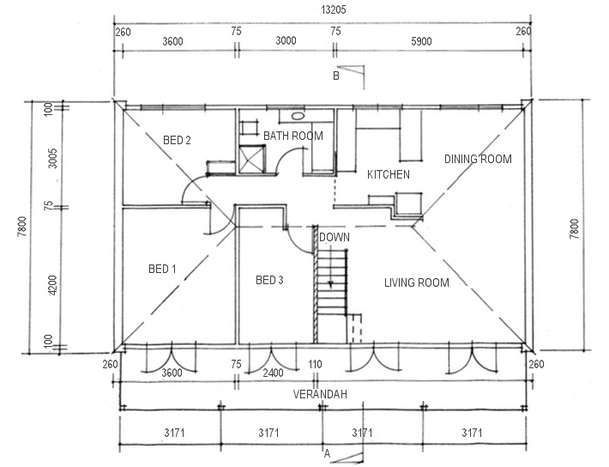

Proportional sketches
Choose a room that is suitable for measuring up and drawing as a proportional sketch. It could be the room you’re in right now. Get a tape measure, pencil, eraser, and ruler.
Follow the steps described in the Learner Guide to draw a proportional sketch of the room. You may either use the grid below or a separate sheet of graph paper or plain paper.
Show the finished sketch to your trainer. If you’re undertaking this unit with other learners compare your sketches and see if there are any discrepancies.

Scale drawings
Take the proportional sketch that you produced for the last Learning activity and re-draw it as a scale drawing. You may either use the grid below or a separate sheet of graph paper or plain paper.
Show the finished drawing to your trainer. If you’re in a group, compare your drawing to the other learners in your group and look for any discrepancies or mistakes. Make any corrections necessary.

Using triangulation
Find a room with walls that meet at unusual angles, or features that change the shape and angles of the floor surface. Measure up the area and record the details on a proportional sketch.
Then produce a scale drawing using the triangulation method described in the Learner Guide. You may either use the space below or a separate sheet of plain paper.

Measuring curves
Find a floor area with a curved detail. Make a proportional sketch of the curve using the technique described in the Learner Guide. You may either use the grid below or a separate sheet of graph paper or plain paper.

Section 3: Estimating quantities

Planning joins and seams
The drawing below shows a floor covering plan for an 'L' shaped room.
The seam is marked with a dotted line. The direction of each run is shown with a green arrow. You will be using a 300 cm wide roll of vinyl.
How many lineal metres of sheeting are required for this job? Show all calculations in the space provided below.
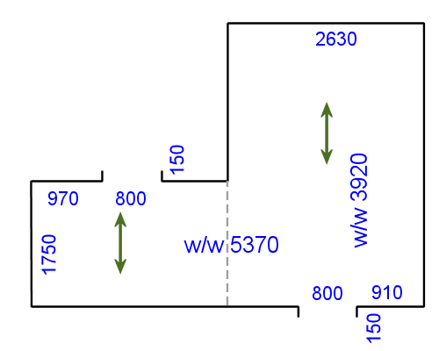

Patterned sheet flooring
The drawing below shows a floor covering plan of the same room used in the sample calculation in the Learner Guide. This time the seam is running lengthwise.
Calculate the lineal metreage of floor covering required.
Show all your workings.
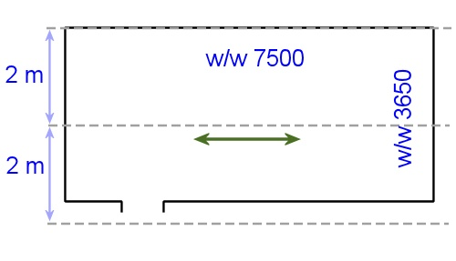

Allowing for angles
Calculate the lineal metreage of sheet flooring required for the floor shown below. You will be using a roll of 300 cm wide vinyl sheeting with an ‘all-over’ pattern (that is, no pattern repeats). Show all your workings.
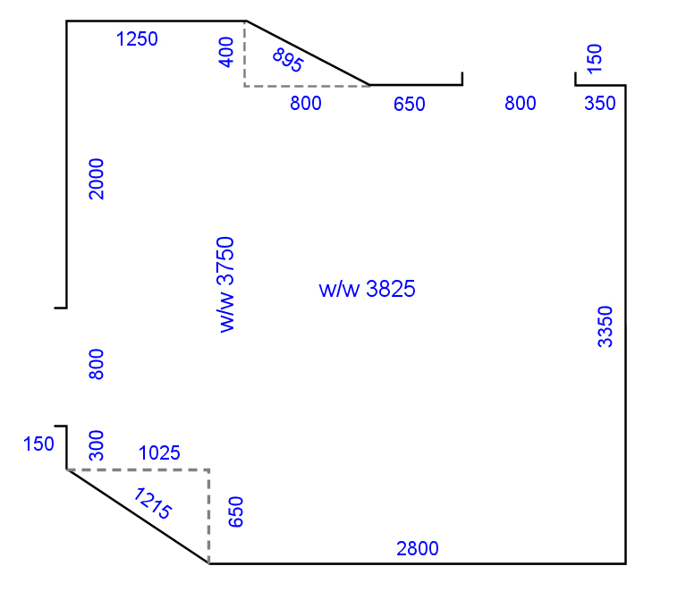

Vinyl tiles
In the Learner Guide, we worked out the finished size of the border tiles on two sides of the room shown below.
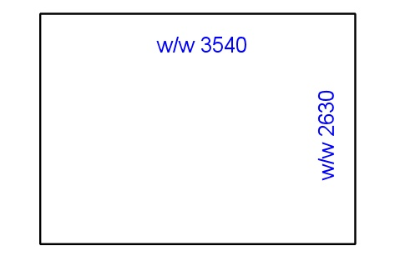

- What will the finished size of the border tiles be at the two ends of the room if they are balanced as well?
- How many field tiles will there be in between?

Stairs
Find a suitable flight of stairs that you can measure up. Note that there are many different designs, so try to pick a simple flight for this exercise.
Measure the important components and calculate the total length required to cover the stairs. Also note the width of the treads. Sketch the stairs below and mark in all measurements. Also show all calculations.

Primers and adhesives
Calculate the amount of primer you’ll need to coat the floor area shown below.
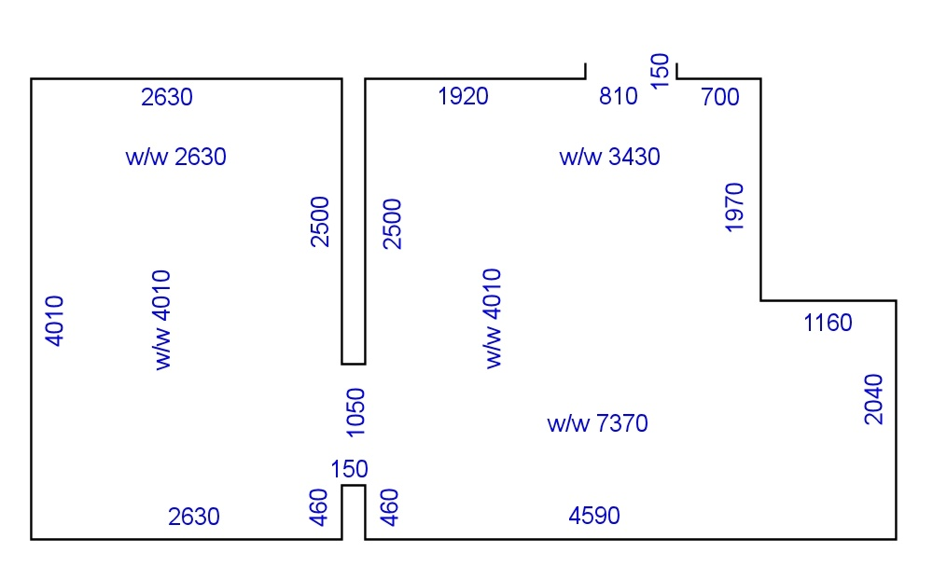
The coverage rate of the primer is 9-11 m²/L, and because the surface is porous you have decided to use the 9 m²/L rate.

Levelling compounds
You are going to put a levelling compound on the floor below. The compound has a coverage rate of 12 m² at 1 mm thick per bag.
How many bags will you need?

Section 4: Estimating costs

Material costs
You have completed a site assessment and measure-up for a flooring installation at Sunnyvale. The materials required to complete the job are shown below.
Work out the total cost of materials, setting out your calculations in the table.
For the purposes of this exercise, we’ll say that all prices exclude GST.
Product | Price (exc. GST) | Quantity | Amount
Vinyl planks ‘Beech’ finish | $35 per m² | 9 boxes  (2.5 m² per box)
Ardit K15 smoothing compound | $67.55 per 20 kg bag | 3 bags
Anchor-weld UF1 adhesive | $57.40 per 15 L drum | 1 drum
Consumables | allowance |  | $20.00
Total cost

Labour costs
In the previous learning activity you calculated the cost of materials for a job at Sunnyvale. Now we’ll say you have estimated that the labour component will be as follows:
Your team comprises two people, who will work together for the whole job. Their rates of pay are:
Supervisor: $31.80 per hour
Apprentice: $12.70 per hour
Work out the total labour cost for this project, using the table below.

Task | Time | Amount
Deliver and unload materials | 2 hours
Pull up old floor  (and place in skip bin outside jobsite) | 3 hours
Prepare subfloor | 3 hours
Install vinyl planks | 6 hours
Downtime allowance | add 10% to total time
Total cost

Overheads
Let’s say your installation business uses an overhead allowance of 30% on the cost of materials and labour. How much will you allow for overheads in your Sunnyvale project costings?
Component | Costs
Material costs
Labour costs
Sub-total
Overheads (+ 30% of sub-total)
Total costs

Profit mark-up and GST
Now you can finish off the calculations for the Sunnyvale project. If your company has a profit mark-up of 40%, what will the final cost be for this installation job?
Write up the complete summary of costs, showing all categories, as well as the final quotation price. Don't forget to add GST before you calculate the quotation price.

Using contract rates
In the Learner Guide we worked out the quotation price for an installation using contract rates. Let’s say you have agreed to a rate increase with the contractor, and the new rates are:
Lay and weld sheet vinyl: $8.50 per m²
Install skim coat underlayment: $6.50 per m²
All other costs remain the same as in the worked example.
What will the total quotation price be now?

Part 2

Assignments

Assignment 1

Name |  | Date
- List the steps involved in turning a customer enquiry into an approval to go ahead with an installation. Start with the initial enquiry from the client and work through to the point where the client signs the contract.
(Insert as many steps as required.)

- Prepare a formal quotation document for the client shown below. Make sure you include all required elements in the quotation (as itemised in the lesson: ‘Writing up the quotation’).
You can make up any details that are not specifically noted below. You may also make up your own company name and design a letterhead if you wish.
Use a computer to develop a professionally laid out document, and submit it to your assessor either in a hard copy or as an electronic file.
Client: Mr and Mrs Hoyle
Address: 15 Greenside Court, Swan Hill Vic 3585
Quotation price: $2840 + GST $284 = $3124
Description: Supply and installation of 8 mm thick cork tiles, coated
with semi-gloss finish. Subfloor preparation.

Assignment 2
Your trainer will ask you to develop three separate floor covering plans for three different flooring installation projects.
Each floor covering plan will include:
- A scale drawing of the area, showing all required measurements, positioning of seams and joins, and the direction of the pile (where relevant)
- Subfloor preparations required
- Descriptions of the floor covering and underlay to be used
- Descriptions of accessories and other information needed to complete the installation.
You may be asked to measure up actual floor areas or work from building plans, or a combination of both.
Use separate pages for this assignment or create electronic documents on a computer.

Assignment 3
Your trainer will ask you to calculate the material quantities for the three separate flooring installation projects from Assignment 2.
You will need to provide quantity estimates for the following items, using an appropriate unit of measure for the purposes of ordering the items from a supplier:
- Floor covering materials
- Underlay (where required)
- Adhesive, primer, accessories and any other materials specified for the projects
Use separate pages for this assignment or create electronic documents on a computer.

Assignment 4
Your trainer will ask you to complete the calculations for the three installation projects introduced in the previous Assignment and write up formal quotations. You will have already developed a floor covering plan and calculated the material quantities for these projects.
Complete the following calculations for each project. Your trainer will provide you with wage rates, unit prices, time allocations and other information needed to carry out the calculations.
Calculations:
- material costs (based the quantity estimates from Assignment 3)
- labour costs
- overhead costs
- profit mark-up
- GST
- total quotation price.
Once you have finished the calculations, you are to write up a formal quotation for the proposed project. You may make up a company name and design your own letterhead.
Use a computer to develop professional-looking documents, and submit them to your assessor either in hard copy or as electronic files.

