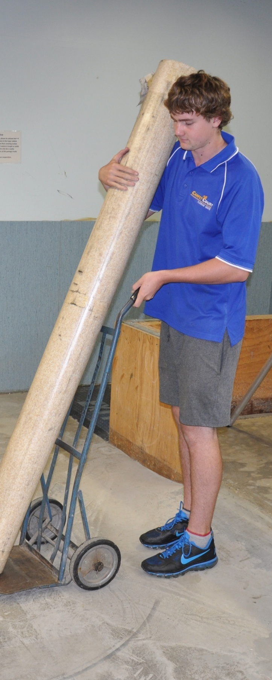
Preparing floor
coverings
DRAFT VERSION
October 11
Learner guide

Supporting:
LMFFL2002A: Receive and prepare floor covering materials for installation

Developed in 2012-2013 for the WELL Program

Preparing floor coverings
Learner guide

This unit is also available in an e-learning format, which contains additional photos, interactive exercises and a voice-over narration of the text. It can be viewed on CD-ROM, or live on the web at:
www.flooringtech.com.au

Developed by Workspace Training for the 2012-2013
Workplace English Language and Literacy (WELL) Program
Flooring Technology resource development project

Copyright and disclaimer
ISBN: 978-1-925087-00-0
Funded under the Workplace English Language and Literacy Program by the Australian Government through the Department of Industry, Innovation, Climate Change, Science, Research and Tertiary Education
© Commonwealth of Australia 2013
CC BY-NC-SA
This work is copyright. Except where otherwise indicated, and save for the Commonwealth Coat of Arms, the Department has applied the Creative Commons Attribution-Noncommercial-Share Alike 3.0 Australia Licence to this work.
The Department of Industry, Innovation, Climate Change, Science, Research and Tertiary Education must be attributed as the author of the Department’s copyright material.
As far as practicable, material for which the copyright is owned by a third party has been clearly labelled. The Department has made all reasonable efforts to ensure that this material has been reproduced in the print-based resources and accompanying website with the full consent of the copyright owners.
Requests and enquiries concerning the Department’s copyright material should be addressed to:
The Legal Branch
Department of Industry, Innovation, Climate Change, Science, Research and Tertiary Education
GPO Box 9839 Canberra ACT 2601
Email: legalservices@innovation.gov.au
Questions about the design and content of the resource itself should be addressed to the project manager:
David McElvenny
Workspace Training
PO Box 1954 Strawberry Hills, NSW, 2012
Email: david@workspacetraining.com.au

Disclaimer
The content of this Learner guide is provided for educational purposes only. No claim is made as to the accuracy or authenticity of the content. The views expressed in this publication do not necessarily represent the view of the Minister for Tertiary Education, Skills, Science and Research or the Australian Government. The Australian Government does not give any warranty nor accept any liability in relation to the contents of this work.

About this resource
This Learner guide is part of a suite of resources developed for the Flooring Technology project, funded by the WELL Program. The resources support 19 competencies from the Certificate III in Flooring Technology (LMF31208). The project comprises a website and an accompanying set of Learner guides and work books.
The individual competencies are grouped into ‘Learning units’ as shown below. Each one is given a title describing the main theme of that set of integrated competencies.

Learning unit title Competencies covered
Safety at work MSAPMOHS200A: Work safely
LMFFL3002A: Establish and maintain a safe flooring technology work environment
Inspecting and testing subfloors LMFFL2004A: Moisture test timber and concrete floors
LMFFL3101A: Inspect sub-floors
Planning and costing LMFFL3001A: Plan and cost flooring technology work
Subfloor coatings and toppings LMFFL2102A: Prepare, select and apply smoothing and patching compounds
LMFFL2103A: Select and apply appropriate compounds and additives
LMFFL2105A: Select, prepare and apply moisture barriers and damp proof membranes to concrete sub-floors
Concrete grinding LMFFL2107A: Select, operate and maintain grinding equipment
Preparing floor coverings LMFFL2002A: Receive and prepare floor covering materials for installation
Lay flat vinyl LMFFL2301A: Install lay flat vinyl floor coverings
Resilient tiles LMFFL2302A: Install resilient tiles using standard installation practices
Commercial vinyl LMFFL3302A: Install commercial vinyl floor coverings
LMFFL3303A: Install resilient floor coverings using custom designs and decorative finishes
Linoleum LMFFL3301A: Install linoleum floor coverings
ESD floors LMFFL3308A: Install anti-static resilient floor coverings
LMFFL3309A: Install conductive resilient floor coverings
Making measurements MSAPMOPS101A: Make measurements
Working sustainably MSAENV272B: Participate in environmentally sustainable work practices
The purpose of these resources is to help trainee floor layers acquire the background knowledge needed to satisfy the theoretical components of the competencies covered in this project. However, the resources are not designed to replace the practical training necessary to develop the hands-on skills required. Learners will still need to receive extensive on-the-job training and supervision before they will be ready to be formally assessed in the relevant competencies.

E-learning version
All of the content material contained in this Learner guide is also available in an e-learning format, which has additional photos, interactive exercises and a voice-over narration of the text. The e-learning version can be viewed on the web at: www.flooringtech.com.au
The web version can also be purchased on a CD at a cost-recovery price from the project developer:
Workspace Training
PO Box 1954 Strawberry Hills, NSW, 2012
Email: david@workspacetraining.com.au

Acknowledgements

Project team
Project manager: David McElvenny
Instructional designer: Kath Ware
Technical developer (website): Jim Vaughan
Assistant technical developer (and voice-over artist): Alex Vaughan
Quality assurance consultant: Giselle Mawer
Industry coordinator: Gary Dunshea (MSA Industry Skills Council)

Technical Advisory Group

Lead advisors
William Tree – South West Sydney Institute of TAFE
Mark Willis – Council of Textile and Fashion Industries of Australia
Craig Bennett – Hunter Institute of TAFE

Reviewers
Ian Ciesla – Polytechnic West
Robert Cole – Furnishing Industry Association of Australia
Steven Dalton – Marleston TAFE
Shane Eales – SkillsTech Australia
David Hayward – Australian Timber Flooring Association
Bruce Ottens – Holmesglen TAFE
Chris Shaw – Skills Institute Tasmania
Warren West – Australian Resilient Floor Covering Association

Industry advisors
Peter Brack – Forbo Flooring Systems
Don Considine – IKW Consulting Group
Gary Eggers – Tarkett Flooring
Jim Hilston – Hilston Floors
Lionel Jacobs – Epoxy Solutions
Owen Jordian – Choices Flooring
Steven King – Armstrong Floors
Jarka Kluth – Pro Grind Australia
Haydn Reynolds – Floorex Products
Naomi Archer – All Preparation Equipment

Photographs
Most of the photos in this suite of resource were taken by David McElvenny. Additional photos were provided by:
David Beeforth (ParexDavco)
Don Considine (IKW Consulting Group)
Craig Bennett (Hunter TAFE)
David Hayward (Australian Timber Flooring Association)
Gary Eggers (Tarkett)
Lionel Jacobs (Epoxy Solutions)
Jarka Kluth (Pro Grind Australia)
Haydn Reynolds (Floorex Products)
Naomi Archer (All Preparation Equipment)
We would like to thank the following organisations for allowing us to take on-site photos of their employees at work or students in class.
Choices Flooring – Sandgate, Bulleen, Thomastown and Mornington
Lidcombe College of TAFE
Lomac Commercial Flooring
Tarkett
Epoxy Solutions

Graphics
Graphics were drawn by Kath Ware. Many of these graphics are based on line drawings or photographs from installation manuals published by the following flooring manufacturers:
Armstrong: http://www.armstrong.com/flooring/guaranteed-installation-systems.html
Forbo: http://www.forbo-flooring.com.au/Commercial-flooring/Support-installation-and-maintenance/Installation/Installation-technique/
Tarkett: http://professionals.tarkett.com.au/commdocu?field_docu_type_value=
Installation+guide

Financial contributions
This resource was funded by the Workplace English Language and Literacy Program by the Australian Government through the Department of Industry, Innovation, Climate Change, Science, Research and Tertiary Education. Additional financial assistance was provided by Manufacturing Skills Australia (Industry Skills Council).

Table of contents
Introduction 1
Documentation 3
Materials and equipment 5
General health and safety 7
Looking after your body 9
On-site storage and handling 13
Conditioning 15
Assignment 17
Practical demonstrations 18

Introduction
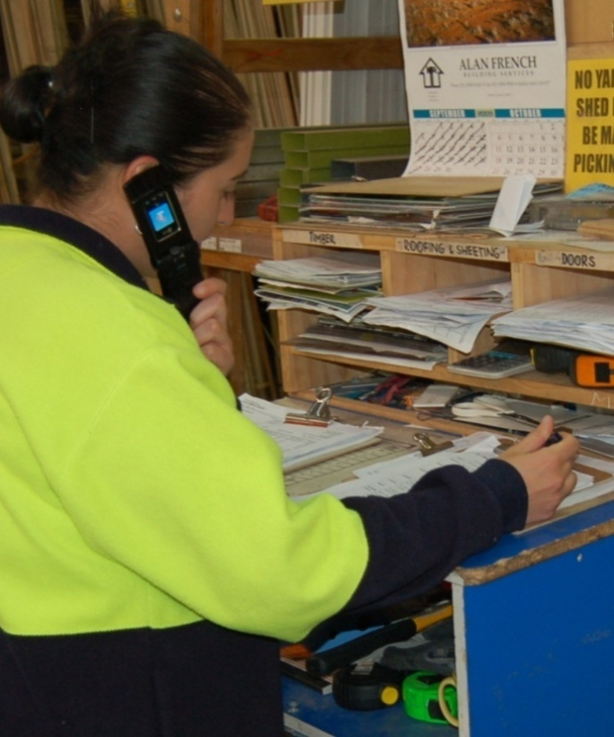
You may have heard the saying: Prior Preparation Prevents Poor Performance.
Professional flooring installers know that careful planning and preparation help to make a job run like clockwork. This lets you work efficiently, finish on time, and keep everyone happy.
Every installation job actually starts back at the warehouse, where you think through the requirements of the job and get everything organised for the on-site work.
These preparations include assembling the correct materials and equipment, and cross-checking all the details.
In this unit, we’ll look at the main warehouse preparations. We’ll also follow through to the on-site tasks of unloading, handling and storing the materials. In particular, we’ll discuss the important task of acclimatising the floor coverings to the surrounding conditions, so they’re ready for installation.

Completing this unit
There are six lessons in this unit:
- Documentation
- Materials and equipment
- General health and safety
- Looking after your body
- On-site storage and handling
- Conditioning.
These lessons will provide you with background information relevant to the assignment and the practical demonstration requirements.

Assignment
Your trainer may ask you to submit the assignment as part of your assessment evidence for the unit. You will find a hard-copy template in the separate workbook.
An electronic ‘Word’ template of the assignment is available on the website for this resource, at: www.flooringtech.com.au

Learning activities
Each of the lessons has a learning activity at the end. The Workbook for this unit contains all of the learning activities together with spaces for written answers.
Again, you will find all of the learning activities on the website version of this resource.

Practical demonstrations
Your final assessment of competency will include various practical demonstrations. Their purpose is to assess your ability to install linoleum floor coverings. To help you get ready for these hands-on assessment activities, see the sample checklist shown in the Practical demonstrations section at the back of this Learner guide.

Documentation
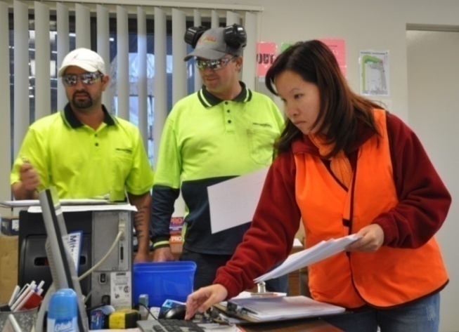
The first step in getting organised for an installation is to pick up the paperwork.
Most companies use a job sheet to list the project details, and a floor covering plan to show the on-site information needed to carry out the installation.
Let’s look at each of these documents more closely.

Job sheet
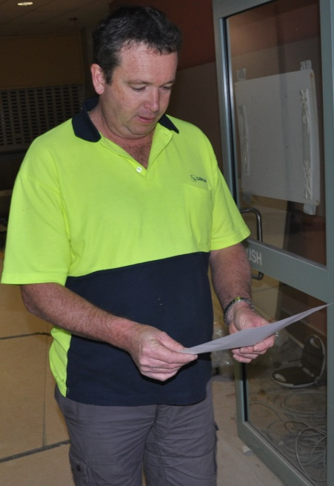
The job sheet should include the following information:
- jobsite address and contact details of the person in charge
- brand names and descriptions of the floor coverings to be laid
- details of other products to be used, including underlay, adhesive and trims
- seam placement and other installation details
- subfloor preparation required
- furniture and appliances to be moved
- unusual site conditions or potential problems.
Some of this information is likely to overlap with the floor covering plan, but there are also particulars relating to the specific products used and arrangements that have been made with the client.

Floor covering plan
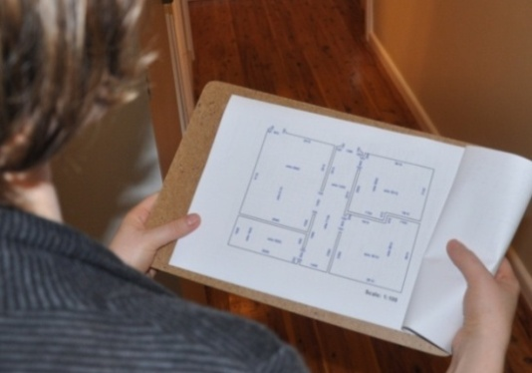
The floor covering plan sets out the details relating to how the flooring will be installed.
Australian Standard 1884 says that the client should be shown a floor covering plan before the installation takes place. This allows them to confirm that they’re happy with it or ask for specific changes to be made before it’s too late.
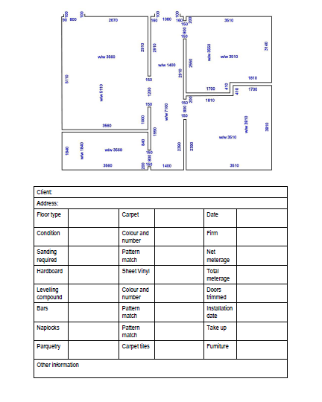
The floor covering plan consists of a proportional sketch or scale drawing of the floor area, together with the following information:
- specifications of the covering and underlay to be installed
- positioning of seams and joins
- direction of the pile, if carpet is being laid
- types of accessories to be used
- subfloor preparations required
- any special features of the job.
For more details about these documents, see:
‘Floor covering plans’ in the unit: Planning and costing.

Learning activity
What sorts of documents do you take with you to the jobsite?
Name each document and list its purpose.

Materials and equipment
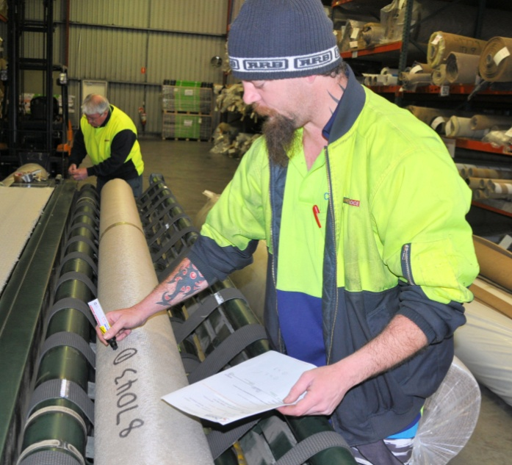
It’s important to carefully check the items listed on the job sheet against the actual materials and accessories you’re putting together for the job.
This includes correctly matching up brand names, colours, quantities, and batch numbers, where appropriate.
While you’re selecting the goods, you should also look at the quality of each item and make sure there’s no damage or blemishes that could cause problems out at the jobsite.
It’s much easier to solve these sorts of issues while you’re still at the warehouse!

Organising tools
Selecting the right tools and equipment for the job takes some thinking ahead. Use the job sheet as a guide and mentally go through the installation process while you’re getting the gear ready.
Some installers make up a list of tools on a piece of plywood or particleboard so they can use it as a permanent checklist. If you put a piece of masking tape down one side, you can tick off each item as you pack it. When you return, you can tear off the masking tape and replace it with a new piece, ready for the next job.

Tagged power tools
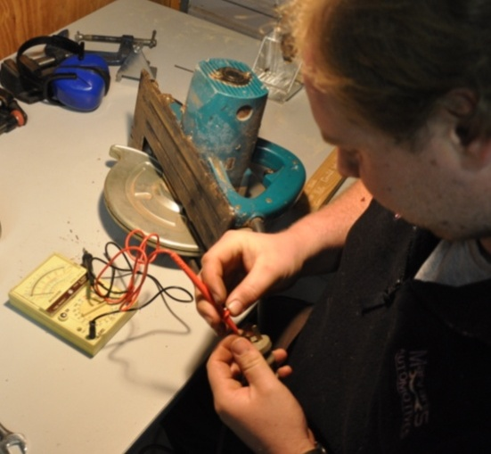
Don’t forget that all power tools used on building sites need to be tested and tagged every three months by an authorised person.
The test is designed to ensure that the tools are safe and not likely to cause a fire or electric shock.
Once a piece of equipment has been tested and passed, the authorised person attaches a tag to it, stating their name or company they work for and the test date.
If a power tool is faulty, or the tag is out of date, make sure you take it to the person responsible for getting it fixed.

Learning activity
The only way you can be sure that your tools will work properly on-site and not let you down is to check them before you leave. Some tools need more maintenance than others.
Some also have parts that are designed to be replaced when they wear out or go blunt. This means that you need to keep spare parts with you at all times, so you can quickly change them over while you’re working.
Name two tools that require replacement parts to be carried with them. Also name the parts that you need to keep on hand.

General health and safety
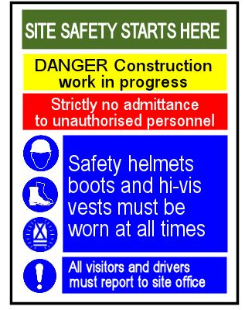
There are lots of on-site safety requirements that you need to think about before you set off for the jobsite.
Large commercial projects have more safety requirements than small domestic jobs, particularly if they involve multi-storey construction.
For example, you may have to wear a hard hat and high visibility clothing just to enter the site. You might also have to present a range of documents to the site manager before you can start work.
But even in someone’s home, you still need to wear appropriate PPE and follow safe work practices.
The main differences are that you’re not being monitored by a site safety officer and you don’t have to worry as much about other workers in the area.
Below are the sorts of questions you should ask yourself when you're getting ready for a jobsite. The size of the project will be a factor in how you answer the questions.

Questions to ask yourself
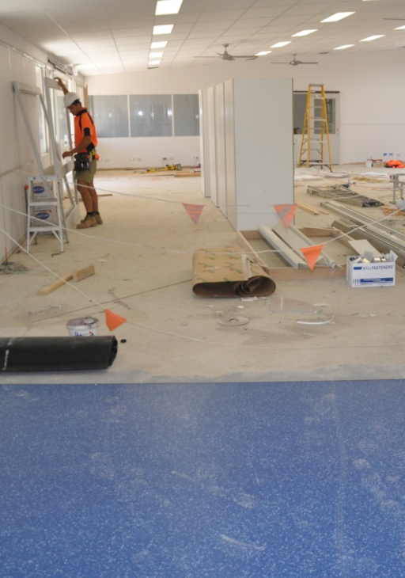
- Will I need to take any signage to indicate where the team is while we're working?
- Have all team members been inducted and received authorisation to come on-site?
- Do all team members have a White Card?
- Have the necessary documents been completed and signed off, such as the Safe Work Method Statement (SWMS) and any relevant Safe Operating Procedures (SOPs)?
- Are there Material Safety Data Sheets (MSDSs) on hand for all chemicals and hazardous substances being taken to the site?
- Have all electrical tools been tested and tagged?
- Will there be a first aid kit on-site, or am I responsible for taking one myself?
- Will there be a fire extinguisher on-site, or should I take one myself?
- Does there need to be a qualified first-aider on-site at all times?

Learning activity
We talked about the different types of safety documentation in the unit: Safety at work. Can you remember what their purpose is?
Briefly describe what each of the following documents is designed for:
- White Card
- Safe Operating Procedure (SOP)
- Safe Work Method Statement (SWMS)
- Material Safety Data Sheet (MSDS).

Looking after your body
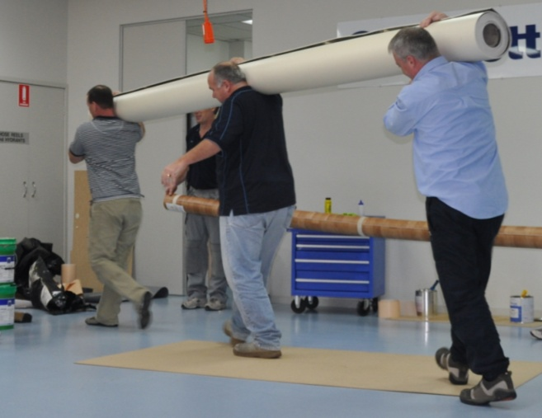
Moving rolls of flooring and other heavy objects around can be back breaking work if you don’t do it properly.
It can also cause other injuries, such as muscle or joint strains in your legs, shoulders and arms.
Below are some hints on how to avoid manual handling injuries while you’re moving heavy items around the jobsite.

Mechanical aids
Fortunately, there are various mechanical devices suitable for use on the job. Although they have names like ‘carpet cart’ and ‘linoleum dolly’, you can use them to carry any similar item, of course – they’re not just designed for that product.

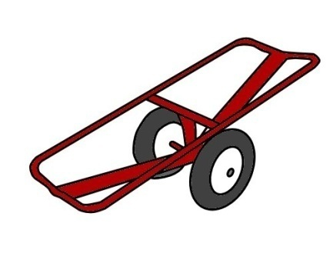
Carpet cart
Carpet carts come in different shapes and sizes. They generally have large pneumatic tyres so you can easily roll them across gravel driveways and over curbs.

Linoleum dolly
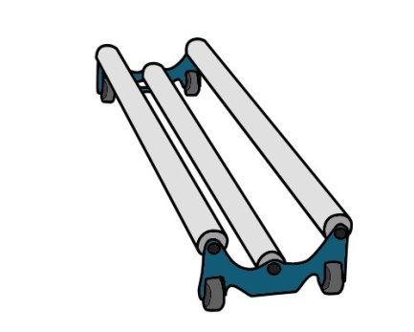
These dollies are designed for rolling out sheet vinyl and linoleum products on a floor. The rollers run on ball bearings so that the flooring can turn while the sheet is being pulled out.

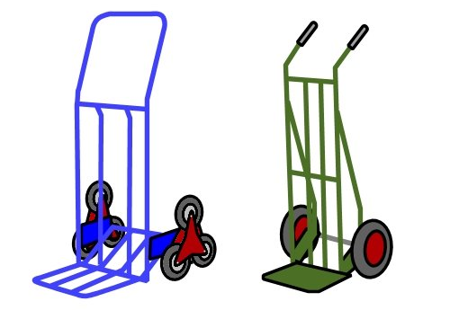
Hand truck
Hand trucks are sometimes called hand ‘trolleys’. When they have a cluster of wheels on each side they are called ‘stair walkers’ or ‘stair climbers’.

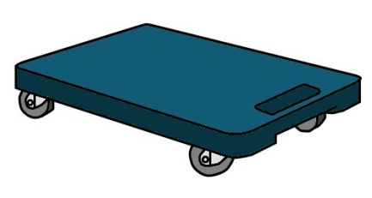
Tile dolly
A tile dolly is basically a platform with wheels underneath. It can be used to hold boxes of tiles or other heavy items that need to be pushed around
the floor.

Loading crane
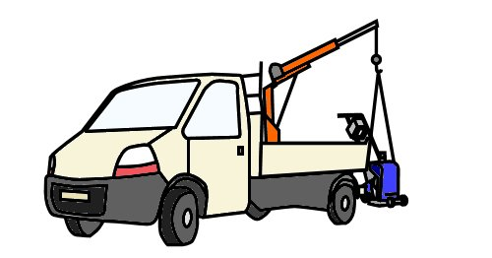
Vehicle mounted loading cranes are handy when you have to take large machines to the jobsite on the back of your truck.
It’s important to use the machine’s built-in lifting hooks in order to maintain its balance and avoid any damage.

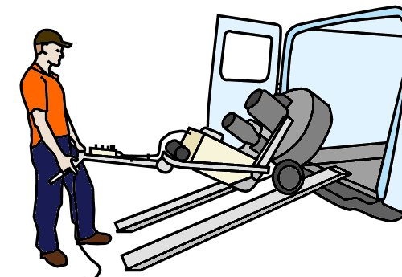
Ramps
Another way to load and unload heavy machines is to use ramps.
Grinding and polishing contractors generally have a winch inside their vehicle, which is used to pull the equipment up the ramps while they balance the machine from behind.

Carrying items by hand
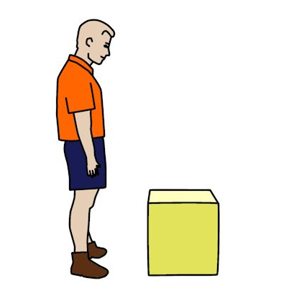
Even with the aid of mechanical devices, you still need to use good manual handling practices while you’re lifting materials into position.
There are also many times when the only practical way to take items to the installation area is to physically carry them.
Below are some hints on carrying items by hand.

Heavy or awkward loads
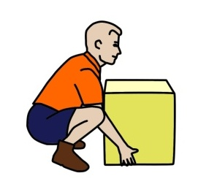
To lift and carry an awkward or heavy object:
- Size up the load and decide whether you’ll need help.
- Check the path you’ll be taking to make sure there are no obstacles in the way.
- Place your feet firmly on the ground and put your body in a balanced position.
- Bend your knees to get down to the load, and keep your back as straight as possible.
- Use your legs to do the lifting as you stand up straight.
- Keep the load close to your body while you’re carrying it.
To put the object down again, use the same procedure as for picking it up – keep your body well balanced and use your legs, not your back.
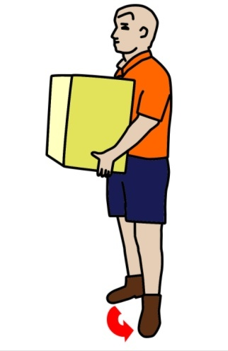
Also remember that while your joints and muscles are under strain, you should avoid twisting your back.
If you need to change direction while you’re picking up, carrying or putting down a load, swivel on your feet so that your whole body moves in the same direction.

Rolls of floor coverings
When you’re lifting and carrying a roll of carpet or resilient flooring, the basic principles are the same – keep your back as straight as possible and your body in a balanced position.
However, this time you should support the middle of the roll on your shoulder.
If the roll is long or heavy, or if you need to manoeuvre it around awkward hallways or up stairs, it’s best to get an offsider to help.
But remember, if you’re lifting and carrying carpet with an offsider, good communication is vitally important. You both need to work in unison and know exactly what the other person is about to do.

Carrying a roll with two people
Here are some hints on how to carry a long roll with another person.
1. Check that your offsider doesn’t have any back or muscle injuries that might affect the work you’re about to do.
2. Talk through the process. State which side you are going to stand on, what path you’ll take, where you’re going to put it, and how you’ll deal with any obstacles or corners on the way.
3. Lift the roll together. You might even want to lift on the count of three: ‘1, 2, 3, lift.’
4. When you get to the destination, count: ‘1, 2, 3, drop’, and both tilt your shoulders at the same time to let the roll drop to the floor.
5. If at any time you’re not comfortable or the roll is too heavy, call out ‘Stop’ and do the ‘1, 2, 3, drop’ procedure together. Don’t let go of your end unexpectedly, because it could jar the other person.

Learning activity
Some installers like to do stretching exercises before they start any heavy work, particularly if they haven’t warmed up yet or they’re nursing an old injury.
There are lots stretches and warm up exercises you could do. If you are a swimmer or play sport on weekends you may already be doing these sorts of activities.
See if you can think of a couple of examples suitable for a floor layer about to unload and carry heavy rolls of flooring into the installation area. Describe the exercises and the benefit they would give you.

On-site storage and handling
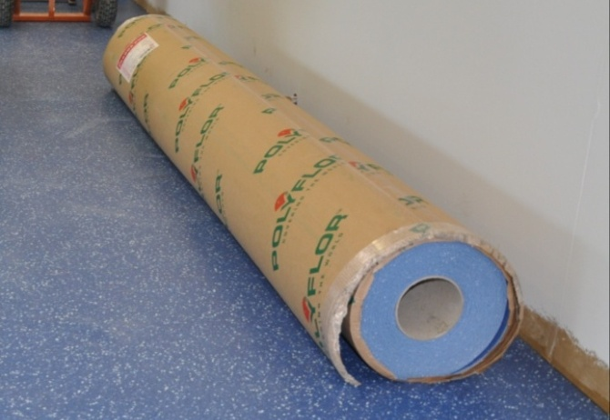
When the materials are delivered to site, it’s important that they’re put in a safe place so they won’t get damaged.
They should also be stored under conditions that will let them acclimatise to the temperature and humidity of the room they’re going to be installed in. We’ll talk more about ‘acclimatisation’ in the next lesson.
Rolls that are 3 metres wide or more need to be laid down flat on a smooth level surface that supports the entire length of the roll. Make sure there are no objects under the roll that might damage the material or cause pressure marks.
Rolls that are 2 metres wide or less should be stood on end and secured so they won’t fall over. Check that the labels are turned forward so you can read the pattern numbers and dye lots easily.
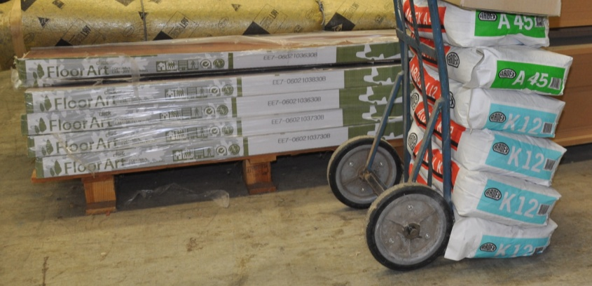
Cartons of tiles should also be handled carefully. Use a trolley to move them around the floor.
Only stack them as high as recommended by the manufacturer, and stack the boxes squarely one on top of another.
This will help to protect the edges of the tiles underneath from damage or curling. Like rolls, tiles should be stored on a flat, level surface – otherwise they can distort and end up with a permanent change in their shape.

Opening a roll
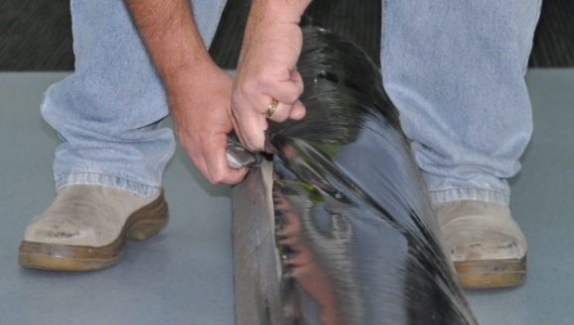
To open a roll, insert a hook knife through the paper packing between the first lap of material and the next layer.
The hook knife will avoid damage to the surface of the material.

Clean the area thoroughly where you plan to roll out the sheet. Even a small stone or metal shaving can embed into the material.

Estimating the length of a roll
If you’re handling an unopened roll of flooring, the length should be printed on a tag on the packaging. But if the packaging has been removed, or you’re using an opened roll, there may not be an indication of the length marked on it.
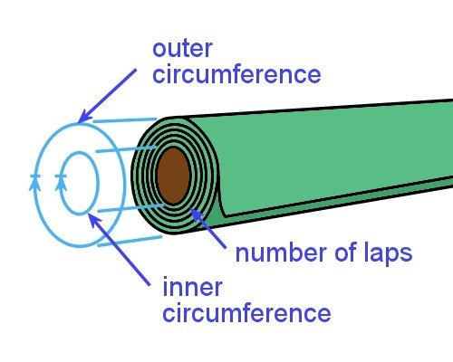
Here a little trick for estimating the length of a roll without having to lay out the flooring:
- Measure the outer circumference and the inner circumference of the roll.
- Add the two measurements together.
- Divide by 2.
- Multiply the answer by the number of laps in the roll.
The circumference of a circle is the distance around the outside. To measure it, you can simply wrap your tape measure around it.
Let’s take an example, to see how this formula works:
If the outer circumference of a roll of sheet vinyl is 750 mm, the inner circumference is 350 mm and there are 65 laps, how long is the sheet?
750 + 350 = 1100
1100 ÷ 2 = 550
550 x 65 laps = 35.75 metres
Note that we’ve converted the answer from millimetres to metres. If you’ve forgotten how to do this with the decimal point, go to the unit Making measurements and revise the lesson: ‘The metric system’.

Learning activity
Try out the estimation rule of thumb for yourself.
Find a roll of sheet material and carry out the calculation. Then unroll the material and take an actual measurement of the length.
How close was your estimate?

Conditioning
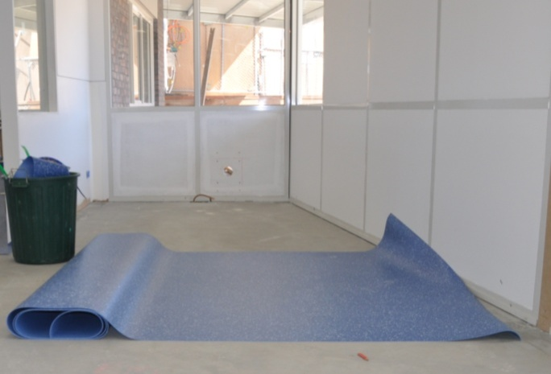
Before you begin an installation, you need to let the floor covering condition – or ‘acclimatise’ – to the surrounding temperature and humidity in the room.
AS 1884-2012 says that the conditioning process should take place for at least 24 hours, or until the product has achieved an ‘ambient room temperature’ range of between 15° and 28° C.
If the room temperature is below 15°, you should use a heater, blower or air conditioner to raise the temperature. In these circumstances the temperature must be kept under control for the duration of the installation, plus another 48 hours after it’s finished.
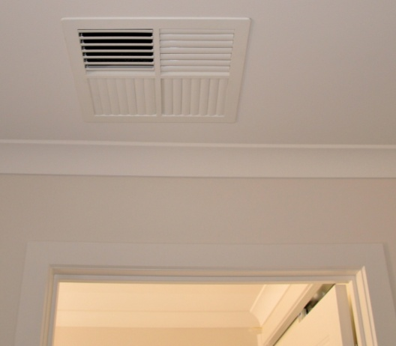
Note that air conditioners tend to lower the air humidity, which is why AS 1884 says that conditioning units must be set to their expected operating temperature and run continuously for at least 7 days before the underlay or floor coverings are laid on the subfloor.
Again, the air conditioner should be left on throughout the installation process and for another 48 hours after that.
Keep in mind, too, that if the room temperature is less than 15°, the subfloor itself could be below 10°.
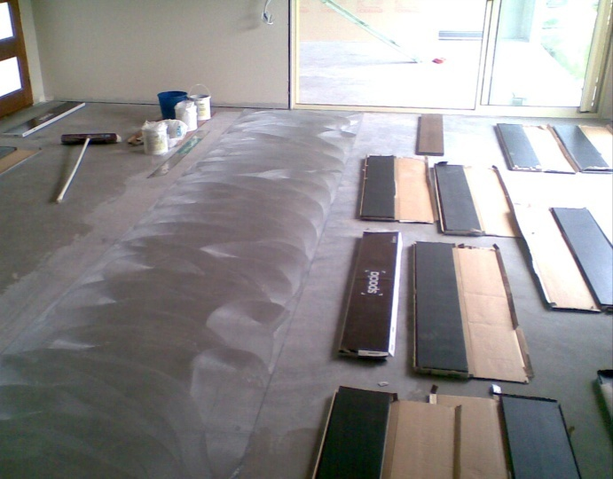
This may have an effect on the adhesive’s performance and curing time, so you should always check the manufacturer’s installation guide to see whether there are special instructions that apply.
To let tiles or planks condition, take them out the box and spread them on the floor. This will allow the air to get to all of the pieces.

Heated floors
Some floors have heating elements in or under the subfloor. You have to be careful with these floors and use the right type of covering, adhesive and installation process. The product manufacturers will list the requirements in their specifications.
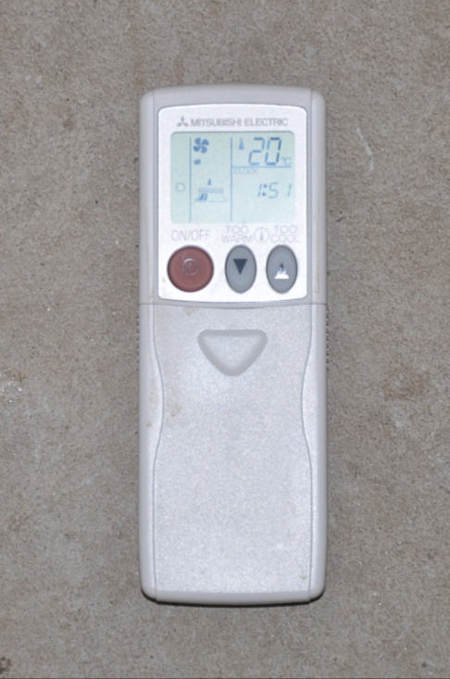
Heating units must be turned on at least 7 days in advance, and then turned off 48 hours before you begin the installation.
This is designed to give the subfloor time to return to the recommended temperature range for the installation.
When the installation is finished, you should leave the heating units off for another 48 hours while the adhesive sets, and then only turn it up at 2° increments per day until it reaches a maximum temperature of 28° C.
You should also avoid reaching this maximum temperature until at least 7 days have elapsed.

Learning activity
The link below will take you to a clip produced by Forbo Flooring called ‘Forbo general jobsite conditions video’.
http://www.youtube.com/watch?v=o89QR8fYno4
Watch the clip and answer the following questions:
- How long does Forbo recommend that the HVAC (heating, ventilation, air conditioning) system be left running – both before and after the floor covering is laid?
- In the sequence of trades undertaking work on the jobsite, where should floor laying be?

Assignment
Go to the Workbook for this unit to write your answers to the questions shown below. If you prefer to answer the questions electronically, go to the website version and download the Word document template for this assignment.
___________________________________________________________________________
Select two job sheets for separate installation projects. They should represent different types of floor covering material and different job types – such as one domestic and one commercial job.
Your trainer may ask you to use job sheets from installations you have carried out at work, or may give you job sheets specifically for this assignment.
Alternatively, your trainer might decide to integrate the assessment for this unit with two practical installation assessments. In this case, the job sheets you use will relate to the actual floor laying tasks you are about to demonstrate.
For each project, answer the following questions.
- Describe the installation project and state the type of floor covering used.
- What is the process for checking that the materials you are loading up in the warehouse are correct in terms of product type, quantity, etc? What would you do if any of the materials were incorrect, or if there was any damage that might cause problems on-site?
- What is the most efficient method for unloading the materials from your vehicle and taking them to the installation area? For example, will you need mechanical aids or an offsider?
- What sorts of damage do you need to protect the materials from on this type of jobsite? Name two possible types of damage and the methods you would use to ensure it doesn’t occur.
- What are the acclimatisation instructions for the floor covering? List the instructions specified by the manufacturer that are relevant to this jobsite.

Practical demonstrations
Your trainer may ask you to keep a log book or diary of the work you do on-the-job that relates to the practical components of this unit. This will help them to determine when you will have had sufficient hands-on practice in these tasks to undertake the assessment events.
It is likely that the practical components of this unit will be assessed while you are undertaking practical demonstration assessments for units of competency relating to laying floors. This will allow your assessor to carry out an integrated assessment of both units at the same time.
While you are demonstrating the hands-on aspects of these tasks, your assessor will be checking that you can:
- follow all work, health and safety requirements and environmental care procedures
- correctly interpret and complete company documents and work instructions
- prepare and package floor coverings correctly
- transport the floor coverings, unload them safety and store them in an appropriate area on-site
- acclimatise the floor coverings according to the manufacturer’s guidelines
- communicate and work effectively with other workers in the area
- prevent damage to goods, equipment and products
- work productively and in an efficient sequence with other trades
- modify activities and techniques used to suit different sites and working conditions.
Make sure you talk to your trainer or supervisor about any of the details you don’t understand, or aren’t ready to demonstrate, before the assessment events are organised. This will give you time to get the hang of the tasks you’ll need to perform, so that you’ll feel more confident when the time comes to be assessed.

